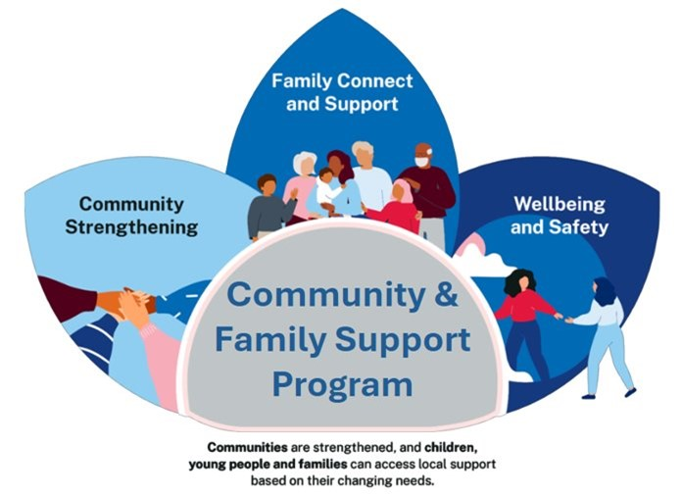
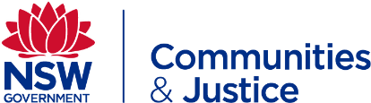
Outcomes Plan

INSTRUCTIONS: Complete the optional Outcomes e-Tool and then store the results in this optional template.
Share with your team and DCJ Commissioning & Planning Officer as needed.

This plan aligns with:
☐ Our contract
☐ Our Program Logic

Who will measure the outcome:
Choose an item.

When will the outcome be measured:
Choose an item.

How will the outcome be measured:
Choose an item.

What is the Program Activity being delivered:
Choose an item.

What is the Service Type being delivered:
Choose an item.

What is the outcome SCORE type:
Choose an item.

What are the client survey questions or practitioner assessments for SCORE (1-5 rating):

Minimum reporting for COMMUNITY outcomes:
- At least one COMMUNITY SCORE
- For 50% of unidentified clients
- Per quarter
Minimum reporting for CLIENT outcomes:
- At least one GOAL or CIRCUMSTANCE SCORE
- For 50% of identified clients
- Per quarter

