**Early Intervention Common Assessment Tool**

Early Intervention CAT Family Self-Assessment Template

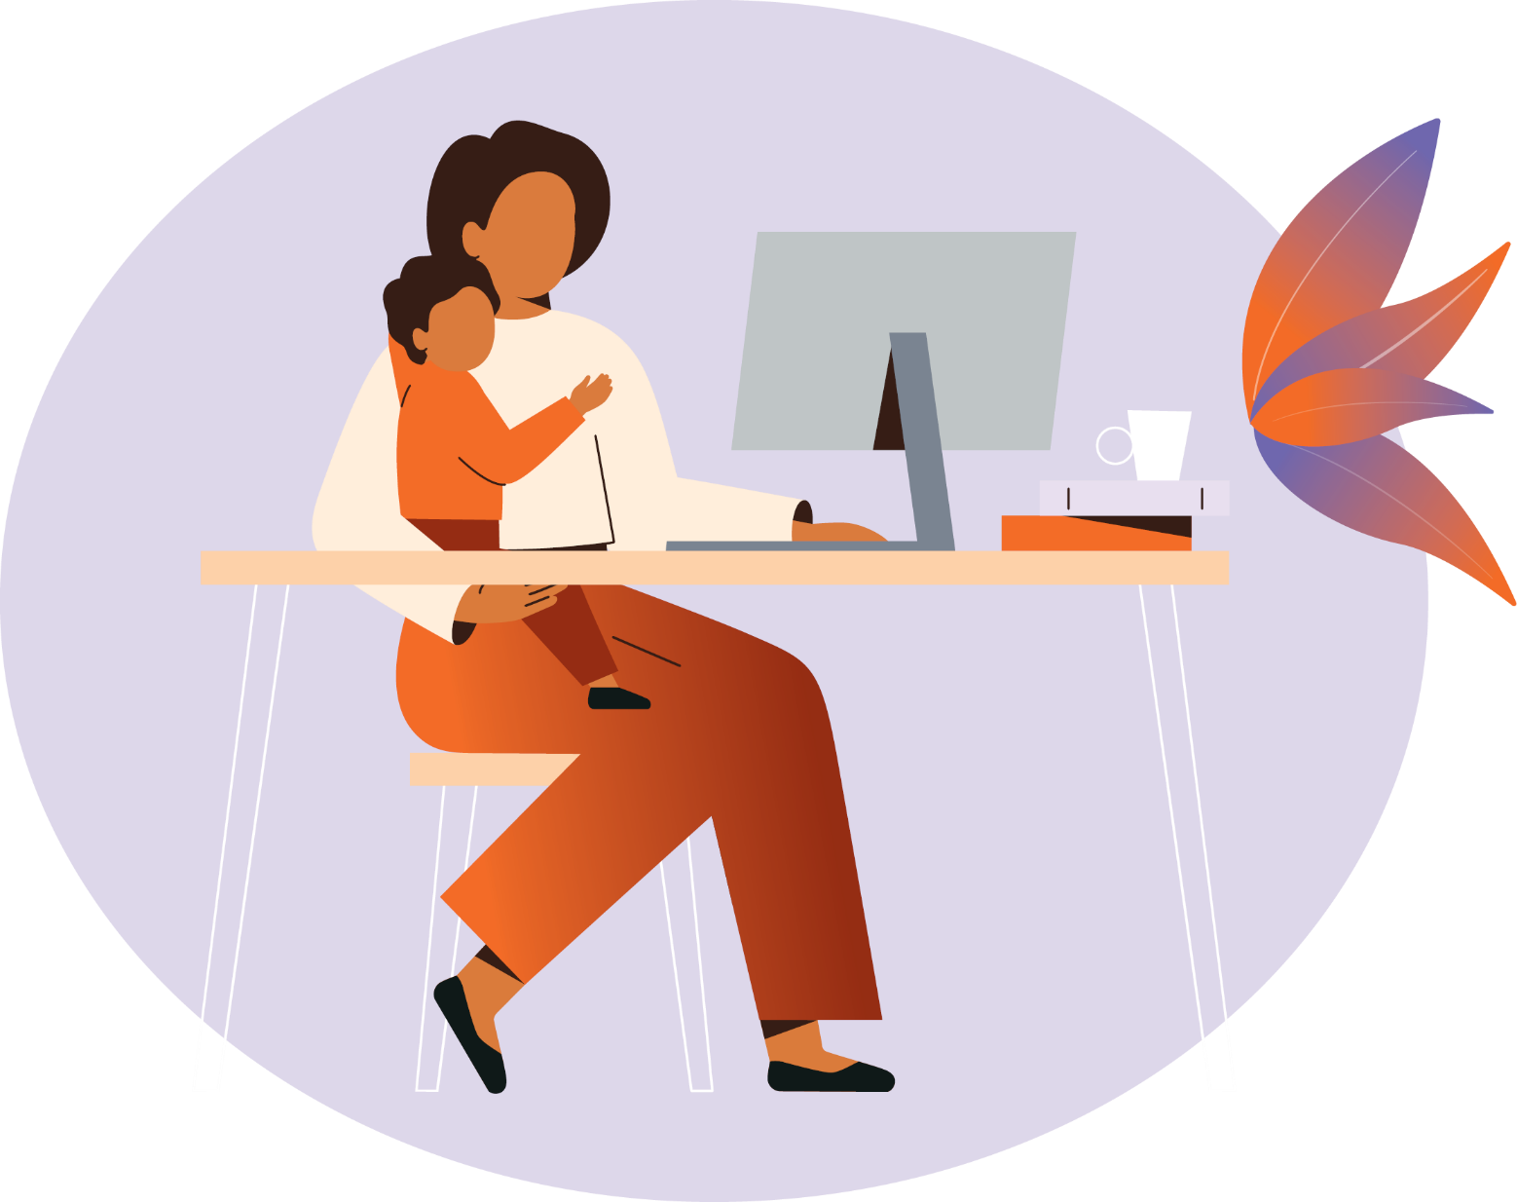

As part of the assessment process, this family self-assessment is a chance for you to indicate the areas of your life that you feel are working for you and your family, and other areas where you might need support. You can discuss the answers with your worker at any time, and they will also go through your answers with you as part of a joint assessment.

Some parts might be hard to answer, and some parts might not be important to you and your family. Answer as best you can based on your experiences and how you feel most of the time. There are no right or wrong answers.

You will receive a copy of this information.

|  |  |
| --- | --- |
| Key information | Details |
| Name of parent/carer(s) |  |
| Relationship to child / young person |  |
| Contact details (phone/email) |  |
| Date |  |

Answer the statements by ticking one box about how much you agree with it

|  |  |  |  |  |  |
| --- | --- | --- | --- | --- | --- |
| Culture, religion and identity | Strongly disagree | Disagree | Undecided | Agree | Strongly agree |
| My family and I are connected to our culture |  |  |  |  |  |
| I have a clear sense of what my culture means to me |  |  |  |  |  |
| I feel connected to my community |  |  |  |  |  |

|  |  |  |  |  |  |
| --- | --- | --- | --- | --- | --- |
| Relationships and connections to family and community | Strongly disagree | Disagree | Undecided | Agree | Strongly agree |
| I have confidence in my parenting and caring skills |  |  |  |  |  |
| My family generally gets along with each other |  |  |  |  |  |
| I have friends and people I can count on outside of my family |  |  |  |  |  |
| My children find it easy to make and maintain friendships |  |  |  |  |  |

|  |  |  |  |  |  |
| --- | --- | --- | --- | --- | --- |
| Physical and mental health − Child’s physical health, mental health and disability | Strongly disagree | Disagree | Undecided | Agree | Strongly agree |
| My children are physically healthy |  |  |  |  |  |
| My children are usually happy and emotionally well |  |  |  |  |  |
| My children can do most things that are expected for their age and ability |  |  |  |  |  |

|  |  |  |  |  |  |
| --- | --- | --- | --- | --- | --- |
| Physical and mental health − Child’s behaviours | Strongly disagree | Disagree | Undecided | Agree | Strongly agree |
| My children cope well with difficult situations |  |  |  |  |  |
| I feel confident in managing my child’s behaviour |  |  |  |  |  |

|  |  |  |  |  |  |
| --- | --- | --- | --- | --- | --- |
| Physical and mental health − Parent’s physical health, mental health and disability | Strongly disagree | Disagree | Undecided | Agree | Strongly agree |
| I am generally in good physical health |  |  |  |  |  |
| I generally feel good emotionally |  |  |  |  |  |

|  |  |  |  |  |  |
| --- | --- | --- | --- | --- | --- |
| Physical and mental health − Alcohol and/or other drugs use | Strongly disagree | Disagree | Undecided | Agree | Strongly agree |
| Drinking alcohol is not a problem for me or my family |  |  |  |  |  |
| Drug use is not a problem for me or my family |  |  |  |  |  |

|  |  |  |  |  |  |
| --- | --- | --- | --- | --- | --- |
| Appropriate and stable housing | Strongly disagree | Disagree | Undecided | Agree | Strongly agree |
| My family’s home is stable |  |  |  |  |  |
| My family’s home is appropriate/suitable for our needs |  |  |  |  |  |

|  |  |  |  |  |  |
| --- | --- | --- | --- | --- | --- |
| Ensuring safety and protection | Strongly disagree | Disagree | Undecided | Agree | Strongly agree |
| My family and I feel safe at home |  |  |  |  |  |
| My family and I feel safe out in the community |  |  |  |  |  |
| My family does not have arguments that lead to aggression or physical abuse |  |  |  |  |  |

|  |  |  |  |  |  |
| --- | --- | --- | --- | --- | --- |
| Employment, finances, food and nutrition | Strongly disagree | Disagree | Undecided | Agree | Strongly agree |
| I can afford the things I need for myself and my family |  |  |  |  |  |
| I am employed in suitable work |  |  |  |  |  |
| I have access to healthy food for myself and my family |  |  |  |  |  |
| I can prepare healthy meals for myself and my family |  |  |  |  |  |

|  |  |  |  |  |  |
| --- | --- | --- | --- | --- | --- |
| Education and skills | Strongly disagree | Disagree | Undecided | Agree | Strongly agree |
| I am happy with my current level of education / training |  |  |  |  |  |
| My children enjoy learning and developing new skills |  |  |  |  |  |
| I am happy with my children’s attendance and engagement with school |  |  |  |  |  |
| I have confidence in my children’s development or ability to learn |  |  |  |  |  |

|  |  |  |  |  |  |
| --- | --- | --- | --- | --- | --- |
| Connecting with services and making informed decisions | Strongly disagree | Disagree | Undecided | Agree | Strongly agree |
| I feel confident in making decisions for my family |  |  |  |  |  |
| I know about the services that can provide support for myself and my family |  |  |  |  |  |
| I feel confident in talking with services to seek support for myself and my family |  |  |  |  |  |

|  |
| --- |
| Any other comments |
|  |