0

NSW Aboriginal Domestic Family & Sexual Violence Plan Artwork EOI

**

**Can I apply for both the branding and feature artworks?**

Yes, if you meet the eligibility outlines in the terms of entry document. If you are applying for both please ensure you tick that option on the application form.

**Why is the branding artwork eligibility for Aboriginal Women in NSW only.**

The NSW Aboriginal Domestic, Family & Sexual Violence plan responds directly to CTG T13 Target 13: By 2031, the rate of all forms of family violence and abuse against Aboriginal and Torres Strait Islander women and children is reduced at least by 50%, as progress towards zero. The main artwork eligibility provides an opportunity to hold Aboriginal women at the heart of this strategy and centres their knowledge, wisdom & experience.

**Is there any colour limitations for the artwork?**

Please ensure you use the DCJ colour palette. Colours outside of this palette may need to be digitally changed with the artist consent.

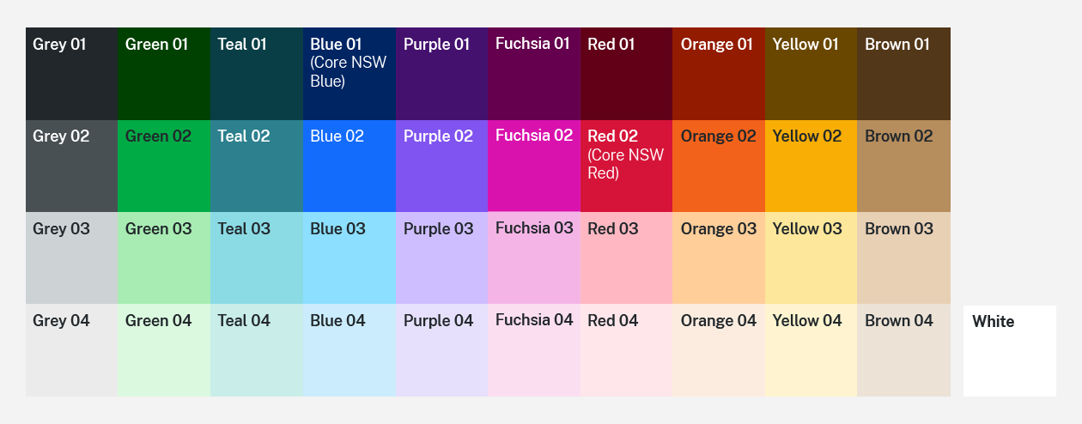

**Who can I contact if I have any questions?**

Please email [taofamilyviolence@dcj.nsw.gov.au](mailto:taofamilyviolence@dcj.nsw.gov.au) with attention: Rebecca.

**What happens if I send my artwork concept after the EOI close date?**

The Department of Communities and Justice accepts no responsibility for lost or late applications. The assessment panel will not accept late applications.