The District Court of New South Wales

Annual Review 2013

Contents
Annual Review 2013 1
Foreword by Chief Judge 2
The District Court 4
History 4
Jurisdiction 5
Judiciary 5
Court Staff 10
Strategic Plan 11
Civil Business Committee Report 11
Criminal Business Committee Report 13
Professional Development (Education) Committee Report 14
Civil Jurisdiction 17
New South Wales 17
Caseload 17
Sydney 18
Caseload 19
Residual Jurisdiction 21
Alternative Dispute Resolution 21
Sydney West 22
Country 22
Criminal Jurisdiction 23
Trials 23
Caseload 24
Short Matters 31
Judicial Resources 33
Allocated Sittings 33
Actual Sittings 34
Annexures 38
Annexure A – Civil Caseload 38
Annexures B – Criminal Caseload 40
Annexure C – Compliance with Criminal Time Standards 44
Annexure D – Court Committees 47

Foreword by Chief Judge
I reported in last year’s Annual Review a significant increase in criminal trials being sent to the District Court. In the course of 2013 that trend continued almost unabated. The Court registered 1,814 new trials compared to 1,876 in 2012 and although the Court disposed of 1,662 trials compared to 1,532 in 2012 the result was that at the end of the year the caseload of criminal trials stood at 1,515. That compares with a caseload at the end of 2012 of 1,363 and prior to 2012 the caseload of criminal trials was generally just above 1,000. For example, at the end of 2011 it was 1,019. What that means is that the caseload of criminal trials has increased by about 50%.
Criminal trials represent the biggest part of the workload of the Court because they take an average of just less than two weeks per trial. The impact of this increase in trials is a gradual worsening of the timeliness in disposing of criminal trials with the result that accused persons spend longer periods in custody while on remand. The problems in the country circuits are worse than in Sydney or Sydney West because the circuits do not have the flexibility to dispose of cases that exists in the courts in Sydney.
At the same time this major increase in the Court’s workload has occurred, cuts in funding have resulted in two judges’ positions being lost with two more positions to be lost in the next two years. It would appear that a significant cause of the increase in trials is an increase in police numbers and the number of police available for investigations. That being the case it would appear that now would be an appropriate time for the Government to look at the funding arrangements for the whole justice system including the effects on downstream agencies of the increase in police resources.
Despite the problems the Court has been experiencing the Annual Report on the Return of Government Services indicates that the Court still compares favourably with other Courts in Australia. The national standard is that no more than 10% of criminal non-appeal matters should be older than 12 months. This Court’s figure was that there were 10.9% of cases older than 12 months. Last year the figure was 10.6% and it can only be expected that this figure will continue to decline unless there is some change in the system.
The civil business of the Court has remained steady with just under 5,000 matters registered which was only a slight increase from the previous year. As with previous years there has not been a large number of cases in the country circuits. In Sydney where most of the work is finalised, the number of civil actions not reached has been almost nil. That is highly desirable as a result because it provides certainty to the parties that when their cases are listed for trial, they will be heard.
The Australian Productivity Commission’s Report on Government Services again indicates that this Court compares very favourably with other Courts in Australia in the timely disposition of civil actions.
Overall, results which have been achieved have only been achieved by the dedication and hard work of the judges of the Court and the staff that supports them. Since this is my last foreword to an Annual Review before I retire, I would like to express my appreciation to the judges and staff of the Court for their consistent dedication to the aims of the Court. It has been a privilege to work with them.
The Honourable Justice R O Blanch AM
Chief Judge

The District Court

History
By the middle of the 19th Century the court system in New South Wales consisted of:
- The Supreme Court of New South Wales which, under the Third Charter of Justice sealed in 1823, had a criminal and civil jurisdiction similar to that of the superior Courts of England;
- Courts of General and Quarter Sessions which could deal with “crimes and misdemeanours not punishable by death”
- Courts of Requests in Sydney and the County of Cumberland, with a civil jurisdiction not exceeding £30; and
- Courts of Petty Sessions, which dealt with criminal misdemeanours in a summary way and had a civil jurisdiction up to £10 (or £30 if the defendant consented).
With the discovery of gold in 1851 the Colony’s population increased and became more dispersed. Litigation grew as the Colony prospered, and crime was not declining. The Supreme Court began to fall seriously into arrears, and this was not helped by the fact that it did not visit a lot of towns. Courts of Quarter Sessions were also few in number and had no civil jurisdiction.
By the mid 1850’s there were calls for a revision of the court system, to meet the growing needs of the Colony. As a result, the District Court Act 1858 (22 Vic No 18) was assented to on 12 November 1858.
This Act established District Courts, as courts of records, to replace Courts of Requests and divided the Colony into Districts. It conferred upon the District Courts a civil jurisdiction.
It also provided for the appointment of a District Court judge as Chairman of any Court of Quarter Sessions or General Sessions, to be held within the limits of the District for which that judge was appointed.
The purpose of the Act was briefly described in The Practice of the District Courts of NSW by W.J. Foster and C.E.R. Murray (Sydney, 1870), as follows:
“District Courts were established by the Legislature for the purpose of simplifying legal proceedings in the recovery of amounts under £200, and lessening the expenses of attending such proceedings, as well as to relieving the Supreme Court of some portion of the overwhelming civil business which the rapid progress of the colony had lately engendered.
The Act providing for the institution of these Courts also extended the jurisdiction of Courts of General and Quarter Sessions of the Peace, and prepared the way for a great increase in their numbers, under the presidency of District Court judges as Chairmen, whereby criminal proceedings have been much facilitated, especially in the more distant and outlying portions of the country…”
The District Courts Act 1858 remained in force until 1973, although the jurisdiction of the Court was increased from time to time.
The District Court Act 1973 commenced on 1 July 1973. It abolished the District Courts and Courts of Quarter Sessions and established one District Court of New South Wales, with a state wide criminal and civil jurisdiction.

Jurisdiction
The District Court is the intermediate Court in the State’s judicial hierarchy. It is a trial court and has an appellate jurisdiction. In addition, the judges of the Court preside over a range of tribunals.
In its criminal jurisdiction, the Court may deal with all criminal offences except murder, treason and piracy.
In its civil jurisdiction the Court may deal with:
- All motor accident cases, irrespective of the amount claimed;
- Other claims to a maximum amount of $750,000, although it may deal with matters exceeding this amount if the parties consent.
In addition, the Court may deal with equitable claims or demands for recovery of money or damages for amounts not exceeding $750,000.
The Court is also empowered to deal with applications under the De Facto Relationships Act 1984, the Family Provisions Act 1982 and the Testator Family Maintenance and Guardianship of Infants Act 1916 that involve amounts, or property to the value of, not more than $250,000.

Judiciary
The following were the judges of the Court as at 31 December 2013.
Chief Judge
The Honourable Justice Reginald Oliver Blanch AM*
Judges
Her Honour Judge Dianne Joy Truss, His Honour Judge Garry William Neilson, His Honour Judge Christopher John Armitage, His Honour Judge Christopher John George Robison, Her Honour Judge Robyn Christine Tupman, His Honour Judge James Patrick Curtis*, Her Honour Judge Deborah June Payne, His Honour Judge Martin Langford Sides QC, Her Honour Judge Anne Mary Quirk, His Honour Judge Gregory David Woods QC, His Honour Judge Norman Edward Delaney, His Honour Judge Kevin Patrick O’Connor AM, Her Honour Judge Jennifer Anne English, Her Honour Judge Susan Jennifer Gibb, His Honour Judge Robert Arthur Sorby, His Honour Judge Stephen Ronald Norrish QC, Her Honour Judge Audrey Suzanne Balla, His Honour Judge Michael John Finnane RFD QC*, Her Honour Judge Penelope Jane Hock, Her Honour Judge Judith Clare Gibson, His Honour Judge Anthony Martin Blackmore SC, His Honour Judge Peter Graeme Berman SC, His Honour Judge Raymond Patrick, McLoughlin SC, His Honour Judge Colin David Charteris SC, His Honour Judge Roy David Ellis, His Honour Judge Mark Curtis Marien SC, His Honour Judge Brian John Knox SC, His Honour Judge John Roger Dive, Her Honour Judge Deborah Anne Sweeney, His Honour Judge James Leonard Alexandre Bennett SC, His Honour Judge Peter Lind Johnstone, His Honour Judge William Patrick Kearns SC*, His Honour Judge Paul Vincent Conlon SC, His Honour Judge Peter Raymond Zahra SC, His Honour Judge Richard Dominic Cogswell SC, Her Honour Judge Leonie Flannery SC, His Honour Judge Robert Stephen Toner SC, His Honour Judge Gregory Michael Keating, His Honour Judge Paul Ivan Lakatos SC, His Honour Judge Leonard Levy SC, His Honour Judge Michael Elkaim SC, His Honour Judge Michael King SC, His Honour Judge David Clement Frearson SC, His Honour Judge Andrew Michael Colefax SC, Her Honour Judge Helen Syme, His Honour Michael Ivan Bozic SC, His Honour John North, His Honour Judge Graham Leslie Henson, Her Honour Judge Laura Kathleen Wells SC, His Honour Judge Ross Victor Letherbarrow SC, His Honour Judge Andrew Carl Haesler SC, Her Honour Judge Donna Mary Lisa, Woodburne SC, Her Honour Judge Elizabeth Margaret Olsson SC, His Honour Judge Clive Vaughan Jeffreys, His Honour Judge David Ulric Arnott SC, His Honour Judge Peter George Maiden SC, His Honour Judge Phillip Gregory Mahony SC, His Honour Judge Christopher Phillip Hoy SC, His Honour Judge Phillip Thomas Taylor SC, His Honour Judge Gordon Bruce Lerve, His Honour Judge Ian Hartley McClintock SC, His Honour Judge Christopher Bruce Craigie SC, Her Honour Judge Sarah Jane Huggett, His Honour Judge Antony Edward Townsden, His Honour Judge Peter Raymond Whitford, His Honour Judge Stephen Scott Hanley SC, Her Honour Judge Sharron Norton SC, His Honour Judge Mark Lloyd Williams SC
*denotes Member of the Dust Diseases Tribunal
Appointments
The following Judges were appointed during 2013:
• His Honour Judge Antony Edward Townsden was appointed on 6 May 2013
• His Honour Judge Peter Raymond Whitford SC was appointed on 24 June 2013
• His Honour Judge Stephen Scott Hanley SC was appointed on 15 July 2013
• Her Honour Judge Sharron Norton SC was appointed on 16 September 2013, and
• His Honour Judge Mark Lloyd Williams SC was appointed on 23 September 2013
Retirements
The following Judges retired during 2013:
• His Honour Judge James Walter Black QC retired on 7 February 2013
• His Honour Judge Robert Keleman SC retired on 28 February 2013
• His Honour Judge Kevin Peter Coorey retired on 29 March 2013
• Her Honour Judge Linda Margaret Ashford retired on 15 May 2013
• His Honour Judge Jonathan Steuart Williams retired on 28 July 2013
• His Honour Judge Ronald Herbert Solomon retired on 16 August 2013, and
• His Honour Judge Stephen Lewis Walmsley SC retired on 27 September 2013
Appointment to the Supreme Court of the ACT
• Her Honour Judge Helen Gay Murrell SC was appointed to the position of Chief Justice of the Supreme Court of the ACT on 28 October 2013.
Appointments Held
• The Honourable Justice Reginald Oliver Blanch AM, held the appointment of President of the Dust Diseases Tribunal of NSW.
• His Honour Judge Kevin Patrick O’Connor AM, held the appointment of President of the Administrative Decisions Tribunal of NSW.
• His Honour Judge John Roger Dive held the appointment of Senior Judge of the Drug Court of NSW.
• His Honour Judge Peter Lind Johnstone held the appointment of President of the Children’s Court of NSW.
• His Honour Judge Gregory Michael Keating held the appointment of President of the Workers Compensation Commission of NSW.
• His Honour Judge Graeme Leslie Henson held the appointment of Chief Magistrate of the Local Court of NSW.
Medical Tribu4nal of NSW
• The Honourable Justice Reginald Oliver Blanch AM, Chief Judge, held the appointment of Chairperson of the Medical Tribunal of New South Wales.
The following Judges held appointments as Deputy Chairpersons of the Tribunal as at 31 December 2013:
• Her Honour Judge Audrey Suzanne Balla
• His Honour Judge Peter Lind Johnstone
• Her Honour Judge Leonie Flannery SC
• His Honour Judge Paul Ivan Lakatos SC
• His Honour Judge Michael Elkaim SC
• His Honour Judge Leonard Levy SC
• His Honour Judge Andrew Michael Colefax SC, and
• His Honour Judge Phillip Gregory Mahony SC
Acting Judges (in alphabetical order)
• Mr Warwick John Andrew CBE
• Ms Linda Margaret Ashford
• Mr Ian Barnett
• Mr James Walter Black QC
• Mr Grant Thomas Britton SC
• Mr Terence Joseph Christie QC
• Mr Paul Cloran
• Ms Elizabeth Corbett
• Mr Garry Spencer Forno QC
• Mr David James Freeman
• Mr Anthony Frederick Garling
• Mr Geoffrey John Graham
• Mr Gregory Scott Hosking SC
• Mr Luigi Maria Baliano Lamprati
• Mr Rodney Neville Madgwick QC
• The Honourable Francis Marks
• Ms Helen Jane Morgan
• Mr John Cecil Nicholson SC
• Mr John Roscoe Nield
• Mr Colin Emmett O’Connor QC
• Mr John Lawrence O’Meally AM RFD
• Mr Colin Phegan
• Mr Anthony Francis Puckeridge QC
• Ms Margaret Sidis
• Mr Ronald Herbert Solomon
• Mr Kenneth Victor Taylor AM RFD
• Mr Stephen Lewis Walmsley SC
• Mr Jonathan Steuart Williams
Judicial Registrar
Mr James Howard is the Judicial Registrar and exercises functions pursuant to Section 18FA of the District Court Act 1973.

Court Staff
Venues
In 2013 the Court sat permanently in Sydney at the Downing Centre, 143-147 Liverpool Street, Sydney (in crime), where it occupies 18 courtrooms, and at the John Maddison Tower, 86 Goulburn Street, Sydney, where it occupies 23 courtrooms (mostly in civil).
In Sydney West, Judges sat full-time in the Court Houses at Parramatta (8 courtrooms), Penrith (1 courtroom) and Campbelltown (1 courtroom).
In addition, continuous sittings were conducted at Gosford, Lismore, Newcastle and Wollongong.
Other places where the Court sat were:
Albury, Armidale, Bathurst, Bega, Bourke, Broken Hill, Coffs Harbour, Coonamble, Dubbo, East Maitland, Goulburn, Grafton, Griffith, Lismore, Moree, Nowra, Orange, Parkes, Port Macquarie, Queanbeyan, Tamworth, Taree, and Wagga Wagga.
Principal Registrar
Ms Pam Olsoen is the Principal Registrar and exercises functions pursuant to Section 18H(3) of the District Court Act 1973.
Criminal Listings and Judicial Arrangements
Schedules cases in accordance with Court policy; prepares lists, allocates courtrooms and co-ordinates the assignment of judges to venues throughout the State.
Mr Robert Fornito is the District Court Criminal Listing Director. Pursuant to Section 123 of the Criminal Procedure Act 1986, the Criminal Listing Director is responsible to the Chief Judge in making arrangements for the listing of criminal proceedings.
Civil Listings and Case Management
Implements civil case management and listing practices for the timely finalisation of cases, schedules cases, prepares lists and allocates courtrooms.
Ms Jane Dunn is the Civil List and Case Manager and works in conjunction with the Civil List Judge and the Judicial Registrar in making arrangements for the listing of civil proceedings.

Strategic Plan

Civil Business Committee Report
In 2012 the Court introduced its fourth Strategic Plan. The first such plan was adopted in 1995 and it provided a template for significant changes in the way the Court operated as did the subsequent Strategic Plans released in 2000 & 2007.
The current Strategic Plan articulates the values of the Court and sets out the goals to be achieved over 2012-2017 in carrying out this role in line with these values.
The Court is committed to discharging its responsibilities to ensure:
- That the Court is accessible to the public and those who need to use its services
- The effective determination of cases in an orderly, cost effective and expeditious manner. The equal protection of the law to all
- The independence of the judges of the Court, and the Court as a branch of our system of government
- Accountability for the performance of the Court and its use of public funds, and
- The highest standard of excellence in the functioning of the Court.
As in past plans, the Court will continue to maintain a Policy and Planning Committee to provide advice to the Chief Judge on matters relating to the business of the Court. There are also three major committees that are accountable to the Policy and Planning Committee. Those Committees are:
- The Civil Business Committee
- The Criminal Business Committee, and
- The Professional Development (Education) Committee.
Terms of Reference
To monitor, report and advise on any matter relating to the Court’s objective of providing a system for the earliest, most effective and efficient resolution of civil disputes.
The Committee
The Committee consists of judges of the Court, the Judicial Registrar, the Civil List and Case Manager and representatives of the Law Society of NSW, the Bar Association of NSW, the Insurance Council of Australia and the Motor Accidents Authority.
Activities
The Committee met on three occasions during the year and matters considered included:
- The Court’s Operational Performance Report with up-to-date statistical information presented at each meeting.
- Proposed amendments to the rules and practice notes.
- Particular concerns of the various representatives and matters which the Court wished to bring to their attention.
- The Committee considered a wide range of issues including:
- The components of the caseload by cause of action
- Pre-action protocols under Part 2A of the Civil Procedure Act
- The Court Information Act
- Issues arising under the Motor Accidents Compensation Act and the latest reforms
- Judicial and listing arrangements including pre-trial conferences
- Practical difficulties associated with the shortage of court officers
- Lack of compliance with the practice note in relation to approval applications
- Problems associated with expert evidence, and
- The on-line registry and amendments to Part 3 of the UCPR (Electronic Case Management).

Criminal Business Committee Report
Terms of Reference
To monitor, report and advise on any matter relating to the Court’s goal of providing a system for the earliest, most effective and efficient resolution of criminal matters.
Consultation with court users is carried out through the Criminal Business Committee. The Committee consists of a judge of the Court, the Criminal Listing Director and representatives from the Law Society of NSW, Bar Association of NSW, Legal Aid, Commonwealth and State DPP’s, Aboriginal Legal Service, Public Defenders and Crown Prosecutors.
Activities
The Committee met on four occasions during the year.
- The Court continues to target older pending cases throughout the state.
- The Court continues to manage and list criminal trials in country circuits by way of telephone call over.
- The average length of trials in Sydney rose to 11.41 days (compared to 10.98 days in 2012). The state wide trial average was 8.51 days.
- In 2012 there was a 19% increase in trial registrations on the previous year. In the year 2013 there was a 3 % drop in trial registrations.
- The Court continues to maintain a collaborative approach in its partnership with the Court’s stakeholders in its criminal jurisdiction.

Professional Development (Education) Committee Report
Terms of Reference
The District Court, in partnership with the Judicial Commission of New South Wales, provides a continuing judicial education program for judges. The program aims to:
- Enhance professional expertise
- Facilitate the development of judicial knowledge and skills, and
- Promote the pursuit of juristic excellence.
With a focus on interactive learning, the program is based on enhancing skills, attitudes and knowledge in a judicially relevant environment.
Sessions range from orientation programs for new judges and an annual conference to specialist seminars on practical matters, social awareness issues and legislative changes. The focus in education for District Court judges is on sentencing, important legal developments, improving knowledge in difficult areas of legal practice and procedure, and the development of judicial skills.
The Professional Standards (Education) Committee composed of judges and the Judicial Commission’s Education Director, develops each education program based on the identified needs of judges. Judges are involved in the development and delivery of the education program to ensure its relevance to the judicial role. A member of the Committee is also a member of the Judicial Commission’s Standing Advisory Committee on Judicial Education.
During 2013, judges:
- Continued to receive focused and tailored training to meet their educational needs, and
- Attended 162 days of face-to-face judicial education organised by the Judicial Commission, an average of 2.4 days of judicial education per judge.
Activities
Annual Conference
The Annual Conference held in Newcastle on 2-3 April 2013 was attended by 50 judges, 5 acting judges and the Judicial Registrar. The conference focused on providing challenging and interesting educational sessions, while also providing a valuable opportunity for discussion and debate. The program consisted primarily of sessions relevant to the day-to-day work of a judge. Topics for the conference were determined by the Education Committee based on previous evaluation reports, suggestions by colleagues and suggestions from the Judicial Commission.
The sessions dealt with a variety of topics including substantive law and practice, sentencing issues and civil law. Topics included:
- “Judge Yourself: Professionals Keeping Healthy”, Professor Simon Willcock, Head, Discipline of General Practice, Sydney Medical Program, University of Sydney and Dr Vicky Phillips, Principal Exercise Physiologist, ExPhys
- “Court of Criminal Appeal Review”, The Honourable Justice Robert A Hulme, Supreme Court of NSW
- “Child Care Appeals”, His Honour Judge Peter Johnstone
- “Civil Liability Update”, His Honour Judge Phillip Mahony SC
- “Rural Crime and its Consequences”, His Honour Judge Gordon Lerve
- “Court of Appeal Review”, The Honourable Justice Cliff Hoeben AM RFD, Chief Judge at Common Law, Supreme Court of NSW
- “Developments in Online Resources”, Mr Murali Sagi PSM, Director, Information Management and Corporate Services and Ms Joy Blunt, Senior Systems Officer – Training, Judicial Commission of NSW
- “Oral Language Competence in Young Offenders”, Associate Professor Pamela Snow, School of Psychology and Psychiatry, Monash University
- “Judicial Bullying”, The Honourable Keith Mason AC QC, Chairman, Tristan Jepson Memorial Foundation and Dr Robert Fisher, Head of Department of Psychiatry and Psychological Services, St Vincent’s Private Clinic and Hospital, and
- “Current Issues in Sentencing”, His Honour Judge Martin Blackmore SC.
Occasional Seminars
The Education Committee has continued to work with the Judicial Commission to organise a series of twilight education sessions for District Court judges. These seminars provide useful, informative and timely information on a range of topical matters relevant to the work of the District Court. They aim to enhance judicial performance and assist in the further development of judicial skills and knowledge. Seminars were held on the following topics:
- “Personal Property Securities Act”, Professor John Stumbles, Professor Finance Law, University of Sydney, 15 May 2013
- “Judge Alone Trials”, His Honour Judge Greg Woods QC, Twilight Seminar, 12 June 2013
- “DNA Testing in NSW”, Mr Bob Goetz, Acting Deputy Director and Ms Sharon Neville, Laboratory Manager, DNA Laboratory, NSW Forensic & Analytical Science Service, Twilight Seminar, 9 October 2013, and
- “Complaints Against Judicial Officers”, Mr Ernie Schmatt PSM, Chief Executive, Judicial Commission of NSW, Twilight Seminar, 26 November 2013.
Judges also attended a number of cross jurisdictional events, including:
- “Field Trip to the NSW Police Service Telecommunications Interception Branch, State Electronic Evidence Branch and State Technical Investigation Branch”, Commander Jeffrey Conly, State Electronic Evidence Branch, Acting Commander Arthur Kopsias APM, Telecommunications Interception Branch, Acting Commander Gregory Taylor, State Technical Investigation Branch and Inspector Stuart Davis, Telecommunications Interception Branch, 27 February 2013
- “Judgment Writing Workshop: Cross jurisdictional Refresher”, Professor James Raymond, 27 August 2013, and
- “Evidence Amendment (Evidence of Silence) Act & Criminal Procedure Amendment (Mandatory Pre-trial Defence Disclosure) Act” The Honourable Megan Latham, Supreme Court of NSW, Cross jurisdictional Seminar, 10 September 2013.
Judicial Orientation
Three new judges of the Court attended the National Judicial Orientation Program at Manly in March 2013. This five-day orientation program assists newly appointed judicial officers with their transition to judicial office by facilitating the development and refinement of the skills and knowledge necessary for effective judging. It is conducted by the National Judicial College of Australia with the assistance of the Judicial Commission of New South Wales and the Australian Institute of Judicial Administration.
Ngara Yura Program
The judges continued to participate in the Judicial Commission’s Ngara Yura Program which aims to increase awareness among judicial officers about contemporary Aboriginal society, customs and traditions, and their effect on Aboriginal people in the justice system. Judges participated in the following Ngara Yura Program events:
- “Understanding Kinship”, Ms Lynette Riley, Senior Lecturer, University of Sydney, Twilight Seminar, 10 April 2013
- “Constitutional Recognition of Indigenous Australians”, Professor Megan Davis, Professor of Law, Faculty of Law, University of NSW and Dr Sarah Pritchard SC, Barrister and Adjunct Professor at the University of NSW, Twilight Seminar, 2 October 2013, and
- “Ngara Yura Program: Community Visit to Campbelltown”, 16 November 2013. Civil Jurisdiction

Civil Jurisdiction

New South Wales
Full statistical data on the Court’s civil operations is set out in Annexures A (1) and (2).
In 2013:
- Registrations rose by less than 2%
- Finalisations fell by 3%
- Pending cases rose by 3%
- Median finalisation time fell from 12.2 months to 10.0 months

Caseload
Explanatory Background
Comparing registrations and finalisations is not an exact science. For example, a matter in the course of its life may, for various reasons, be registered more than once. Multiple parties and cross actions can further affect the equation. Cases determined at arbitration can be re-heard. A matter previously dismissed can be restored or a retrial may be ordered. Registries also conduct stock-takes of cases on hand during the course of the year, with pending statistics being adjusted as necessary.
It is therefore important to view comparisons of registrations and finalisations against pending caseload with some caution, as it is often difficult to reconcile the figures. However, they are helpful in providing general trends concerning the incoming and outgoing work of the Court.
Registrations
There were 4,968 matters registered in 2013, compared to 4,849 in 2012.
Finalisations
There were 4,792 matters finalised in 2013, compared to 4,956 in 2012.
Pending
At the end of 2013 the pending caseload was 5,804, compared to 5,629 in 2012.
Comparison with Previous Years
Figure 1 below tracks the Court’s caseload for the past 5 years.
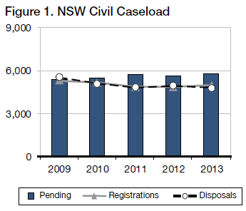
Finalisation Times
In 2013, 51% of all actions finalised were completed within 12 months, with 87% being completed within 24 months. This compares to 50% and 88%, respectively, in 2012.
Of the pending caseload at the end of 2013, 21% exceeded 12 months and not more than 24 months and 6% more than 24 months.

Sydney
In 2013:
- Registrations rose by 7%
- Finalisations fell by 6%
- Pending cases rose by 6%
- Median finalisation time fell from 12.1 months to 9.0 months

Caseload
In 2013, Sydney civil case managed matters represented 69% of the State’s registrations and 70% of the matters on hand.
Figure 2 below shows the ratio of new civil actions commencing in Sydney, as compared to the whole State for the past 5 years.
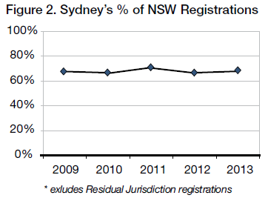
Registrations, Finalisations and Pending
Excluding the Residual Jurisdiction, there were 3,437 new actions registered and 3,188 finalised in Sydney in 2013. At the end of the year there were 4,071 actions pending. Figure 3 tracks Sydney’s caseload for the last five years.
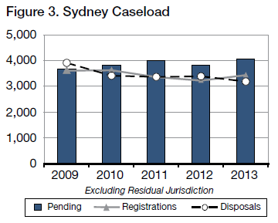
Finalisation Times
The Court’s ideal time standard for civil cases is to achieve a 90% finalisation rate within 12 months of commencement, and 100% within 2 years.
In 2013, 50% of all actions finalised were completed within 12 months, with 87% being completed within 24 months. This compares to 52% and 88%, respectively in 2012.
Of the pending caseload at the end of 2013, 19% exceeded 12 months and not more than 24 months and 5% exceeded 24 months.
How Cases are finalised
Table 1 below shows the break-up of how case managed list matters were finalised in 2013. The categories of “Dismissed” and “Discontinued” include matters that settled without judgment being entered and/or terms of settlement being filed.
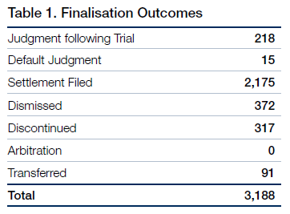
Table 2 below compares two of the seven categories of finalised outcomes as against the total number of finalised outcomes. These two categories are selected because i. “Finalised following trial” represents the number of hearings to judgment before judges, and ii. “Finalised by settlement filed” includes matters that settled as a result of ADR.
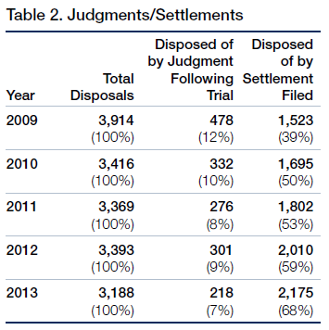

Residual Jurisdiction
The Compensation Court Repeal Act 2002 abolished the Compensation Court, and transferred the Compensation Court’s jurisdiction to the Workers Compensation Commission or the District Court. The Act commenced on 1 January 2004.
The disputes that were transferred to the District Court are commonly referred as its “Residual Jurisdiction” and involve the following:
- The Police Act 1990 concerning police officers “hurt on duty” and the Police Regulation (Superannuation) Act 1906 concerning the payment of superannuation benefits to police officers
- Payment under the Police Regulations (Superannuation) Act 1906, paid to STC (the SAS Trustee Corporation continued under the Superannuation Administration Act 1996) and special risk benefits payable by the Commissioner of Police
- The Workers’ Compensation Act 1987 concerning workers in or about a coal mine
- The Workers Compensation (Dust Diseases) Act 1942
- The Sporting Injuries Insurance Scheme, and
- The Workers’ Compensation (Bush Fire, Emergency & Rescue Services) Act 1987.
During 2013, 319 actions were commenced and 337 were finalised. There were a total of 173 matters on hand in the residual jurisdiction at the end of 2013.

Alternative Dispute Resolution
Mediation
Pursuant to Civil Practice Note 1, cases before the Sydney District Court are referred to mediation where appropriate. The referral may be either to private mediation or to court provided mediation. The Assistant Registrars in Sydney undertake the court provided mediation. In 2013 the Sydney District Court referred 648 matters to mediation (565 were referred to private mediation and 83 to court provided mediation). Settlement conferences were ordered in 1,808 matters.
Approximately 49% of matters referred to mediation by Assistant Registrars were settled. There are no available statistics in relation to settlement of matters referred to private mediators.

Sydney West
Sydney West had 4% of the total number of new actions started in the State in 2013 (excluding the Court’s residual jurisdiction). Figure 4 below tracks the variation in the proportional rate of registrations in Sydney West.
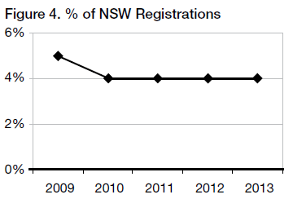
In Sydney West there were 187 matters registered and 217 finalisations throughout the year. At the end of 2013 the total pending caseload was 207, as compared to 237 the previous year.
Figure 5 shows comparative registrations, finalisations and pending caseloads for the past 5 years.
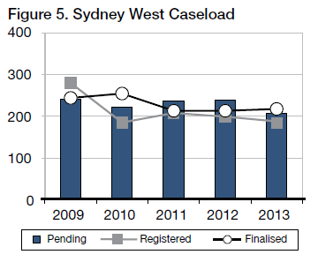
Pending matters in Sydney West fell by 14% and the median finalisation time was 10.0 months.
22% of pending cases exceeded 12 months and not more than 24 months and 6% exceeded 24 months.

Country
Venues outside of Sydney and Sydney West had 21% of the total number of new actions started in 2013 (excluding the Court’s Residual Jurisdiction).
Figure 6 tracks the proportional rate of registrations for Country venues.
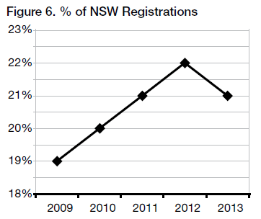
Outside of Sydney and Sydney West, there were 1,025 matters registered and 1,050 finalisations throughout the year. At the end of the year the total pending caseload was 1,353 as compared to 1,377 the previous year.
Figure 7 shows comparative registrations, finalisations and pending caseloads for the past 5 years.
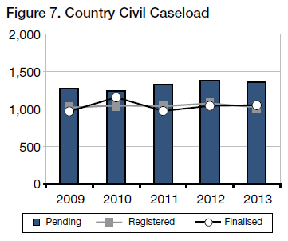
Pending matters in the country fell by 2% and the median finalisation time was 12.0 months.
29% of pending cases exceeded 12 months and not more than 24 months and 9% exceeded 24 months.

Criminal Jurisdiction

Trials
In 2013:
- Registrations fell by 3%
- Finalisations rose by 8 %
- Pending trials rose by 11%
- Median finalisation time rose to 44 weeks
- Average length of trials fell from 8.71 days to 8.51 days from 12.1 months to 9.0 months

Caseload
There were 1,814 criminal trials registered during 2013 in New South Wales, as compared to 1,876 in 2012 and 1,576 in 2011.
There were 1,662 trials finalised in 2013, as compared to 1,532 in 2012 and 1,534 in 2011.
There were 1,515 trials on hand at the end of 2013, as compared to 1,363 trials at the end of 2012.
Figure 8 tracks the state wide trends in the criminal trial caseload for the past 5 years.
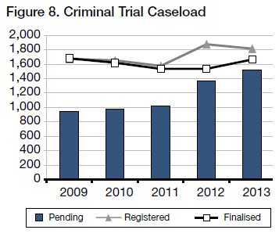
Figure 9 shows variation in trial and sentence registrations for the last 5 years.
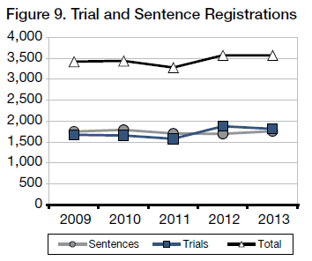
Sentence hearings are far less demanding on victims. They also absorb far less resources than trials. It is therefore important to ensure that in appropriate cases guilty pleas are entered at the earliest possible time, preferably at the committal stage.
Time Standards
The Court’s ideal time standards for the commencement of criminal trials are:
- 90% of cases within 4 months of committal, or such other event which causes the proceedings; and
- 100% of cases within 1 year.
In 2013, 19% of trial finalisations where the accused was in custody were finalised within 4 months, and 15% exceeded 12 months. Where the accused was on bail, 13% of finalisations occurred within 4 months, with 24% exceeding 12 months.
Figure 10 sets out comparative compliance rates with time standards for all trials finalised.
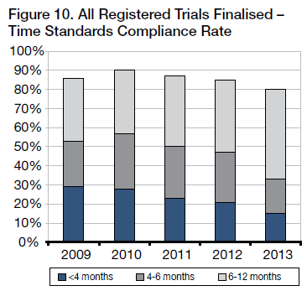
Figure 11 shows the age of all trials which were pending at the end of the year indicated.
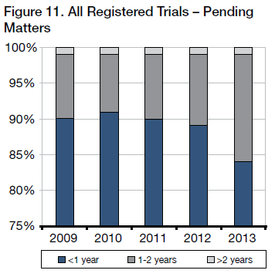
Figure 12 tracks the median finalisation times, from committal to commencement of the trial, for matters finalised during the year indicated.
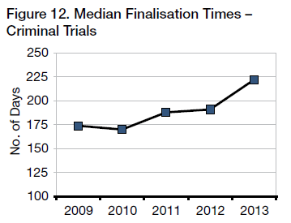
Trial Durations
The state wide average length of criminal trials finalised in 2013 was 8.51 days, as compared to 8.71 days in 2012. In Sydney the average duration was 11.41 days in 2013, compared to 11.98 days in 2012.
Figure 13 illustrates the fluctuating rise in the average trial duration time.
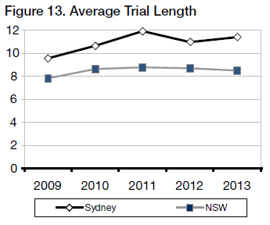
Trial Listing Outcomes
About 2,281 trials were listed for hearing in 2013.
Figure 14 shows the break-up of those matters not dealt with.
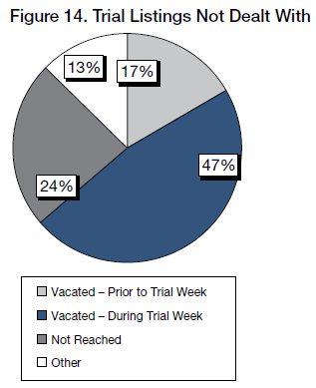
Figure 15 shows the break-up of those matters that were dealt with after being listed.
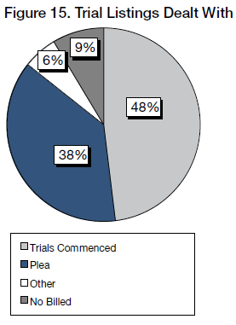
Figure 16 shows the outcome of those that commenced.
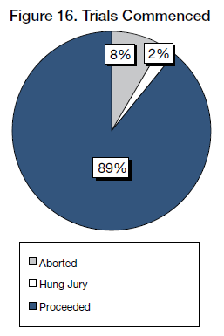
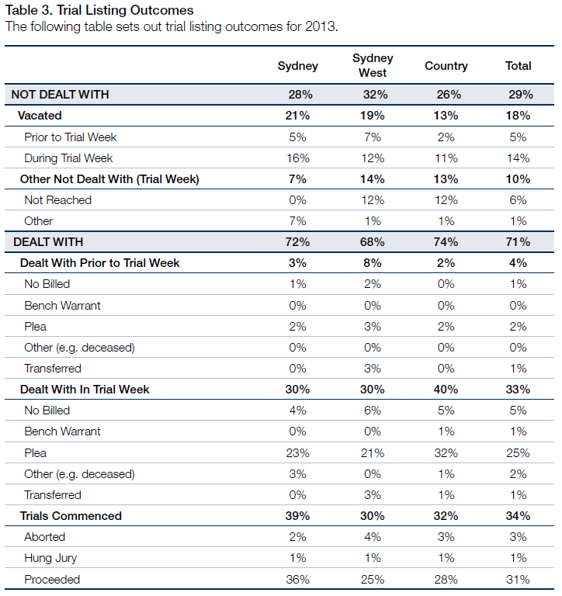
Of trials dealt with in 2013 (i.e. 71% of total listings):
- 38% pleaded Guilty
- 43% proceeded to verdict
- 9% were “no billed”
- 3% were transferred
- 4% were aborted
- 1% ended with a “hung Jury”
- 2% were otherwise disposed
- 1% had bench warrants issued

Short Matters
Sentences
There were 1,752 committals for sentence received in 2013 and 1,725 matters were finalised. At the end of the year there were 755 sentence matters pending, compared to 728 at the end of 2012.
Figure 17 tracks the sentence caseload for the last 5 years.
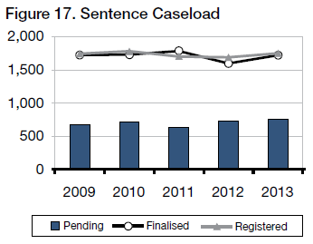
The ideal time standard from committal for sentence to hearing is 3 months in 90% of cases, with 100% being completed within 6 months.
Figure 18 illustrates compliance rates with time standards.
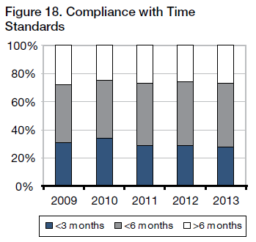
Conviction Appeals
There were 1,314 conviction appeals lodged in 2013 and 1,387 finalisations. At the end of the year there were 407 conviction appeals pending, compared to 480 at the end of 2012.
Figure 19 tracks the conviction appeal caseload for the last 5 years.
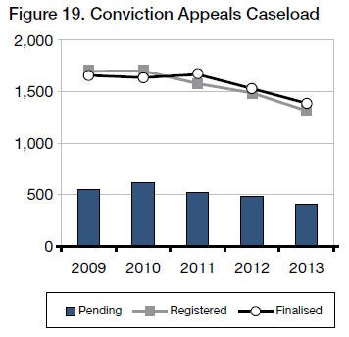
The ideal time standard from lodgement to finalisation is 4 months in 90% of cases, with 100% being completed within 12 months.
Figure 20 illustrates compliance rates with time standards.
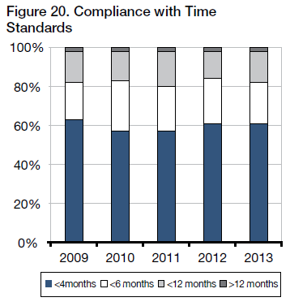
Sentence Appeals
There were 5,116 sentence appeals lodged in 2013 and 5,094 finalised. At the end of the year there were 837 sentence appeals pending, compared to 815 at the end of 2012.
Figure 21 tracks the sentence appeals caseload for the last 5 years.
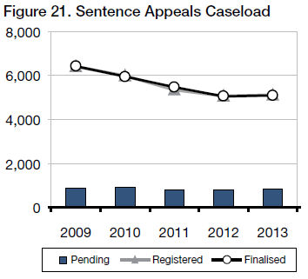
The ideal time standard from lodgement to finalisation for sentence appeals is 2 months in 90% of cases, with 100% being completed within 6 months.
Figure 22 illustrates compliance rates with time standards.
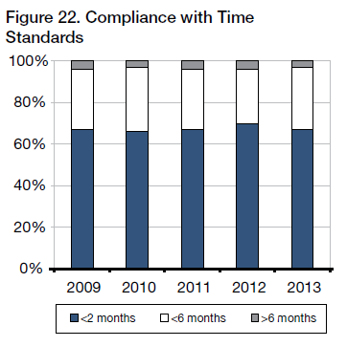

Judicial Resources

Allocated Sittings
Table 4 sets out the number of judicial sitting weeks allocated in 2013 as published in the Court’s Calendar of Sittings.
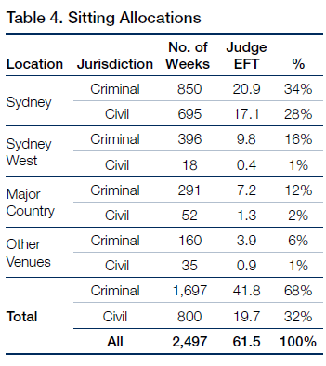
Judge EFT is calculated at 40.6 sitting weeks p.a. – i.e. 52 weeks less judicial vacations, public holidays and Annual Judges’ Conference.

Actual Sittings
Table 5 sets out the number of days actually sat by the court in 2013 converted into weeks (by dividing the number of days by 5).
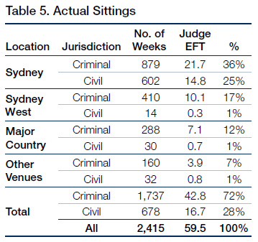
Judge EFT is calculated at 40.6 sitting weeks p.a. - i.e. 52 weeks less judicial vacations, public holidays and Annual Judges’ Conference.
Comparison with 2012
Overall, there was an increase of 37 weeks for sittings in 2013 compared to 2012. This included 29 extra weeks of criminal sittings and 8 extra weeks of civil sittings.
The increase in sittings was due to an increase in pending workload.
Acting Judges
Acting Judges provided an extra 722 days of actual sitting. Based on the maximum of 40.6 sitting weeks per year for a permanent judge, this equated to 3.6 additional judges.
Figure 23 below shows the fluctuations in the number of Acting Judge weeks attained since 2009.
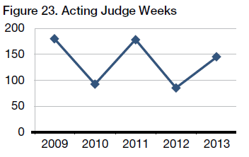
Sitting Details
The final table sets out the allocated, available and actual sittings at all venues, as well as the average daily recorded sitting hours.
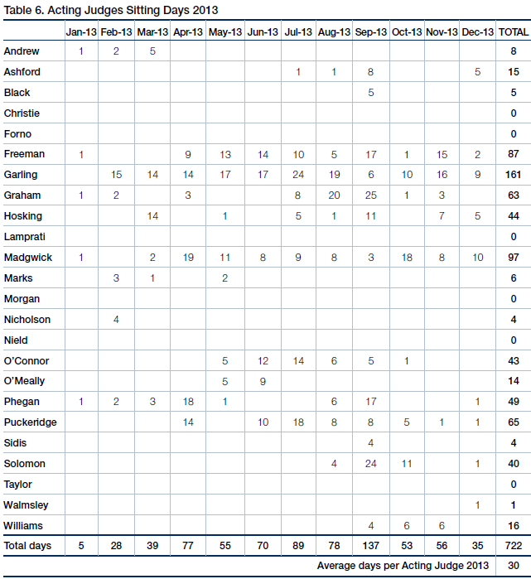
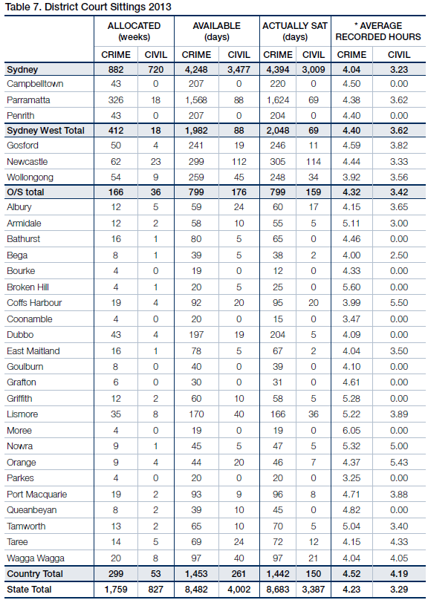
* “Average Recorded Hours” are based on the number of siting hours during which proceedings were recorded, as provided by the Reporting Services Branch, NSW Department of Justice & Attorney General. This is often less than the actual hours the Court sat.

Annexures

Annexure A – Civil Caseload
Annexure A1 - Civil Caseload
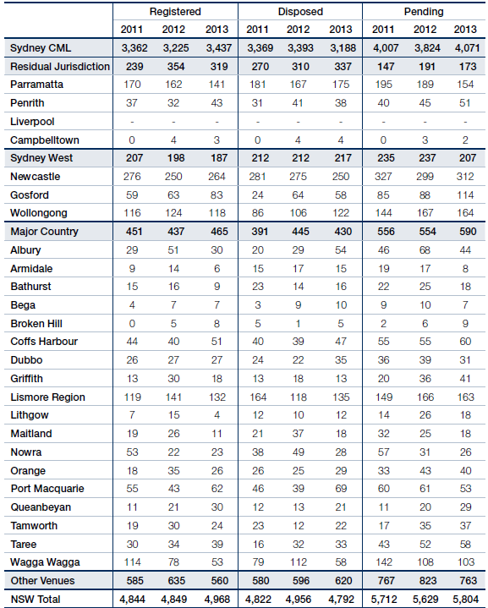
Annexure A2 - Civil Disposal Times
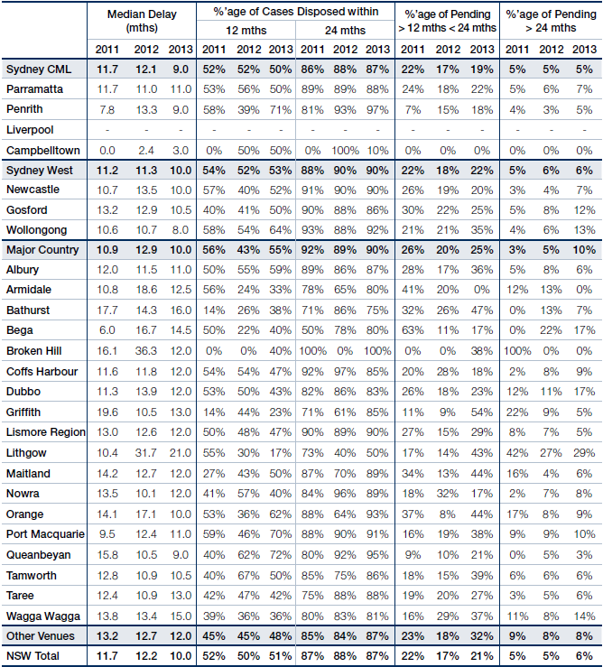

Annexures B – Criminal Caseload

Annexure B1 - Criminal Caseload
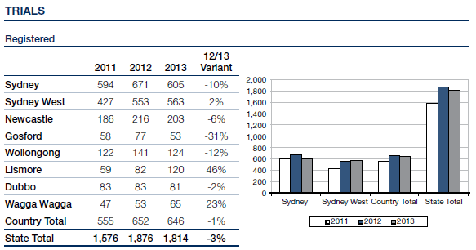
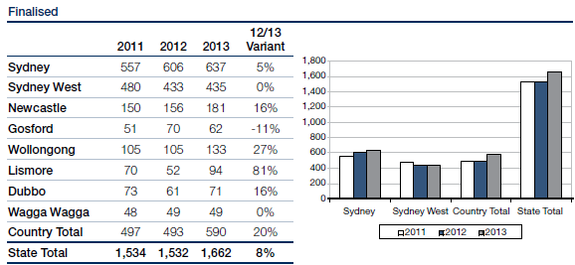
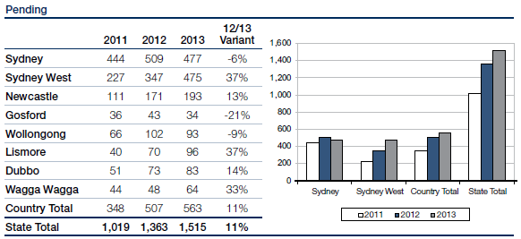
Annexure B2 - Criminal Caseload
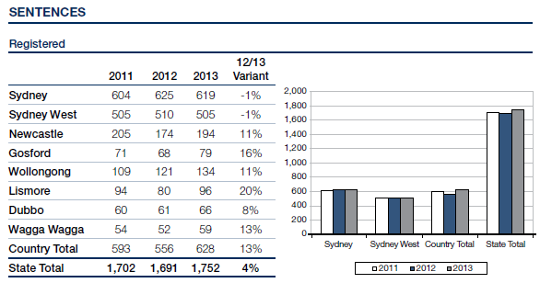
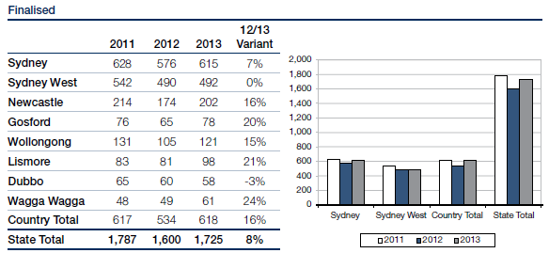
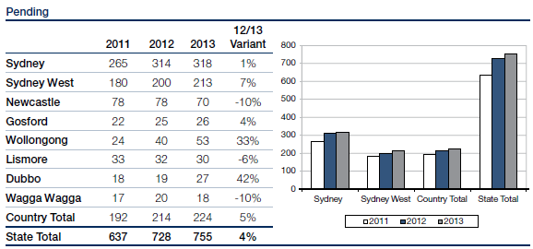
Annexure B3 - Criminal Caseload
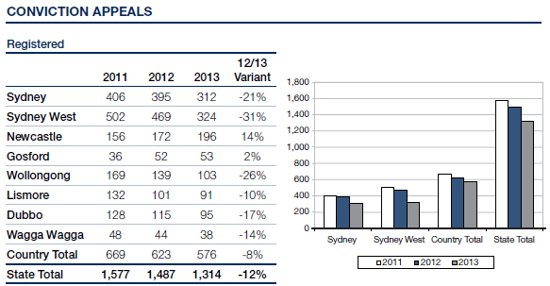
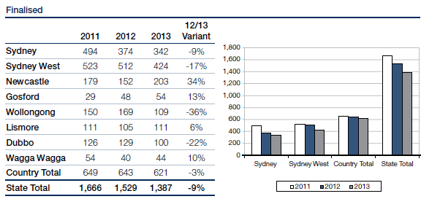
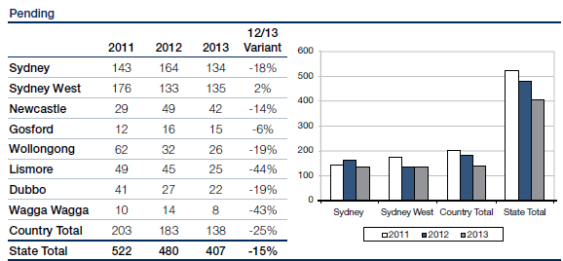
Annexure B4 - Criminal Caseload
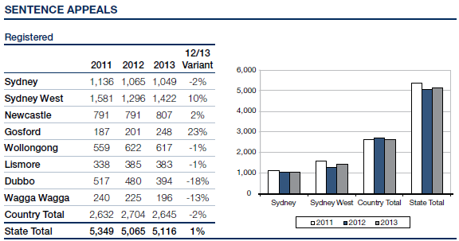
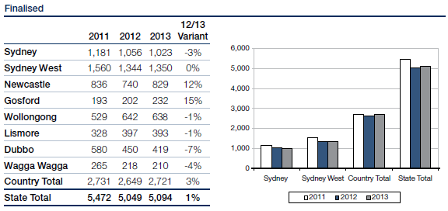
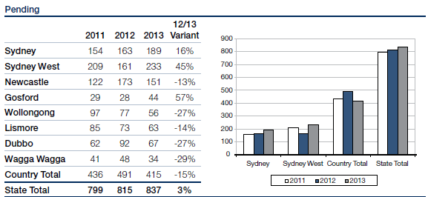

Annexure C – Compliance with Criminal Time Standards
Annexure C1 - Compliance with Criminal Time Standards
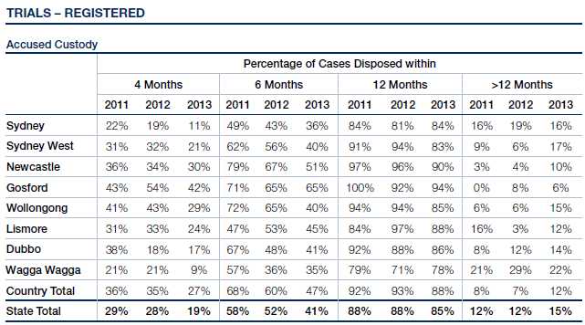
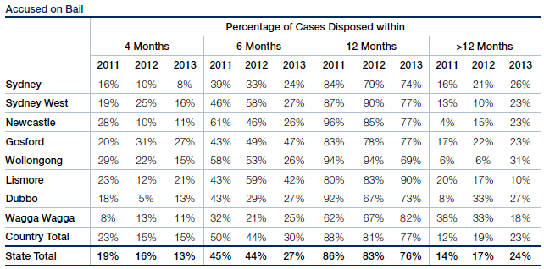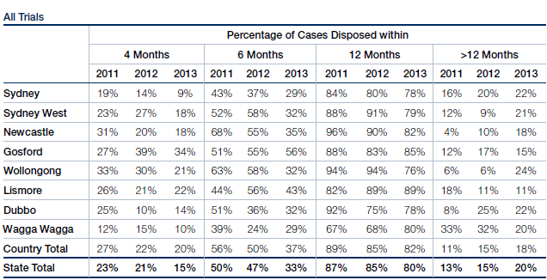
Annexure C2 - Compliance with Criminal Time Standards
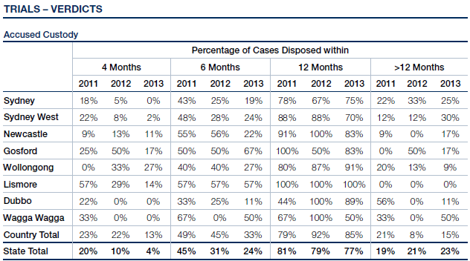
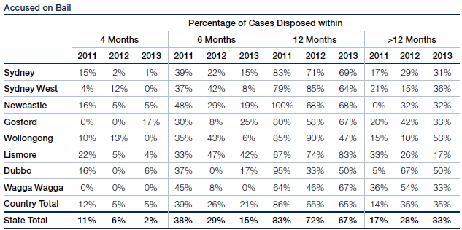
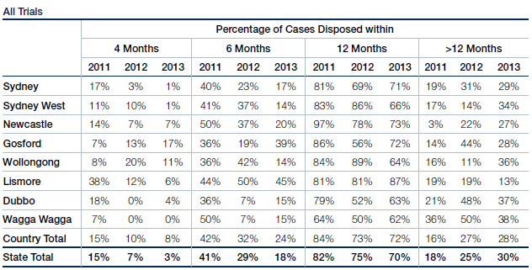
Annexure C3 - Compliance with Criminal Time Standards
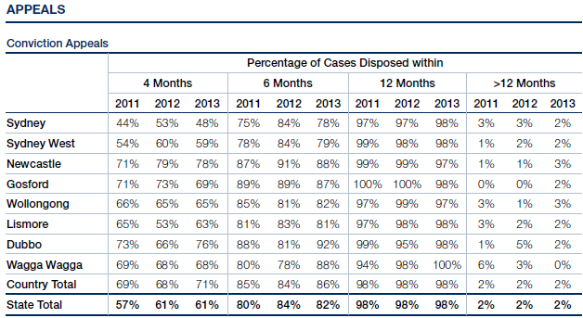
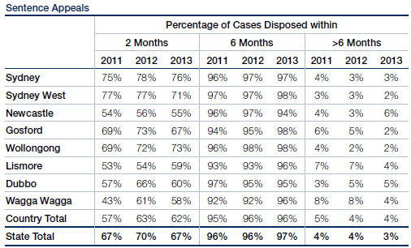
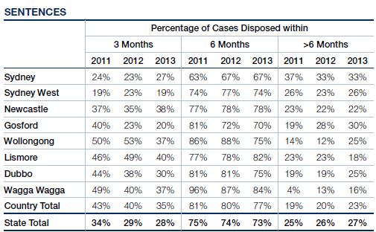

Annexure D – Court Committees
Annexure D - District Court Committees
Chief Judge’s Policy and Planning Committee
• The Honourable Justice Blanch AM (Chair)
• His Honour Judge Solomon
• His Honour Judge Neilson
• Her Honour Judge Truss
• Her Honour Judge Ashford
• Her Honour Judge Gibb
• His Honour Judge Blackmore SC
• His Honour Judge Lakatos SC
• His Honour Judge Letherbarrow SC
• Her Honour Judge Woodburne SC
• Her Honour Judge Huggett
• Mr J Howard, Judicial Registrar (Secretary)
Rule Committee
• The Honourable Justice Blanch AM (Chair)
• Her Honour Judge Truss (Deputy Chair)
• His Honour Judge Neilson
• His Honour Judge Robison
• His Honour Judge Armitage
• His Honour Judge Levy SC
• Her Honour Judge Olsson SC
• His Honour Judge Mahony SC
• Mr P Khandhar, Bar Association of NSW
• Mr A Saxton, Law Society of NSW
Civil Business Committee
• Her Honour Judge Truss (Convenor)
• His Honour Judge McLoughlin SC
• His Honour Judge Letherbarrow SC
• Her Honour Judge Olsson SC
• His Honour Judge Mahony SC
• His Honour Judge Colefax SC
• Mr J Howard, Judicial Registrar
• Ms J Dunn, Civil Case Management and Listing
• Mr L King SC, Bar Association of NSW
• Mr T Stern, Law Society of NSW
• Ms M Boyle, Motor Accidents Authority
• Ms J Hall, Insurance Council of Australia
Criminal Business Committee
• The Honourable Justice Blanch AM (Chair)
• Mr J Howard, Judicial Registrar
• Mr R Fornito, Criminal Listing Director
• Ms E Mackenzie, Office of the Director of Public Prosecutions (Commonwealth)
• Mr K Alder, Office of the Director of Public Prosecutions (NSW)
• Ms C Girotto, Office of the Director of Public Prosecutions (NSW)
• Mr M Ierace, Senior Public Defender
• Ms K Traill, Bar Association of NSW
• Mr D Giddy, Law Society of NSW
• Mr S. O’Connor, Legal Aid Commission
• Ms J Boulos, Legal Aid Commission
• Mr J Styles, Aboriginal Legal Service
• Ms J Garvey, Judicial Support (Secretary)
Professional Development (Education) Committee
• Her Honour Judge Ashford (Chair until May 2013)
• Her Honour Judge Hock (Chair from August 2013)
• His Honour Judge Neilson
• His Honour Judge Woods QC
• His Honour Judge Berman SC
• His Honour Judge Zahra SC
• His Honour Judge Lakatos SC
• His Honour Judge Elkaim SC
• His Honour Judge Levy SC
• Her Honour Judge Wells SC
• His Honour Judge Lerve
• Mr J Howard, Judicial Registrar
• Ms R Windeler, Judicial Commission of NSW
• Ms R Sheard, Judicial Commission of NSW
John Maddison Tower and Downing Centre Building Committee
• His Honour Judge Robison (Convenor until February 2013)
• Her Honour Judge Tupman (Convenor from March 2013)
• His Honour Judge Kearns SC
• His Honour Judge Driver, Federal Circuit Court
• Ms P Olsoen, Principal Registrar
• Mr J Howard, Judicial Registrar
• Ms P Green, Registrar, Administrative Decisions Tribunal
• Ms K Byrne, Sheriff’s Officer
• Mr R Gounder, Asset Management Services
• Mr R Cowburn, Brookfield Multiplex Ltd
• Mr K Breen, Judicial Support (Secretary)
Downing Centre Library Committee
• Her Honour Judge Truss (Chair)
• His Honour Judge Berman
• Ms J Culver, Deputy Chief Magistrate
• Ms V Blackmore, Library Services
• Ms S Ramsay, Library Services
Judicial Commission, Criminal Trial Courts Bench Book Committee
• His Honour Judge Lakatos SC
• His Honour Judge Arnott SC
Judicial Commission, Civil Trials Bench Book Committee
• His Honour Judge Neilson
• His Honour Judge Elkaim SC
• His Honour Judge Townsden
Judicial Commission, Equality before the Law Bench Book Committee
• His Honour Judge Norrish QC
Judicial Commission, Sexual Assault Trials Handbook Committee
• His Honour Judge Ellis (Chair)
• Her Honour Judge Huggett (from February 2013)
• His Honour Judge Norrish QC (from February 2013)
Judicial Commission, Standing Advisory Committee of Judicial Education
• His Honour Judge Lakatos SC
Judicial Commission, Ngara Yura Committee
• His Honour Judge Haesler SC

