The District Court of New South Wales

Annual Review 2011

Contents
Annual Review 2011 1
Foreword by Chief Judge 2
The District Court 4
History 4
Jurisdiction 5
Judiciary 5
Venues 11
Court Staff 11
Strategic Plan 12
Civil Business Committee Report 12
Criminal Business Committee Report 13
Professional Development (Education) Committee Report 15
Civil Jurisdiction 19
New South Wales 19
Caseload 19
Sydney 20
Caseload 20
Alternative Dispute Resolution 22
Residual Jurisdiction 23
Sydney West 23
Country 24
Criminal Jurisdiction 25
Trials 25
Caseload 25
Short Matters 31
Judicial Resources 34
Allocated Sittings 34
Actual Sittings 34
Annexures 38
Annexure A – Civil Caseload 38
Annexures B – Criminal Caseload 40
Annexure C – Compliance with Criminal Time Standards 44
Annexure D – Court Committees 47

Foreword by Chief Judge
During the course of 2011 the criminal business of the Court has been affected by the removal to New South Wales of a number of people smuggler cases. A total of 86 accused were committed to this Court for trial and by the end of the year 14 trials had been completed usually involving two or three accused. The trials normally take two to three weeks. In more than half of the cases where a verdict was returned, the accused were acquitted and there were a number of cases where juries could not reach an agreement. The particular problem is that all of the accused who have come to this Court are unsophisticated farmers or fishermen who are given small amounts of money by the organisers of the smuggling and it is sometimes difficult to determine if they knew what they were doing.
In many of the cases the accused had been in custody for between 12 months and two years before coming to this Court and all of them are kept in custody awaiting trial. It is therefore necessary to arrange trials for them as soon as possible and that has placed a burden on the Court. It has been necessary to conduct at least two trials at any given time in order to deal with the trials quickly. By the end of the year that was not enough to clear the backlog of trials and in consequence through negotiations with the Commonwealth Director of Public Prosecutions we arranged for three trials to be conducted at any given time from the beginning of 2012. The particular problem this creates is that the capacity of the Commonwealth Director of Public Prosecutions to conduct the cases is limited and there is also a shortage of interpreters sufficient to provide interpreting in any more than three trials at any time, bearing in mind the interpreters are required throughout Australia for this purpose. The delay in getting these cases to trial is a matter of real regret.
The cases have caused a problem in dealing with other cases in the Court and because of this, for the first time in a number of years, this Court did not comply with the Australian standard of having no more than 10% of trials outstanding after 12 months from committal. We had 10.8% of cases more than 12 months old from committal. It was previously 5.6%.
The civil business of the Court continued very much at the same level as in previous years. Of particular note is the decline in the registration of civil cases in country areas and I have continued to add one week of civil sittings to some country criminal sittings in order to continue to provide a service to country centres.
As a consequence of the Work Health and Safety Act 2011 which is to commence on 1 January 2012 the District Court will assume a summary jurisdiction to deal with prosecutions under that Act. The Rules have been amended and I have issued a Practice Note prescribing the arrangements to apply to the prosecutions under the Act. It is the expectation of the Court that once these prosecutions are filed they will be listed for a hearing within six months of filing. These cases form a significant part of the work of the Industrial Court and it is unclear at this stage what extra resources the Court will need to absorb that work but the Government has given an undertaking to provide the extra judges necessary to hear these cases.
The Honourable Justice R O Blanch, AM
Chief Judge

The District Court

History
By the middle of the 19th Century the court system in New South Wales consisted of:
- The Supreme Court of New South Wales which, under the Third Charter of Justice sealed in 1823, had a criminal and civil jurisdiction similar to that of the superior Courts of England;
- Courts of General and Quarter Sessions which could deal with “crimes and misdemeanours not punishable by death”
- Courts of Requests in Sydney and the County of Cumberland, with a civil jurisdiction not exceeding £30; and
- Courts of Petty Sessions, which dealt with criminal misdemeanours in a summary way and had a civil jurisdiction up to £10 (or £30 if the defendant consented).
With the discovery of gold in 1851 the Colony’s population increased and became more dispersed. Litigation grew as the Colony prospered, and crime was not declining. The Supreme Court began to fall seriously into arrears, and this was not helped by the fact that it did not visit a lot of towns. Courts of Quarter Sessions were also few in number and had no civil jurisdiction.
By the mid 1850’s there were calls for a revision of the court system, to meet the growing needs of the Colony. As a result, the District Court Act 1858 (22 Vic No 18) was assented to on 12 November 1858.
This Act established District Courts, as courts of records, to replace Courts of Requests and divided the Colony into Districts. It conferred upon the District Courts a civil jurisdiction.
It also provided for the appointment of a District Court judge as Chairman of any Court of Quarter Sessions or General Sessions, to be held within the limits of the District for which that judge was appointed.
The purpose of the Act was briefly described in The Practice of the District Courts of NSW by W.J. Foster and C.E.R. Murray (Sydney, 1870), as follows:
“District Courts were established by the Legislature for the purpose of simplifying legal proceedings in the recovery of amounts under £200, and lessening the expenses of attending such proceedings, as well as to relieving the Supreme Court of some portion of the overwhelming civil business which the rapid progress of the colony had lately engendered.
The Act providing for the institution of these Courts also extended the jurisdiction of Courts of General and Quarter Sessions of the Peace, and prepared the way for a great increase in their numbers, under the presidency of District Court judges as Chairmen, whereby criminal proceedings have been much facilitated, especially in the more distant and outlying portions of the country…”
The District Courts Act 1858 remained in force until 1973, although the jurisdiction of the Court was increased from time to time.
The District Court Act 1973 commenced on 1 July 1973. It abolished the District Courts and Courts of Quarter Sessions and established one District Court of New South Wales, with a state wide criminal and civil jurisdiction.

Jurisdiction
The District Court is the intermediate Court in the State’s judicial hierarchy. It is a trial court and has an appellate jurisdiction. In addition, the judges of the Court preside over a range of tribunals.
In its criminal jurisdiction, the Court may deal with all criminal offences except murder, treason and piracy.
In its civil jurisdiction the Court may deal with:
- all motor accident cases, irrespective of the amount claimed;
- other claims to a maximum amount of $750,000, although it may deal with matters exceeding this amount if the parties consent.
In addition, the Court may deal with equitable claims or demands for recovery of money or damages for amounts not exceeding $750,000.
The Court is also empowered to deal with applications under the De Facto Relationships Act 1984, the Family Provisions Act 1982 and the Testator Family Maintenance and Guardianship of Infants Act 1916 that involve amounts, or property to the value of, not more than $250,000.

Judiciary
The following were the judges of the Court as at 31 December 2011.
Chief Judge
The Honourable Justice Reginald Oliver Blanch, AM
Judges
His Honour Judge Ronald Herbert Solomon
Her Honour Judge Margaret Ann O’Toole
His Honour Judge Anthony Frederick Garling
Her Honour Judge Dianne Joy Truss
His Honour Judge Garry William Neilson
His Honour Judge Christopher John Armitage
Her Honour Judge Margaret Sidis
His Honour Judge Christopher John George Robison
Her Honour Judge Robyn Christine Tupman
His Honour Judge James Patrick Curtis*
Her Honour Judge Helen Gay Murrell, SC
Her Honour Judge Deborah June Payne
His Honour Judge Martin Langford Sides, QC
His Honour Judge Robert Keleman, SC
Her Honour Judge Anne Mary Quirk
Her Honour Judge Linda Margaret Ashford
His Honour Judge Gregory David Woods, QC
His Honour Judge Norman Edward Delaney
His Honour Judge Jonathan Steuart Williams
His Honour Judge Kevin Patrick O’Connor, AM
Her Honour Judge Jennifer Anne English
Her Honour Judge Susan Jennifer Gibb
His Honour Judge Kevin Peter Coorey
His Honour Judge Richard Anthony Rolfe
His Honour Judge James Walter Black, QC
His Honour Judge Robert Arthur Sorby
His Honour Judge Stephen Ronald Norrish, QC
Her Honour Judge Audrey Suzanne Balla
His Honour Judge Michael John Finnane, RFD, QC
Her Honour Judge Penelope Jane Hock
Her Honour Judge Judith Clare Gibson
His Honour Judge John Cecil Nicholson, SC
His Honour Judge Stephen Lewis Walmsley, SC
His Honour Judge Anthony Martin Blackmore, SC
His Honour Judge Colin Emmett O’Connor, QC
His Honour Judge Peter Graeme Berman, SC
His Honour Judge Raymond Patrick McLoughlin, SC
His Honour Judge Colin David Charteris, SC
His Honour Judge Roy David Ellis
His Honour Judge Mark Curtis Marien, SC
His Honour Judge Brian John Knox, SC
His Honour Judge John Roger Dive
Her Honour Judge Deborah Anne Sweeney
His Honour Judge James Leonard Alexandre Bennett, SC
His Honour Judge Peter Lind Johnstone
His Honour Judge William Patrick Kearns, SC*
His Honour Judge Paul Vincent Conlon, SC
His Honour Judge Peter Raymond Zahra, SC
His Honour Judge Richard Dominic Cogswell, SC
Her Honour Judge Leonie Flannery, SC
His Honour Judge Robert Stephen Toner, SC
His Honour Judge Gregory Micheal Keating
His Honour Judge Paul Ivan Lakatos, SC
His Honour Judge Leonard Levy, SC
His Honour Judge Michael Elkaim, SC
His Honour Judge Michael King, SC
His Honour Judge David Clement Frearson, SC
His Honour Judge Andrew Michael Colefax, SC
Her Honour Judge Helen Syme
His Honour Michael Ivan Bozic, SC
His Honour John North
His Honour Judge Graham Leslie Henson
Her Honour Judge Laura Kathleen Wells, SC
His Honour Judge Ross Victor Letherbarrow, SC
His Honour Judge Andrew Carl Haesler, SC
Her Honour Judge Donna Mary Lisa Woodburne, SC
Her Honour Judge Elizabeth Margaret Olsson, SC
His Honour Judge Clive Vaughan Jeffreys
* denotes Members of the Dust Diseases Tribunal
Judicial Appointments
The following Judges were appointed during 2011 on the dates indicated in the brackets after their name:
Her Honour Judge Donna Mary Lisa Woodburne, SC (7 February 2011)
Her Honour Judge Elizabeth Margaret Olsson, SC (7 March 2011)
His Honour Judge Clive Vaughan Jeffreys (15 March 2011)
Judicial Death in Office
Sadly, on 30 November 2011, His Honour Judge Ralph Coolahan died in office.
Judicial Retirements
The following Judges retired during 2011 on the dates indicated in brackets after their name:
His Honour Judge Gregory Scott Hosking, SC (1 May 2011)
His Honour Judge David James Freeman (27 October 2011)
His Honour Judge John Lawrence O’Meally, AM, RFD (18 November 2011)
District Court Judge Acting as a Judge of the Supreme Court of New South Wales
His Honour Judge Stephen Lewis Walmsley, SC acted as a Judge of the Supreme Court of NSW from 19 September to 16 December 2011.
Appointments Held During 2011
His Honour Judge John Lawrence O’Meally, AM, RFD, held the appointment of President of the Dust Diseases Tribunal of NSW.
His Honour Judge Kevin Patrick O’Connor, AM, held the appointment of President of the Administrative Decisions Tribunal of NSW.
His Honour Judge Gregory Michael Keating held the position of President of the Workers Compensation Commission of NSW.
His Honour Judge John Roger Dive held the position of Senior Judge of the Drug Court of NSW.
His Honour Judge Mark Curtis Marien, SC, held the position of President of the Children’s Court of NSW.
His Honour Judge Graeme Leslie Henson held the position of Chief Magistrate of the Local Court of NSW.
Medical Tribunal of NSW
The Honourable Justice Reginald Oliver Blanch, AM, Chief Judge, held the appointment of Chairperson of the Medical Tribunal of New South Wales.
The following Judges held appointments as Deputy Chairpersons of the Tribunal as at 31 December 2011:
His Honour Judge Ronald Herbert Solomon
His Honour Judge Anthony Frederick Garling
Her Honour Judge Margaret Sidis
Her Honour Judge Helen Gay Murrell, SC
His Honour Judge Robert Keleman, SC
Her Honour Judge Audrey Suzanne Balla
His Honour Judge Stephen Lewis Walmsley, SC
His Honour Judge Peter Lind Johnstone
His Honour Judge Michael Elkaim, SC
His Honour Judge Andrew Michael Colefax, SC
Acting Judges During 2011
Mr Warwick John Andrew, CBE
Mr Ian Barnett
Mr Terence Joseph Christie, QC
Mr Garry Spencer Forno, QC
Mr David James Freeman
Mr Geoffrey John Graham
Mr Gregory Scott Hosking, SC
The Honourable Barrie Clive Hungerford, QC
Mr Luigi Maria Baliano Lamprati
Mr Rodney Neville Madgwick, QC
Mr Neil McLauchlan, QC
Mr John Kennedy McLaughlin
Mr Joseph Anthony Moore
Ms Helen Jane Morgan
Mr John Roscoe Nield
Mr Colin Phegan
Mr Anthony Francis Puckeridge, QC
Mr Kenneth Victor Taylor, AM, RFD
Sir Robert Kynnersley Woods, CBE
Judicial Registrar, District Court of NSW
Mr Craig Kieron Smith is the Judicial Registrar and exercises functions pursuant to Section 18FA of the District Court Act 1973.

Venues
In 2011 the Court sat permanently in Sydney at the Downing Centre, 143-147 Liverpool Street, Sydney (in crime), where it occupies 17 courtrooms, and at the John Maddison Tower, 86 Goulburn Street, Sydney, where it occupies 22 courtrooms (mostly in civil).
In Sydney West, Judges sat full-time in the Court Houses at Parramatta (8 courtrooms), Penrith (1 courtroom) and Campbelltown (1 courtroom).
In addition, continuous sittings were conducted at Newcastle, Gosford, Wollongong and Lismore.
Other places where the Court sat were: Albury, Armidale, Bathurst, Bega, Bourke, Broken Hill, Coffs Harbour, Coonamble, Dubbo, East Maitland, Goulburn, Grafton, Griffith, Lismore, Moree, Nowra, Orange, Parkes, Port Macquarie, Queanbeyan, Tamworth, Taree, Wagga Wagga.

Court Staff
Principal Registrar, District Court of NSW
Ms Pam Olsoen is the Principal Registrar and exercises functions pursuant to Section 18H(3) of the District Court Act 1973.
Criminal Listings and Judicial Arrangements
Schedules cases in accordance with Court policy; prepares lists, allocates courtrooms, and co-ordinates the assignment of judges to venues throughout the State.
Mr Robert Fornito is the District Court Criminal Listing Director. Pursuant to Section 123 of the Criminal Procedure Act 1986, the Criminal Listing Director is responsible to the Chief Judge in making arrangements for the listing of criminal proceedings.
Civil Case Management and Listings
Implements civil case management and listing practices for the timely disposition of cases, schedules cases, prepares lists and allocates courtrooms.
Ms Jane Dunn is the Civil List and Case Manager and works in conjunction with the Civil List Judge and the Judicial Registrar in making arrangements for the listing of civil proceedings.

Strategic Plan

Civil Business Committee Report
In August 2007 the Court introduced its third Strategic Plan. The first such plan was adopted in 1995 and it provided a template for significant changes in the way the Court operated as did the second Strategic Plan in 2000.
The Strategic Plan articulates the values of the Court and sets out the goals to be achieved over 2007-2012 in carrying out this role in line with these values.
The Court is committed to discharging its responsibilities to ensure:
- That the Court is accessible to the public and those who need to use its services;
- The effective determination of cases in an orderly, cost effective and expeditious manner. The equal protection of the law to all;
- The independence of the Judges of the Court, and the Court as a branch of our system of government;
- Accountability for the performance of the Court and its use of public funds;
- The highest standard of excellence in the functioning of the Court.
As in past plans, the Court will continue to maintain a Policy and Planning Committee to provide advice to the Chief Judge on matters relating to the business of the Court. There are also three major business committees that are accountable to the Policy and Planning Committee. Those Committees are:
- The Civil Business Committee;
- The Criminal Business Committee;
- The Professional Development (Education) Committee.
Terms of Reference
To monitor, report and advise on any matter relating to the Court’s objective of providing a system for the earliest, most effective and efficient resolution of civil disputes.
The Committee
The Committee consists of judges of the Court, the Judicial Registrar, the Civil List and Case Manager and representatives of the Law Society of NSW, the Bar Association of NSW, the Insurance Council of Australia and the Motor Accidents Authority.
Activities
The Committee met on four occasions during the year and matters considered included:
- The Court’s Operational Performance Report with up-to-date statistical information presented at each meeting.
- Proposed amendments to the rules and practice notes.
- Particular concerns of the various representatives and matters which the Court wished to bring to their attention.
- The Committee considered a wide range of issues including:
- The increased adjournment of long matters and the newly instigated practice of matters having a directions hearing before the List Judge prior to the allocated hearing date to ensure readiness;
- Pre-action protocols under Part 2A of the Civil Procedure Act;
- The amendment of Practice Note 8 – Early Return of Subpoena and the new subpoena forms;
- The outsourced civil daily transcript arrangement;
- The provision of robing rooms for the profession;
- The monitoring of the timeliness of country venue judgments;
- Adherence to timetable orders in the Professional Negligence List;
- The operation of the offer of compromise rules;
- The service of surveillance evidence;
- The operation of the searchable lists facility;
- The Court Information Act;
- The review of the Civil Procedure Act;
- The review of the Costs Assessment regime;
- The components of the caseload by cause of action.

Criminal Business Committee Report
Terms of Reference
To monitor, report and advise on any matter relating to the Court’s goal of providing a system for the earliest, most effective and efficient resolution to criminal matters.
Consultation with court users is carried out through the Criminal Business Committee.
The Committee consists of representatives from the Judiciary, Criminal Listing Director, Law Society of NSW, Bar Association of NSW, Legal Aid, Commonwealth and State DPP’s, Aboriginal Legal Service, Public Defenders and Crown Prosecutors.
Activities
The Committee met on four occasions during the year.
- The Court continued to target older pending cases throughout the state. The ROGS (Report on Government Services) for the year continues to show NSW leading the nation in the disposal of criminal cases.
- The Court continues to manage and list criminal trials in country circuits by way of a telephone call over.
- The average length of trials continues to increase. In Sydney the average duration is 11.93 days (compared to 10.66 in 2010). State wide the average duration is 8.79 days (compared with 8.64 in 2010)
- As a consequence of the Work Health and Safety Act 2011, that is to commence on 1 January 2012, the District Court will have a summary jurisdiction to deal with summary prosecutions under that Act. The District Court Rules have been amended and now Part 53 Division 3 provides rules in relation to summary proceedings. On 6 December 2011 the Chief Judge issued Criminal Practice Note 10 prescribing the arrangements to apply from the commencement of the Work Health and Safety Act 2011.
- Construction commenced on a new multi accused trial court being built on level 3 of the Downing Centre. This courtroom will primarily be used by the District Court but will also be made available to both the Supreme and Local Courts when required for multi accused hearings. The courtroom is designed to accommodate 14 accused and up to 36 at the bar table.
- The Court commenced hearing people smuggling trials in June. A total of 86 accused have been committed to the District Court.
As at December the Court has dealt with 14 trials (7 in Sydney and 7 at Campbelltown). Most trials were two to three weeks in length involving up to three co-accused in each trial.
Of the 30 accused that were listed for trial this year: - 8 were convicted; 11 acquitted; 6 hung jury; 1 jury discharged; 2 withdrawn; 2 trial dates vacated by the defence.
In addition to this, 7 individual matters were committed for trial but discontinued on the basis that there was a possibility of the accused being under the age of 18 years.
18 matters have been dealt with by way of sentence committals.
- The Court continues to maintain a collaborative approach in its partnership with the Court’s stakeholders in its criminal jurisdiction.

Professional Development (Education) Committee Report
Terms of Reference
The District Court, in partnership with the Judicial Commission of New South Wales, provides a relevant and practical continuing judicial education program designed to:
- Promote high standards of judicial performance;
- Assist in the development of appropriate judicial skills and values;
- Keep judges up-to-date with current legal developments and emerging trends;
- Result in a better-informed and more professional judiciary.
Sessions range from orientation programs for new judges to specialist seminars on practical matters, social awareness issues and legislative changes. The Professional Standards (Education) Committee, composed of judges and the Judicial Commission’s Education Director, develops each education program based on the identified needs of judges. Judges are involved in the development and delivery of the education program to ensure its relevance to the judicial role. A member of the Committee is also a member of the Judicial Commission’s Standing Advisory Committee on Judicial Education.
Activities
During 2011, judges:
- Received more focused and tailored training as a result of continuing efforts to meet their educational needs;
- Attended 197 days of face-to-face judicial education organised by the Judicial Commission, an average of 2.7 days of judicial education per judge.
Annual Conference
The Annual Conference held in Wyong on 27–28 April 2011 was attended by 56 judges, 4 acting judges and the judicial registrar. The conference focused on providing challenging and interesting educational sessions, while also providing a valuable opportunity for discussion and debate. The program consisted primarily of sessions relevant to the day-to-day work of a judge. Topics for the conference were determined by the Education Committee based on previous evaluation reports, suggestions by colleagues and suggestions from the Judicial Commission.The sessions dealt with a variety of topics including substantive law and practice, psychological/physiological topics, sentencing issues, child witnesses, Aboriginal youth diversion programs and recidivism. Topics included:
- Court of Appeal Review: Administrative Law by The Honourable Justice John Basten, Supreme Court of NSW;
- Psychiatric Diseases, Brain Function and Diminished Responsibility by Professor Max Bennett, AO, Professor of Neuroscience, University Chair, Director Brain and Mind Research Institute, University of Sydney;
- Current Issues in Sentencing by Her Honour Judge Helen Murrell, SC and His Honour Judge Peter Berman, SC;
- Simplifying Sentencing Laws by The Honourable Justice Reg Blanch, AM, Chief Judge;
- Are We There Yet? — Using a Question Trail to Assist the Jury to Reach a Verdict by Her Honour Judge Penelope Hock;
- Aboriginal Youth Diversion Programs by Mr Shane Phillips, CEO, Tribal Warrior Association and Superintendent Luke Freudenstein, Commander, Redfern Local Area Command;
- Court of Criminal Appeal Review by The Honourable Justice Derek Price, AM, Supreme Court of NSW;
- Insolvent Parties by Her Honour Judge Dianne Truss;
- Care Proceedings and Appeals to the District Court by His Honour Judge Mark Marien, SC;
- Service of Surveillance Evidence in Personal Injury Cases by His Honour Judge Ross Letherbarrow, SC;
- Case Management Post Aon by Her Honour Judge Margaret Sidis;
- Child Witnesses by His Honour Judge Paul Lakatos, SC and Dr Judy Cashmore, AO, University of Sydney;
- Reducing Recidivism Rates: What Works? by Professor James Ogloff, Monash University;
- Q & A: Everything you wanted to know but did not like to ask with a panel of judges consisting of The Honourable Justice Reg Blanch, AM, His Honour Judge Ron Solomon, Her Honour Judge Dianne Truss and His Honour Judge Martin Blackmore, SC.
Occasional Seminars
The Education Committee has continued to work with the Judicial Commission to organise a series of twilight education sessions for District Court judges in the John Maddison Tower. These seminars provide useful, informative and timely information on a range of topical matters relevant to the work of the District Court. They aim to enhance judicial performance and assist in the further development of judicial skills and knowledge.
Seminars were held on the following topics:
- “Classification and Placement of Prisoners”, presented by Mr Terry Halloran, Executive Director, Offender Case Management and Classification, Department of Corrective Services, 8 March 2011;
- “Community Justice Project”, presented by Mr Matt Frize, Team Leader and Ms Natalie Namone, Director, Community Justice Program, Office of the Senior Practitioner, Ageing Disability & Home Care, NSW Department of Family and Community Services, 17 May 2011;
- “Blood Alcohol Analysis”, presented by Associate Professor Anthony Moynham, Adjunct Associate Professor, Sydney Forensic Medicine and Science Network, Sydney Medical School, University of Sydney and Inspector John Lipman and Senior Constable Dave Gardner, Breath Analysis and Research Unit, NSW Police, 6 October 2011;
- “Defamation”, presented by The Honourable Justice Carolyn Simpson, Supreme Court of NSW, 30 November 2011. Judges also attended a number of cross jurisdictional events, including:
- “The Power of Sorry”, presented by Mr Chris Wheeler, NSW Deputy Ombudsman, Twilight Seminar, 16 February 2011;
- “Criminal Case Management”, panel presentation by The Honourable Justice Peter McClellan, AM, Chief Judge at Common Law, The Honourable Justice Cliff Hoeben, AM, RFD, The Honourable Justice Megan Latham, The Honourable Justice Robert A Hulme and The Honourable Justice Reg Blanch, AM, Chief Judge, Twilight Seminar, 16 June 2011;
- “Field Trip to the Forensic Hospital, Malabar”, hosted by Ms Julie Babineau, Chief Executive, Justice Health, Professor Karin Lines, Executive Director, Adolescent Health, Drug & Alcohol & Mental Health Services, Justice Health, Dr. Adrian Keller,Clinical Director, Forensic Hospital, Dr. John Basson, Statewide Clinical Director, Forensic Mental Health, Justice Health, Mr Anderson Miller, General Manager, Forensic Hospital and Ms Kelly Yates, Senior Nurse, Forensic Hospital, 8 June 2011.
Judgment Writing Workshop
Continuing our focus on skills development, three judges attended a two-day cross jurisdictional Judgment Writing Workshop in August 2011 led by Professor James Raymond. Through analysing and discussing their own writing, participants worked on developing their judgment writing skills and the ability to write clear, concise, well-structured judgments. Participants found the workshop very worthwhile: interesting, informative, useful, practical and thought provoking. They noted that there would be personal and/or practical benefits to their work resulting from this workshop including focusing them on what they say in their judgments, and making them more efficient and clearer in their writing.
Judicial Orientation
Two new judges of the Court attended the National Judicial Orientation Program at the Crowne Plaza, Coogee Beach in April 2011 and three new judges attended the program held at Aitken Hill in November 2011.
This five-day orientation program assists newly appointed judicial officers with their transition to judicial office by facilitating the development and refinement of the skills and knowledge necessary for effective judging. It is conducted by the National Judicial College of Australia with the assistance of the Judicial Commission of New South Wales and the Australian Institute of Judicial Administration.
NgaraYura Program
Judges were enthusiastic participants in the Judicial Commission’s NgaraYura Program which aims to increase awareness among judicial officers about contemporary Aboriginal society, customs and traditions, and their effect on Aboriginal people in the justice system. Five judges attended the visit organised by the Judicial Commission to the Aboriginal communities at Balunda and Lismore, and 7 judges attended the Exchanging Ideas Conference. This last conference was a two-day residential program that provided an important opportunity for social and professional interaction between judicial officers and Aboriginal community members, and some insights into Aboriginal culture. The conference provided the context for Aboriginal incarceration, discussed problems in custody for Aboriginal prisoners, and canvassed strategies for effective post custody supervision, rehabilitation, mentoring or diversion.

Civil Jurisdiction

New South Wales
Full statistical data on the Court’s civil operations is set out in Annexures A (1) and (2).
In 2011:
- Registrations fell by 6%
- Finalisations fell by 5%
- Pending cases rose 4%
- Median time for disposals rose from 11.2 to 11.7 month

Caseload
Explanatory Background
Comparing registrations and finalisations is not an exact science. For example, a matter in the course of its life may, for various reasons, be registered more than once. Multiple parties and cross actions can further affect the equation. Cases determined at arbitration can be re-heard. A matter previously dismissed can be restored or a retrial may be ordered. Registries also conduct stock-takes of cases on hand during the course of the year, with pending statistics being adjusted as necessary.
It is therefore important to view comparisons of registrations and finalisations against pending caseload with some caution, as it is often difficult to reconcile the figures.
However, they are helpful in providing general trends concerning the incoming and outgoing work of the Court.
Registrations
There were 4,844 matters registered in 2011, compared to 5,158 in 2010.
Disposals
There were 4,822 disposals in 2011, compared to 5,088 in 2010.
Pending
At the end of 2011 the pending caseload was 5,712, compared to 5,511 in 2010.
Comparison with Previous Years
Figure 1 below tracks the Court’s caseload for the past 5 years.
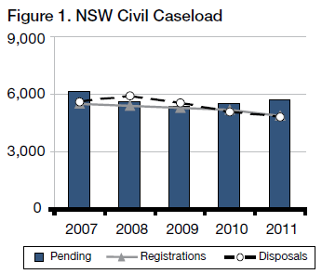
Disposal Times
In 2011, 52% of all actions completed were finalised within 12 months, with 87% being completed within 24 months. This compares to 55% and 87%, respectively, in 2010.
Of the pending caseload at the end of 2011, 22% exceeded 12 months and not more than 24 months and 5% more than 24 months.

Sydney
In 2011:
- Registrations fell by 7%
- Finalisations fell by 1%
- Pending cases rose by 5%
- Median disposal time rose from 10.9 to 11.7 months

Caseload
In 2011, Sydney civil case managed matters represented 69% of the State’s registrations and 70% of the matters on hand.
Figure 2 below shows the ratio of new civil actions commencing in Sydney, as compared to the whole State for the past 5 years
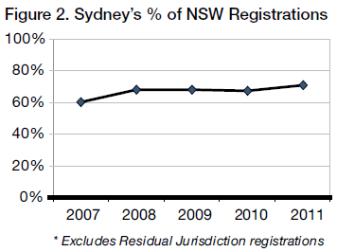
Registrations, Disposals and Pending
Excluding the Residual Jurisdiction, there were 3,362 new actions commenced and 3,369 finalised in Sydney in 2011. At the end of the year there were 4,007 actions pending. Figure 3 tracks Sydney’s caseload for the last five years.
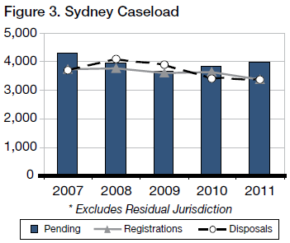
Disposal Times
The Court’s ideal time standard for civil cases is to achieve a 90% disposition rate within 12 months of commencement, and 100% within 2 years.
In 2011, 52% of all actions completed were finalised within 12 months, with 86% being completed within 24 months. This compares to 57% and 87%, respectively in 2010.
Of the pending caseload at the end of 2011, 22% exceeded 12 months and not more than 24 months and 5% exceeded 24 months.
How Cases are Finalised
Table 1 below shows the breakup of how case managed list matters were completed in 2011. The categories of “Dismissed” and “Discontinued” include matters that settled without judgment being entered and/or terms of settlement being filed.
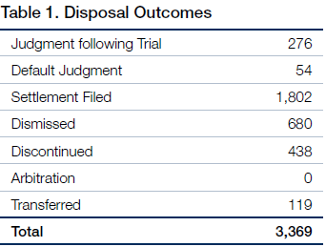
Table 2 below compares two of the seven categories of disposal outcomes as against the total number of disposal outcomes. These two categories are selected because i. ‘Disposed of by judgment following trial’ represents the number of hearings to judgment before judges, and ii. “Disposed of by settlements filed” includes matters that settled as a result of ADR.
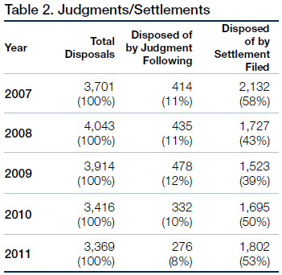

Alternative Dispute Resolution
Mediation
Pursuant to Civil Practice Note 1, cases before the Sydney District Court are referred to mediation where appropriate. The referral may be either to private mediation or to court provided mediation. The Assistant Registrars in Sydney undertake the court provided mediation. In 2011 the Sydney District Court referred 786 matters to mediation (670 were referred to private mediation and 116 to court provided mediation). Settlement conferences were ordered in 933 matters.
Approximately 52% of matters referred to mediation by Assistant Registrars were settled. There are no available statistics in relation to settlement of matters referred to private mediators.

Residual Jurisdiction
The Compensation Court Repeal Act 2002 abolished the Compensation Court, and transferred the Compensation Court’s jurisdiction to the Workers Compensation Commission or the District Court. The Act commenced on 1 January 2004.
The disputes that were transferred to the District Court are commonly referred as its “residual jurisdiction” and involve the following:
- The Police Act 1990 concerning police officers “hurt on duty” and the Police Regulation (Superannuation) Act 1906 concerning the payment of superannuation benefits to police officers;
- Payment under the Police Regulations (Superannuation) Act 1906, paid to STC (the SAS Trustee Corporation continued under the Superannuation Administration Act 1996) and special risk benefits payable by the Commissioner of `Police;
- The Workers’ Compensation Act 1987 concerning workers in or about a coal mine;
- The Workers Compensation (Dust Diseases) Act 1942;
- The Sporting Injuries Insurance Scheme;
- The Workers’ Compensation (Bush Fire, Emergency & Rescue Services) Act 1987.
During 2011, 239 actions were commenced and 270 were finalised. There were a total of 147 matters on hand in the residual jurisdiction at the end of 2011.

Sydney West
Sydney West had 4% of the total number of new actions started in the State in 2011 (excluding the Court’s residual jurisdiction). Figure 4 below tracks the variation in the proportional rate of registrations in Sydney West.
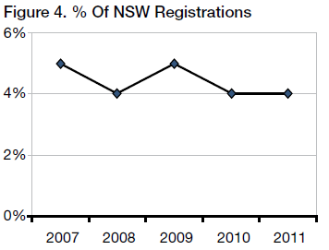
In Sydney West there were 207 matters registered and 212 dispositions throughout the year. At the end of 2011 the total pending caseload was 235, as compared to 221 the previous year.
Figure 5 shows comparative registrations, finalisations and pending caseloads for the past 5 years.
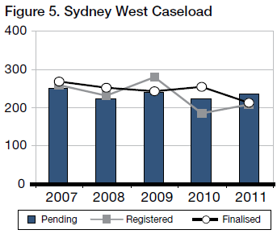
Pending matters in Sydney West rose by 13% and the median finalisation time was 11.2 months.
24% of pending cases exceeded 12 months and not more than 24 months and 5% exceeded 24 months.

Country
Venues outside of Sydney and Sydney West had 21% of the total number of new actions started in 2011 (excluding the Court’s Residual Jurisdiction).
Figure 6 tracks the proportional rate of registrations for Country venues.
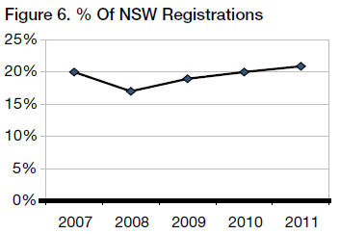
Outside of Sydney and Sydney West, there were 971 dispositions throughout the year. At the end of the year the total pending caseload was 1,323 as compared to 1,238 the previous year.
Figure 7 shows comparative registrations, finalisations and pending caseloads for the past 5 years.
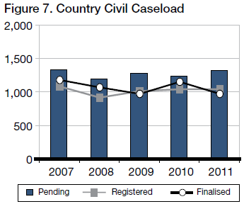
Pending matters in the country fell by 3% and the median finalisation time was 12.4 months.
23% of pending cases exceeded 12 months and not more than 24 months and 9% exceeded 24 months.

Criminal Jurisdiction

Trials
In 2011:
- Trial registrations fell by 4%
- Finalisations fell by 5%
- Number of pending trials rose by 3%
- Median disposals times rose from 34 to 38 weeks
- Average length of trials rose by 2%, from 8.64 to 8.79 days

Caseload
There were 1,576 criminal trials registered during 2011 in New South Wales, as compared to 1,650 in 2010 and 1,671 in 2009.
There were 1,534 trials finalised in 2011, as compared to 1,618 in 2010 and 1,681 in 2009.
There were 1,019 trials on hand at the end of 2011, as compared to 977 trials at the end of 2010.
Figure 8 tracks the statewide trends in the criminal trial caseload for the past 5 years.
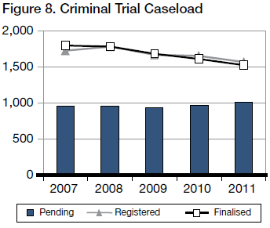
Figure 9 shows variation in trial and sentence registrations for the last 5 years.
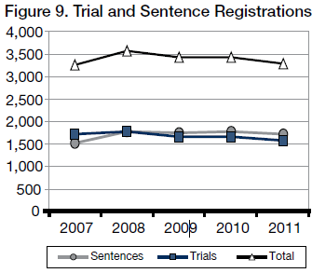
Sentence hearings are far less demanding on victims. They also absorb far less resources than trials. It is therefore important to ensure that in appropriate cases guilty pleas are entered at the earliest possible time, preferably at the committal stage.
Time Standards
The Court’s ideal time standards for the commencement of criminal trials are:
- 90% of cases within 4 months of committal, or such other event which causes the proceedings; and
- 100% of cases within 1 year.
In 2011, 29% of trial disposals where the accused was in custody were finalised within 4 months, and 12% exceeded 12 months.
Where the accused was on bail, 19% of disposals occurred within 4 months, with 14% exceeding 12 months.
Figure 10 sets out comparative compliance rates with time standards for all trials finalised.
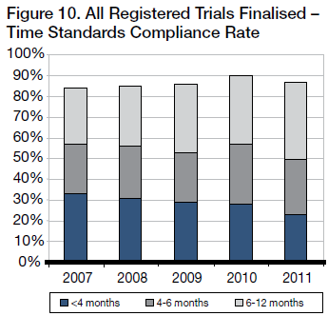
Figure 11 shows the age of all trials which were pending at the end of the year indicated.
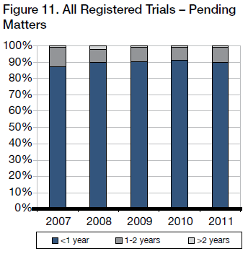
Figure 12 tracks the median disposal times, from committal to commencement of the trial, for matters finalised during the year indicated.
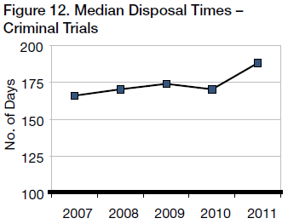
Trial Durations
The state-wide average length of criminal trials finalised in 2011 was 8.79 days, as compared to 8.64 days in 2010. In Sydney the average duration was 11.62 days in 2011, compared to 10.66 days in 2010.
Figure 13 illustrates the fluctuating rise in the average trial duration time.
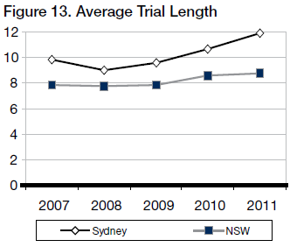
Trial Listing Outcomes
About 1,855 trials were listed for hearing in 2011.
Figure 14 shows the breakup of those matters not dealt with.
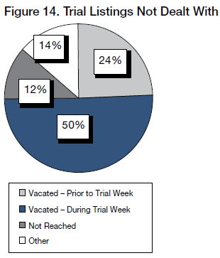
Figure 15 shows the break-up of those matters that were dealt with after being listed.
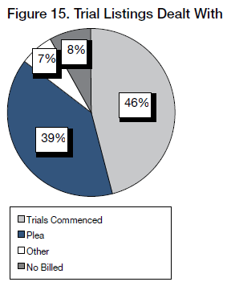
Figure 16 shows the outcome of those that commenced.
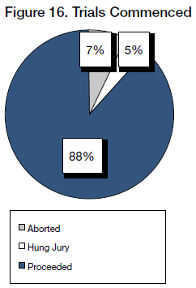
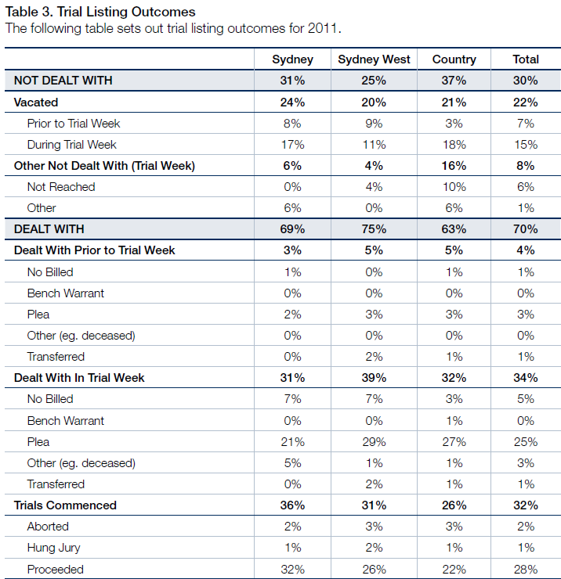
Of trials dealt with in 2011 (i.e. 70% of total listings):
- 50% pleaded Guilty
- 40% proceeded to verdict
- 8% were “no billed”
- 2% were transferred
- 3% were aborted
- 2% ended with a “hung Jury”
- 4% were otherwise disposed
- 0% had bench warrants issued

Short Matters
Sentences
There were 1,702 committals for sentence received in 2011 and 1,787 matters were finalised. At the end of the year there were 637 sentence matters pending, compared to 722 at the end of 2010.
Figure 17 tracks the sentence caseload for the last 5 years.
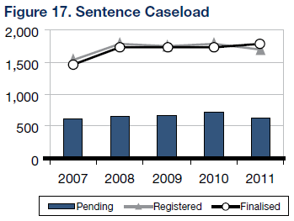
The ideal time standard from committal for sentence to hearing is 3 months in 90% of cases, with 100% being completed within 6 months.
Figure 18 illustrates compliance rates with time standards.
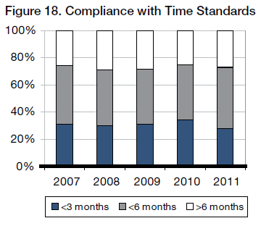
Conviction Appeals
There were 1,577 conviction appeals lodged in 2011 and 1,666 finalisations. At the end of the year there were 522 conviction appeals pending, compared to 611 at the end of 2010.
Figure 19 tracks the conviction appeal caseload for the last 5 years.
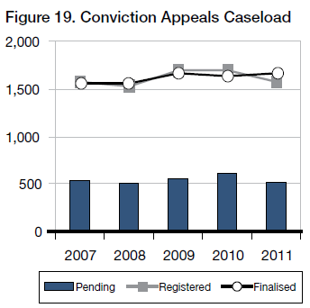
The ideal time standard from lodgement to finalisation is 4 months in 90% of cases, with 100% being completed within 12 months.
Figure 20 illustrates compliance rates with time standards.
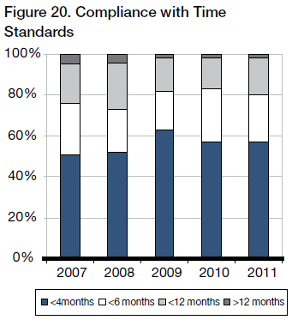
Sentence Appeals
There were 5,349 sentence appeals lodged in 2011 and 5,472 finalised. At the end of the year there were 799 sentence appeals pending, compared to 922 at the end of 2010.
Figure 21 tracks the sentence appeals caseload for the last 5 years.
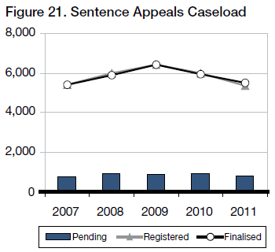
The ideal time standard from lodgement to finalisation for sentence appeals is 2 months in 90% of cases, with 100% being completed within 6 months.
Figure 22 illustrates compliance rates with time standards.
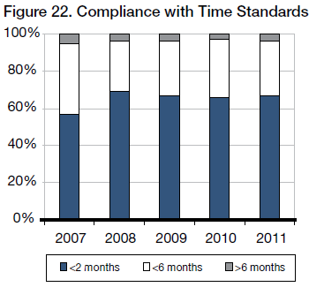

Judicial Resources

Allocated Sittings
Table 4 sets out the number of judicial sitting weeks allocated in 2011 as published in the Court’s Calendar of Sittings.
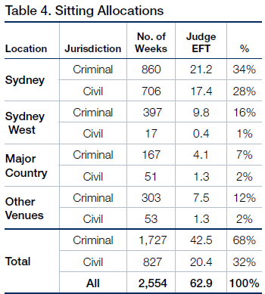
Judge EFT is calculated at 40.6 sitting weeks p.a. – i.e. 52 weeks less judicial vacations, public holidays and Annual Judges’ Conference

Actual Sittings
Table 5 sets out the number of days actually sat by the court in 2011 converted into weeks (by dividing the number of days by 5)
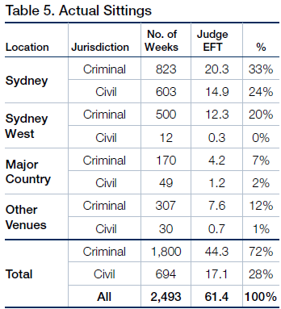
Judge EFT is calculated at 40.6 sitting weeks p.a. – i.e. 52 weeks less judicial vacations, public holidays and Annual Judges’ Conference
Comparisons with 2010
Overall, there was an increase of 162 weeks for sittings in 2011 compared to 2010. This included 190 extra criminal sittings and 28 fewer weeks in civil sittings.
The increase in sittings was due to an increase in pending workload as a result of additional criminal weeks added to Sydney West to finalise pending Commonwealth People Smuggling trials.
Acting Judges
Acting Judges provided an extra 893 days of actual sitting. Based on the maximum of 40.6 sitting weeks per year for a permanent judge, this equated to 4.4 additional judges.
Figure 23 below shows the fluctuations in the number of Acting Judge weeks attained since 2007.
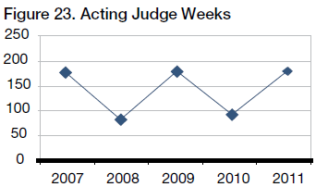
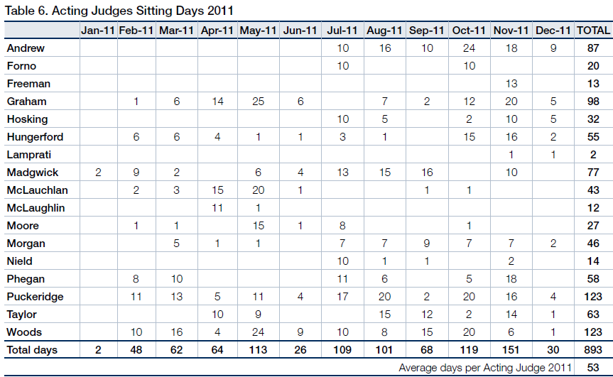
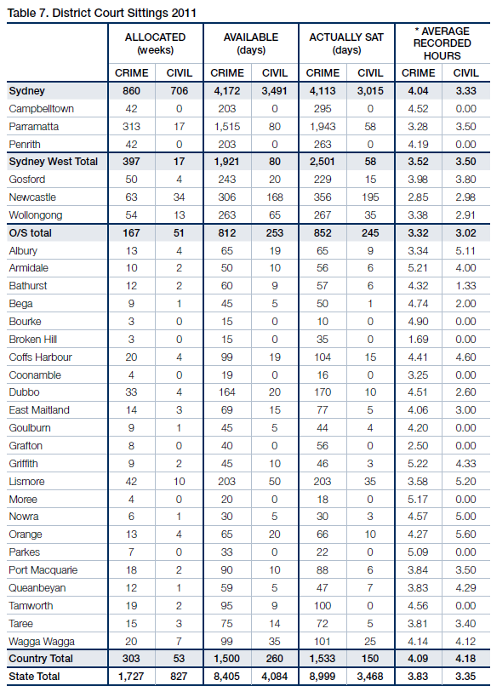

Annexures

Annexure A – Civil Caseload

Annexure A1 - Civil Caseload
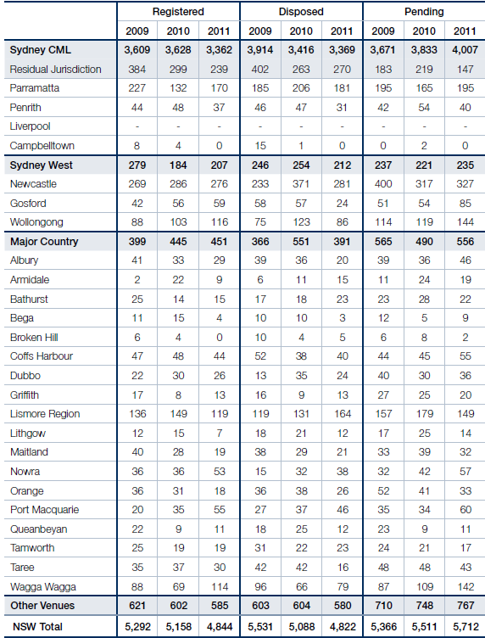
Annexure A2 - Civil Disposal Times
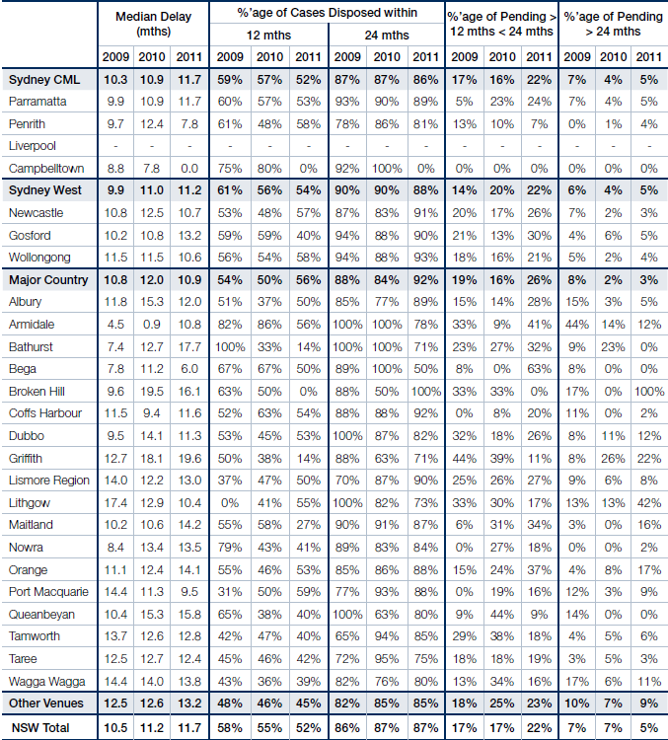

Annexures B – Criminal Caseload
Annexure B1 - Criminal Caseload
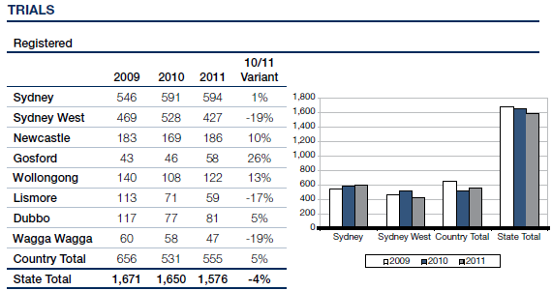
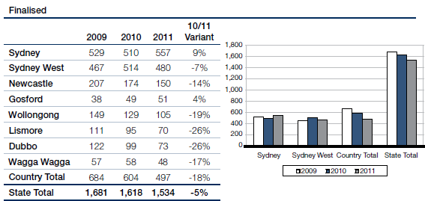
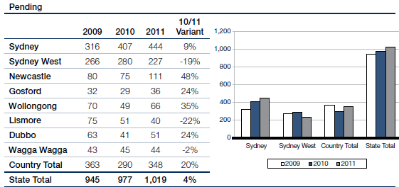
Annexure B2 - Criminal Caseload
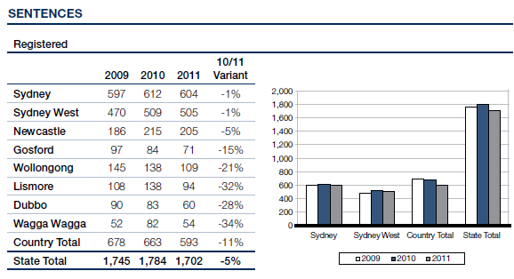
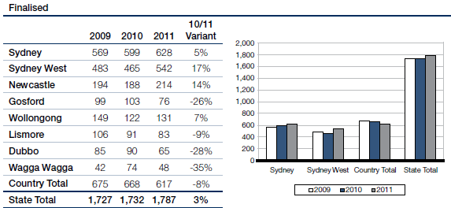
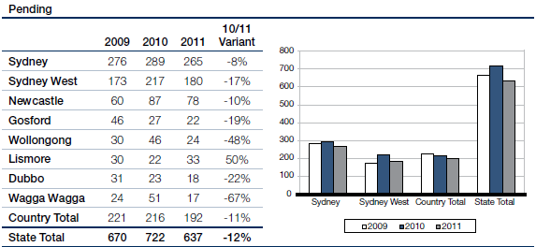
Annexure B3 - Criminal Caseload
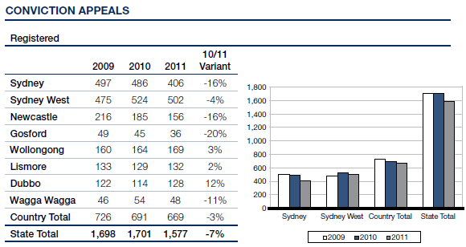
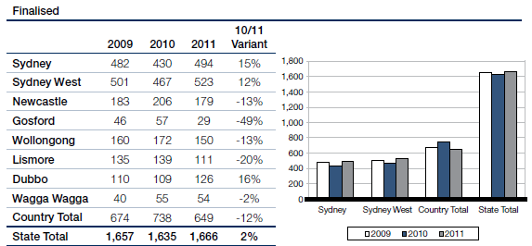
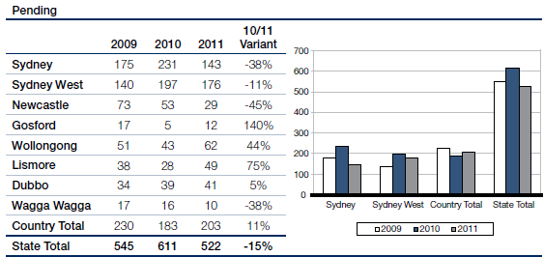
Annexure B4 - Criminal Caseload
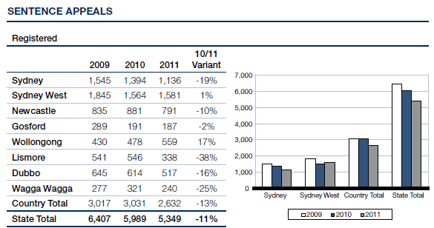
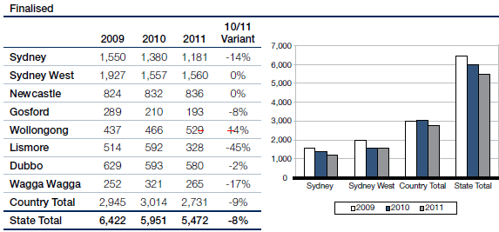
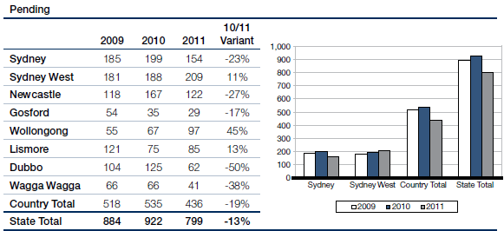

Annexure C – Compliance with Criminal Time Standards
Annexure C1 - Compliance with Criminal Time standards
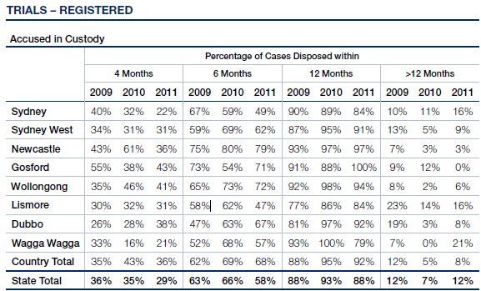
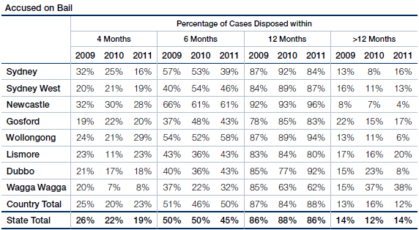
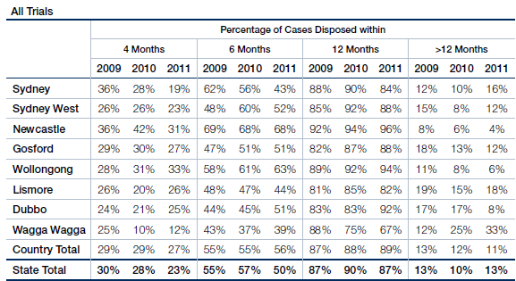
Annexure C2 - Compliance with Criminal Time standards
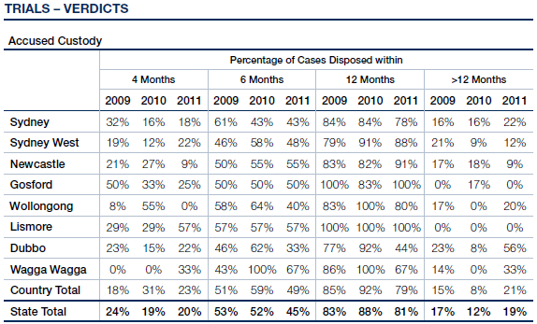
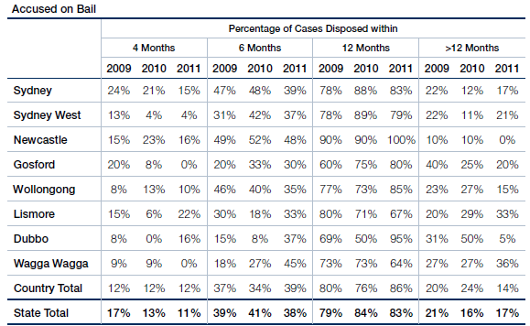
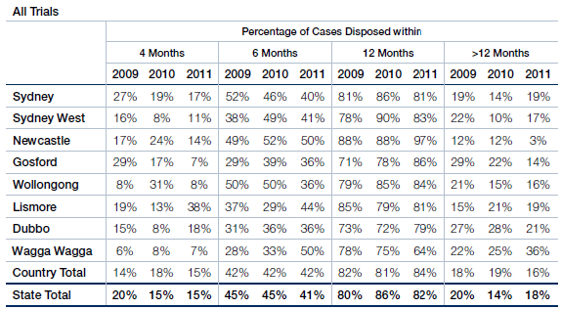
Annexure C3 - Compliance With Criminal Time Standards
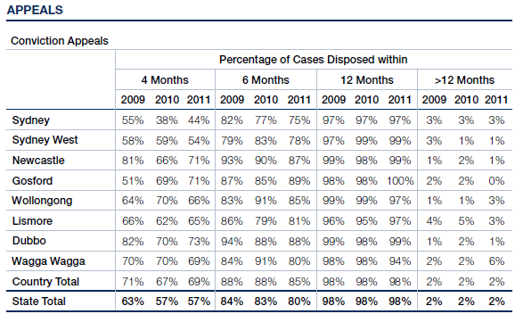
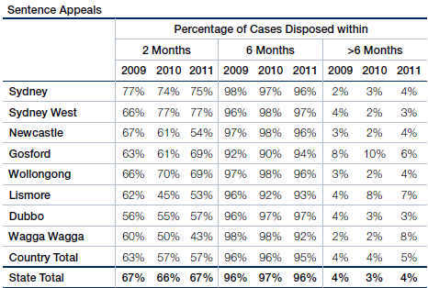
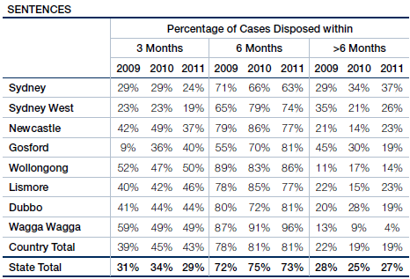

Annexure D – Court Committees

Annexure D - District Court Committees
Chief Judge’s Policy and Planning Committee
The Honourable Justice Blanch, AM, Chief Judge (Chair)
His Honour Judge Solomon (ex officio as Chair, Criminal Business Committee)
Her Honour Judge Truss, (ex officio as Chair, Civil Business Committee)
Her Honour Judge Tupman
Her Honour Judge Ashford
Her Honour Judge Balla
His Honour Judge Toner
His Honour Judge Levy
Mr C Smith, Judicial Registrar (Secretary)
Rule Committee
The Honourable Justice Blanch, AM, Chief Judge (Chair)
His Honour Judge Garling (Deputy Chair)
Her Honour Judge Sidis
His Honour Judge Robison
His Honour Judge Rolfe
His Honour Judge Neilson
His Honour Judge Johnstone
His Honour Judge Armitage
Mr P Khandhar, NSW Bar Association
Mr A Saxton Law Society of NSW
Mr A Grew (Secretary)
Civil Business Committee
Her Honour Judge Truss (Convenor)
Her Honour Judge Sidis
His Honour Judge Rolfe
His Honour Judge McLoughlin, SC
His Honour Judge Johnstone
His Honour Judge Colefax, SC
Mr C Smith, Judicial Registrar
Ms J Hall, Insurance Council of Australia
Ms J Probert, Motor Accidents Authority
Mr P Deakin, QC, NSW Bar Association
Mr L King, SC, NSW Bar Association
Mr A McMurran, Law Society of NSW
Mr T Stern, Law Society of NSW
Ms J Dunn, Civil List and Case Manager, District Court
Criminal Business Committee
His Honour Judge Solomon (Chair)
Mr J Kiely, Crown Prosecutor
Mr M Ierace, Senior Public Defender
Mr R Fornito, Criminal Listing Director, District Court
Mr D Giddy, NSW Law Society
Ms C Girotto, Office of the Director of Public Prosecutions (NSW)
Ms E Mackenzie, Office of the Director of Public Prosecutions (Commonwealth)
Mr R Kozanecki, Legal Aid Commission
Ms K Traill, Bar Association of NSW
Mr J Styles, Aboriginal Legal Service
Ms J Garvey, Judicial Support Coordinator, District Court (Secretary)
Professional Development (Education) Committee
Her Honour Judge Ashford (Chair)
Her Honour Judge Sidis
His Honour Judge Woods, QC
Her Honour Judge Hock
His Honour Judge Nicholson, SC
His Honour Judge Berman, QC
His Honour Judge Zahra, SC
His Honour Judge Lakatos, SC
His Honour Judge Elkaim, SC
Her Honour Judge Wells, SC
Mr C Smith, Judicial Registrar
Ms R Windeler, Education Director, Judicial Commission of NSW (Convenor)
Judicial Support Committee
His Honour Judge Solomon
His Honour Judge Garling
Her Honour Judge Truss
Her Honour Judge Sidis
Her Honour Judge Ashford
Judicial Commission, Standing Advisory Committee of Judicial Education
His Honour Judge Nicholson, SC
Judicial Commission, Ngara Yura Committee
His Honour Judge Norrish, QC (Chair)
His Honour Judge Nicholson, SC
Judicial Commission, Criminal Trial Courts Bench Book Committee
His Honour Judge Lakatos, SC
Downing Centre Library Committee
Her Honour Judge Truss
His Honour Judge Coorey
Deputy Chief Magistrate Culver Magistrate Farnan
Ms L Fairbairn, Director, Library Services
Ms V Blackmore, Manager, Client Services
Ms S Ramsay, Manager, Information Resources
Ms M Wearin, Research Officer, Dust Diseases Tribunal
John Maddison Tower and Downing Centre Building Committee
His Honour Judge Robison
His Honour Judge Kearns
Deputy Chief Magistrate Culver
Federal Magistrate Raphael
Mr C Smith, Judicial Registrar, District Court
Ms B Toomey, Sheriff’s Officer
Ms P Olsoen, Principal Registrar, District Court
Ms J Haywood, Executive Officer, Chief Magistrates Office
Mr R Gounder, Facilities Manager, Asset Management Services
Mr R Cowburn, Building Manager, John Maddison Tower & Downing Centre
Mr K Breen, Judicial Support Officer
Judicial Electronic Case Management Steering Committee
His Honour Judge King, SC

