The District Court of New South Wales

Annual Review 2010

Contents
Annual Review 2010 1
Foreword by Chief Judge 2
The District Court 4
History 4
Jurisdiction 5
Judiciary 5
Venues 10
Court Staff 11
Strategic Plan 11
Civil Business Committee Report 11
Criminal Business Committee Report 13
Professional Development (Education) Committee Report 14
Civil Jurisdiction 15
New South Wales 15
Caseload 15
Sydney 17
Caseload 17
Alternative Dispute Resolution 19
Residual Jurisdiction 19
Sydney West 20
Country 21
Criminal Jurisdiction 22
Trials 22
Caseload 22
Short Matters 28
Judicial Resources 31
Allocated Sittings 31
Annexures 35
Annexure A – Civil Caseload 35
Annexure B – Criminal Caseload 37
Annexure C – Compliance With Criminal Time Standards 41
Annexure D – Court Committees 44

Foreword by Chief Judge
In 2010 the performance of the Court continued to improve in accordance with the Strategic Plan of the Court and the commitment of the Court to continue to improve efficiencies. This can be readily gauged by the Productivity Commission Report for 2010 which indicated only 5.6% of criminal non-appeal cases took more than 12 months and only 0.4% of cases took more than two years. Those figures are the best in Australia for comparative jurisdictions in spite of the fact there are more cases in New South Wales. We also have many serious cases which take up a significant amount of hearing time in the Court. Trials which last between one and six months are common. The performance in dealing with criminal matters was an improvement over the previous year but because the performance levels are now so high, the improvement is only small.
In the civil business of the Court the Productivity Commission’s figures again show New South Wales is the best performing State with only 17.2% of cases taking more than 12 months to conclude. That again was an improvement on the previous year.
The country circuit work of the Court has been maintained at a steady level, both in the criminal and civil jurisdictions. The tendency of practitioners to commence civil actions in Sydney rather than other areas where the Court sits has continued in 2010. On the other hand we appear to be succeeding in solving the problem of managing criminal trials in the circuits. That problem arises because the Court sits in the circuit courts for only limited periods during the year and if cases need to be adjourned from one circuit, they often need to be adjourned for three or four months to the next circuit. I have been managing the listing of criminal cases in the circuits by way of a telephone callover which I normally conduct with a view to maintaining a consistent approach and an insistence on readiness for trial. One result has been that the country work now represents less than 30% of the caseload of the Court whereas some years ago it was 45%.
There has been a remarkable consistency in the flow of work into the Court both in the criminal and civil jurisdictions and there is hardly any variation in the number of cases being registered in each category. The jurisdiction of the Court has remained the same except in the civil jurisdiction where de facto relationship disputes have moved to the Family Court and are gradually disappearing from our lists. A transfer to the Court of appeals from costs assessors and the Consumer, Trader and Tenancy Tribunal has compensated for the loss of the other work.
During the course of the year the Court performed a self-evaluation in accordance with the International Framework for Court Excellence. That Framework was created by a number of bodies including the World Bank, the European Commission for the Efficiency of Justice, the National Center for State Courts in the United States, the Singapore Courts and the Australasian Institute of Judicial Administration. The result of the evaluation was that this Court rates in the highest band of excellence and that is largely because this Court has for many years engaged in strategic planning and improvement of performance. The evaluation pointed out that our weakest area was in communicating the processes of the Court to the community. That is a difficult task for courts and of course this Annual Review is one way of achieving communication. We have also allowed the filming of two trials and those films will be shown as part of a television series during 2011.
I acknowledge the importance of maintaining confidence in the judicial system and it is important for there to be an understanding that the courts in New South Wales are highly professional, free of corruption and prejudice and quite independent of the other arms of government. This makes our courts some of the best in the world. When the Court makes a decision, it is a considered and impartial one based on the evidence before it. Because in an individual case some people disagree with the decision does not in any way detract from the integrity or strength of the court system. It is important to continue to try to communicate that message.
The Honourable Justice R O Blanch, AM
Chief Judge

The District Court

History
By the middle of the 19th Century the court system in New South Wales consisted of:
- The Supreme Court of New South Wales which, under the Third Charter of Justice sealed in 1823, had a criminal and civil jurisdiction similar to that of the superior Courts of England;
- Courts of General and Quarter Sessions which could deal with “crimes and misdemeanours not punishable by death”
- Courts of Requests in Sydney and the County of Cumberland, with a civil jurisdiction not exceeding £30; and
- Courts of Petty Sessions, which dealt with criminal misdemeanours in a summary way and had a civil jurisdiction up to £10 (or £30 if the defendant consented).
With the discovery of gold in 1851 the Colony’s population increased and became more dispersed. Litigation grew as the Colony prospered, and crime was not declining. The Supreme Court began to fall seriously into arrears, and this was not helped by the fact that it did not visit a lot of towns. Courts of Quarter Sessions were also few in number and had no civil jurisdiction.
By the mid 1850’s there were calls for a revision of the court system, to meet the growing needs of the Colony. As a result, the District Court Act 1858 (22 Vic No 18) was assented to on 12 November 1858.
This Act established District Courts, as courts of records, to replace Courts of Requests and divided the Colony into Districts. It conferred upon the District Courts a civil jurisdiction.
It also provided for the appointment of a District Court judge as Chairman of any Court of Quarter Sessions or General Sessions, to be held within the limits of the District for which that judge was appointed.
The purpose of the Act was briefly described in The Practice of the District Courts of NSW by W.J. Foster and C.E.R. Murray (Sydney, 1870), as follows:
“District Courts were established by the Legislature for the purpose of simplifying legal proceedings in the recovery of amounts under £200, and lessening the expenses of attending such proceedings, as well as to relieving the Supreme Court of some portion of the overwhelming civil business which the rapid progress of the colony had lately engendered.
The Act providing for the institution of these Courts also extended the jurisdiction of Courts of General and Quarter Sessions of the Peace, and prepared the way for a great increase in their numbers, under the presidency of District Court judges as Chairmen, whereby criminal proceedings have been much facilitated, especially in the more distant and outlying portions of the country…”
The District Courts Act 1858 remained in force until 1973, although the jurisdiction of the Court was increased from time to time.
The District Court Act 1973 commenced on 1 July 1973. It abolished the District Courts and Courts of Quarter Sessions and established one District Court of New South Wales, with a state wide criminal and civil jurisdiction.

Jurisdiction
The District Court is the intermediate Court in the State’s judicial hierarchy. It is a trial court and has an appellate jurisdiction. In addition, the judges of the Court preside over a range of tribunals.
In its criminal jurisdiction, the Court may deal with all criminal offences except murder, treason and piracy.
In its civil jurisdiction the Court may deal with:
- all motor accident cases, irrespective of the amount claimed;
- other claims to a maximum amount of $750,000, although it may deal with matters exceeding this amount if the parties consent.
In addition, the Court may deal with equitable claims or demands for recovery of money or damages for amounts not exceeding $750,000.
The Court is also empowered to deal with applications under the De Facto Relationships Act 1984, the Family Provisions Act 1982 and the Testator Family Maintenance and Guardianship of Infants Act 1916 that involve amounts, or property to the value of, not more than $250,000.

Judiciary
The following were the Judges of the Court as at 31 December 2010.
Chief Judge
The Honourable Justice Reginald Oliver Blanch, AM
Judges
His Honour Judge John Lawrence O’Meally, AM, RFD*
His Honour Judge Ronald Herbert Solomon
Her Honour Judge Margaret Ann O’Toole
His Honour Judge David James Freeman
His Honour Judge Anthony Frederick Garling
Her Honour Judge Dianne Joy Truss
His Honour Judge Garry William Neilson
His Honour Judge Christopher John Armitage
Her Honour Judge Margaret Sidis
His Honour Judge Christopher John George Robison
Her Honour Judge Robyn Christine Tupman
His Honour Judge James Patrick Curtis*
Her Honour Judge Helen Gay Murrell, SC
Her Honour Judge Deborah June Payne
His Honour Judge Martin Langford Sides, QC
His Honour Judge Robert Keleman, SC
Her Honour Judge Anne Mary Quirk
Her Honour Judge Linda Margaret Ashford
His Honour Judge Gregory David Woods, QC
His Honour Judge Norman Edward Delaney
His Honour Judge Jonathan Steuart Williams
His Honour Judge Kevin Patrick O’Connor, AM
Her Honour Judge Jennifer Anne English
Her Honour Judge Susan Jennifer Gibb
His Honour Judge Gregory Scott Hosking, SC
His Honour Judge Ralph Coolahan
His Honour Judge Kevin Peter Coorey
His Honour Judge Richard Anthony Rolfe
His Honour Judge James Walter Black, QC
His Honour Judge Robert Arthur Sorby
His Honour Judge Stephen Ronald Norrish, QC
Her Honour Judge Audrey Suzanne Balla
His Honour Judge Michael John Finnane, RFD, QC
Her Honour Judge Penelope Jane Hock
Her Honour Judge Judith Clare Gibson
His Honour Judge John Cecil Nicholson, SC
His Honour Judge Stephen Lewis Walmsley, SC
His Honour Judge Anthony Martin Blackmore, SC
His Honour Judge Colin Emmett O’Connor, QC
His Honour Judge Peter Graeme Berman, SC
His Honour Judge Raymond Patrick McLoughlin, SC
His Honour Judge Colin David Charteris, SC
His Honour Judge Roy David Ellis
His Honour Judge Mark Curtis Marien, SC
His Honour Judge Brian John Knox, SC
His Honour Judge John Roger Dive
Her Honour Judge Deborah Anne Sweeney
His Honour Judge James Leonard Alexandre Bennett, SC
His Honour Judge Peter Lind Johnstone
His Honour Judge William Patrick Kearns, SC*
His Honour Judge Paul Vincent Conlon, SC
His Honour Judge Peter Raymond Zahra, SC
His Honour Judge Richard Dominic Cogswell, SC
Her Honour Judge Leonie Flannery, SC
His Honour Judge Robert Stephen Toner, SC
His Honour Judge Gregory Micheal Keating
His Honour Judge Paul Ivan Lakatos, SC
His Honour Judge Leonard Levy, SC
His Honour Judge Michael Elkaim, SC
His Honour Judge Michael King, SC
His Honour Judge David Clement Frearson, SC
His Honour Judge Andrew Michael Colefax, SC
Her Honour Judge Helen Syme
His Honour Michael Ivan Bozic, SC
His Honour John North
His Honour Judge Graham Leslie Henson
Her Honour Judge Laura Kathleen Wells, SC
His Honour Judge Ross Victor Letherbarrow, SC
His Honour Judge Andrew Carl Haesler, SC
* denotes Members of the Dust Diseases Tribunal
Judicial Appointments
The following Judges were appointed during 2010 on the dates indicated in the brackets after their name:
His Honour Judge Graham Leslie Henson (20 July 2010)
Her Honour Judge Laura Kathleen Wells, SC (27 July 2010)
His Honour Judge Ross Victor Letherbarrow, SC (11 August 2010)
His Honour Judge Andrew Carl Haesler, SC (20 September 2010)
Judicial Retirements
The following Judges retired during 2010 on the dates indicated in brackets after their name:
His Honour Judge Kenneth Victor Taylor, AM, RFD (11 August 2010)
His Honour Judge Anthony Francis Puckeridge, QC (28 August 2010)
His Honour Judge Allan Hughes (17 November 2010)
Her Honour Judge Helen Jane Morgan (18 December 2010)
District Court Judge Appointed to the Family Court of Australia
Her Honour Judge Ann Margaret Ainslie - Wallace was appointed as a Judge of the Family Court of Australia on 12 July 2010.
Appointments Held During 2010
His Honour Judge John Lawrence O’Meally, AM, RFD, held the appointment of President of the Dust Diseases Tribunal of NSW.
His Honour Judge Kevin Patrick O’Connor, AM, held the appointment of President of the Administrative Decisions Tribunal of NSW.
His Honour Judge Gregory Michael Keating held the position of President of the Workers Compensation Commission of NSW.
His Honour Judge John Roger Dive held the position of Senior Judge of the Drug Court of NSW.
His Honour Judge Mark Curtis Marien, SC, held the position of President of the Childrens Court of NSW.
His Honour Judge Graeme Leslie Henson held the position of Chief Magistrate of the Local Court of NSW.
Medical Tribunal of NSW
The Honourable Justice Reginald Oliver Blanch, AM, Chief Judge, held the appointment of Chairperson of the Medical Tribunal of New South Wales.
The following Judges held appointments as Deputy Chairpersons of the Tribunal as at 31 December 2010:
His Honour Judge Ronald Herbert Solomon
His Honour Judge David James Freeman
His Honour Judge Anthony Frederick Garling
Her Honour Judge Margaret Sidis
Her Honour Judge Helen Gay Murrell, SC
His Honour Judge Robert Keleman, SC
Her Honour Judge Audrey Suzanne Balla
His Honour Judge Stephen Lewis Walmsley, SC
His Honour Judge Peter Lind Johnstone
Acting Judges During 2009
Mr Graham Hamlyn Traill Armitage, QC
Mr Terence Joseph Christie, QC
Mr Geoffrey John Graham
Mr Rodney Neville Madgwick, QC
Mr John Cecil McGuire
Mr Joseph Anthony Moore
Mr Colin Phegan
Mr Brian James Boulton
Mr Garry Spencer Forno, QC
The Honourable Barrie Clive Hungerford, QC
Mr Michael John McGrowdie
Mr Neil McLauchlan
Sir Robert Kynnersley Woods, CBE
Mr Ian Barnett
Judicial Registrar
Section 18FA of the District Court Act 1973 provides for the appointment of a Judicial Registrar.
Ms Catherine Admonisha McDonald’s appointment as Judicial Registrar expired on4 December 2009.

Venues
In 2010 the Court sat permanently in Sydney at the Downing Centre, 143-147 Liverpool Street, Sydney (in crime), where it occupies 17 courtrooms, and at the John Maddison Tower, 86 Goulburn Street, Sydney, where it occupies 22 courtrooms (mostly in civil).
In Sydney West, Judges sat full-time in the Court Houses at Parramatta (8 courtrooms), Penrith (1 courtroom) and Campbelltown (1 courtroom). In addition, continuous sittings were conducted at Newcastle, Gosford, Wollongong and Lismore.
The places where the Court sat were:
Albury, Armidale, Bathurst, Bega, Bourke, Broken Hill, Campbelltown, Coffs Harbour, Coonamble, Dubbo, East Maitland, Gosford, Goulburn, Grafton, Griffith, Lismore, Moree, Newcastle, Nowra, Orange, Parkes, Parramatta, Penrith, Port Macquarie, Queanbeyan, Sydney, Tamworth, Taree, Wagga Wagga, Wollongong.

Court Staff
Principal Registrar, District Court of NSW
Ms Pam Olsoen is the Principal Registrar and exercises functions pursuant to Section 18H(3) of the District Court Act 1973.
Criminal Listings and Judicial Arrangements
Schedules cases in accordance with Court policy; prepares lists; allocates courtrooms; and co-ordinates the assignment of judges to venues throughout the State.
Mr Robert Fornito is the District Court Criminal Listing Director. Pursuant to Section 123 of the Criminal Procedure Act 1986, the Criminal Listing Director is responsible to the Chief Judge in making arrangements for the listing of criminal proceedings.
Civil Case Management and Listings
Implements civil case management and listing practices for the timely disposition of cases; schedules cases; prepares lists and allocates courtrooms.
Ms Jane Dunn is the Civil List and Case Manager and works in conjunction with the Civil List Judge and the Judicial Registrar in making arrangements for the listing of civil proceedings.

Strategic Plan

Civil Business Committee Report
In August 2007 the Court introduced its third Strategic Plan. The first such plan was adopted in 1995 and it provided a template for significant changes in the way the Court operated as did the second Strategic Plan in 2000.
The Strategic Plan articulates the values of the Court and sets out the goals to be achieved over 2007-2012 in carrying out this role in line with these values.
The Court is committed to discharging its responsibilities to ensure:
- That the Court is accessible to the public and those who need to use its services;
- The effective determination of cases in an orderly, cost effective and expeditious manner. The equal protection of the law to all;
- The independence of the Judges of the Court, and the Court as a branch of our system of government;
- Accountability for the performance of the Court and its use of public funds;
- The highest standard of excellence in the functioning of the Court.
As in past plans, the Court will continue to maintain a Policy and Planning Committee to provide advice to the Chief Judge on matters relating to the business of the Court. There are also three major business committees that are accountable to the Policy and Planning Committee. Those Committees are:
- The Criminal Business Committee;
- The Civil Business Committee;
- The Professional Development (Education)
Terms of Reference
To monitor, report and advise on any matter relating to the Court’s goal of providing a system for the earliest, most effective and efficient resolution of civil disputes.
The Committee
The Committee consists of judges of the Court, the Judicial Registrar, the Civil List and Case Manager and representatives of the Law Society of NSW, the Bar Association of NSW, the Insurance Council of Australia and the Motor Accidents Authority.
Activities
The Committee met on four occasions during the year and matters considered included:
- The Court’s Operational Performance Report with up-to-date statistical information presented at each meeting.
- Proposed amendments to the rules and practice notes.
- Particular concerns of the various representatives and matters which the Court wished to bring to their attention.
- The Committee considered a wide range of issues including:
- The operation of the specialist lists. Case management generally and also including child care appeals and appeals from the CTTT;
- The reasons for delay by parties and applications for adjournment;
- The proposed introduction of searchable lists;
- The Court Information Act 2010.

Criminal Business Committee Report
Terms of Reference
To monitor, report and advise on any matter relating to the Court’s goal of providing a system for the earliest, most effective and efficient resolution to criminal matters.
Consultation with court users is carried out through the Criminal Business Committee. The Committee consists of representatives from the Judiciary, Criminal Listing Director, Law Society of NSW, Bar Association of NSW, Legal Aid, Commonwealth and State DPP’s, Aboriginal Legal Service, Public Defenders and Crown Prosecutors.
Activities
The Committee met on four occasions during the year.
- The NSW District Court achieved a very high assessment in a Court of Excellence report. The Court was rated as having an exceptionally well-defined innovative approach, which is fully integrated with organisational needs, practiced consistently at all areas. Performance levels were excellent in most key indicators.
- The start of the law term saw the new Parramatta trial complex running to full capacity of 8 courts. The start of 2010 saw Campbelltown cut to one court with the remaining 2 courts relocated to Parramatta. Catchment areas and police area commands were looked at with some work redirected to Parramatta.
- The Court continues to target older pending cases throughout the state. The ROGS (Report on Government Services) for the year continues to show NSW leading the nation in the disposal of criminal cases.
- The Court continues to manage and list criminal trials in country circuits by way of a telephone call over.
- A new multi accused trial court is proposed to be built on level 3 of the Downing Centre. This courtroom will also be used by the Supreme Court for large trials.
- Advice was received that the Commonwealth DPP was to commence approximately 80 prosecutions relating to people smuggling.
- The court continues to maintain a collaborative approach in its partnership with the Court’s stakeholders in its criminal

Professional Development (Education) Committee Report
Annual Conference
The Annual Conference held in Sydney on 6 & 7 April 2010 was attended by 54 judges and the judicial registrar. The conference focused on providing challenging and interesting educational sessions, while also providing a valuable opportunity for discussion and debate. The program consisted primarily of sessions relevant to the day-to-day work of a judge. The sessions dealt with a variety of topics from substantive law and practice to more psychological/physiological topics and to topics dealing with the skills of judges including performance review and effective communication skills. Topics included:
- Court of Appeal Review by The Honourable Justice James Allsop, President, Court of Appeal;
- Court of Criminal Appeal Review by The Honourable Justice Carolyn Simpson, Supreme Court of NSW;
- Indigenous Offenders by Professor Mick Dodson, AM;
- People with Mental Health in the Criminal Justice System by Dr Eileen Baldry, Associate Professor, School of Social Sciences and International Studies, University of NSW;
- Development of the Brain by Professor Ian Hickie, AM, Executive Director, Brain & Mind Research Institute and Professor of Psychiatry, University of Sydney;
- Introduction to 360 Degree Feedback by Ms Maryanne Mooney, Director, Full Circle Feedback;
- Communicating in Court by Ms Robyn Fraser, Speech and Drama Teacher;
- Running a Consumer Trader & Tenancy Tribunal case by The Honourable Justice Peter Hall, Supreme Court of NSW;
- Delivering Oral Judgments: An Introduction by Mr Tom Wodak;
- Delivering Oral Judgments: Workshop facilitated by Mr Tom Wodak, The Honourable Murray Kellam, AO, QC, The Honourable David Lloyd, QC and Her Honour Judge Margaret Sidis;
- Q & A session about practical matters relating to the Court with a panel consisting of The Honourable Justice Reginald Blanch, AM, His Honour Judge Ronald Solomon, His Honour Judge Anthony Garling, Her Honour Judge Helen Murrell, SC, Her Honour Judge Ann Ainslie- Wallace, His Honour Judge Richard Rolfe, His Honour Judge Peter Berman, SC.
Occasional Seminars
The Education Committee has continued to work with the Judicial Commission to organise a series of breakfast, lunch and twilight education sessions for District Court judges in the John Maddison Tower, including:
- “The Mental Health Legislation Amendment (Forensic Provisions) Act 2008” presented by The Honourable Greg James, QC, President, Mental Health Review Tribunal;
- “Current Issues in Sentencing” presented by Her Honour Judge Helen Murrell, SC, His Honour Judge Steve Norrish, QC and His Honour Judge Peter Berman, SC.
Seventeen judges from the Court also participated in field trips to the Silverwater Correctional Complex and the Windsor Correctional Complex.
Judgment Writing Workshop
Professor James Raymond, a legal writing consultant from New York, conducted a two day Cross-Jurisdictional Judgment Writing Workshop in September 2010 for 12 judicial officers, including two from the District Court. Through analysing and discussing their own writing, participants worked on developing their judgment writing skills and the ability to write clear, concise, well-structured judgments.

Civil Jurisdiction

New South Wales
Full statistical data on the Court’s civil operations is set out in Annexures A (1) and (2).
In 2010:
- Registrations fell by 3%
- Finalisations fell by 8%
- Pending cases rose by 3%
- Median time for disposals rose from 10.5 to 11.2 months

Caseload
Explanatory Background
Comparing registrations and finalisations is not an exact science. For example, a matter in the course of its life may, for various reasons, be registered more than once. Multiple parties and cross actions can further affect the equation. Cases determined at arbitration can be re-heard. A matter previously dismissed can be restored or a retrial may be ordered. Registries also conduct stock-takes of cases on hand during the course of the year, with pending statistics being adjusted as necessary.
It is therefore important to view comparisons of registrations and finalisations against pending caseload with some caution, as it is often difficult to reconcile the figures. However, they are helpful in providing general trends concerning the incoming and outgoing work of the Court.
Registrations
There were 5,158 matters registered in 2010, compared to 5,297 in 2009.
Disposals
There were 5,088 disposals in 2010, compared to 5,531 in 2009.
Pending
At the end of 2010 the pending caseload was 5,511, compared to 5,366 in 2009.
Comparison with Previous Years
Figure 1 below tracks the Court’s caseload for the past 5 years.
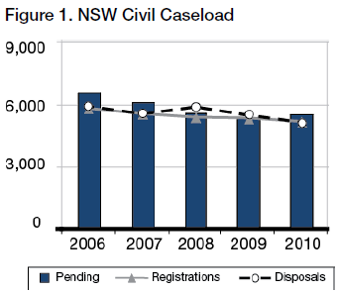
Disposal Times
In 2010, 55% of all actions completed were finalised within 12 months, with 87% being completed within 24 months. This compares to 58% and 86%, respectively, in 2009.
Of the pending caseload at the end of 2010, 17% exceeded 12 months and not more than 24 months and 4% more than 24 months.

Sydney
In 2010:
- Registrations rose by 1%
- Finalisations fell by 13%
- Pending cases rose by 4%
- Median disposal time rose from 10.3 to 10.9 months.

Caseload
In 2010, Sydney civil case managed matters represented 67% of the State’s registrations and 70% of the matters on hand.
Figure 2 below shows the ratio of new civil actions commencing in Sydney, as compared to the whole State for the past 5 years
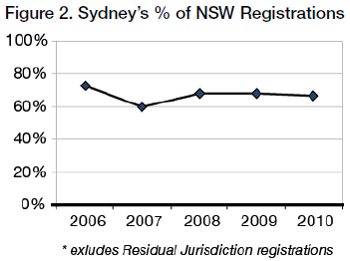
Registrations, Disposals and Pending
Excluding the Residual Jurisdiction, there were 3,628 new actions commenced and 3,416 finalised in Sydney in 2010. At the end of the year there were 3,833 actions pending. Figure 3 tracks Sydney’s caseload for the last five years.
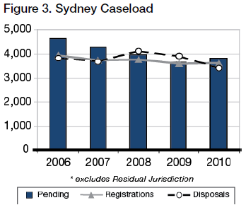
Disposal Times
The Court’s ideal time standard for civil cases is to achieve a 90% disposition rate within 12 months of commencement, and 100% within 2 years.
In 2010, 57% of all actions completed were finalised within 12 months, with 87% being completed within 24 months. This compares to 59% and 87%, respectively in 2009.
Of the pending caseload at the end of 2010, 16% exceeded 12 months and not more than 24 months and 4% exceeded 24 months.
How Cases are Finalised
Table 1 below shows the breakup of how case managed list matters were completed in 2010. The categories of “Dismissed” and “Discontinued” include matters that settled without judgment being entered and/or terms of settlement being filed.
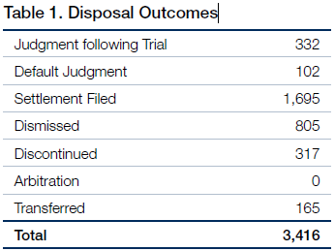
Table 2 below compares two of the seven categories of disposal outcomes as against the total number of disposal outcomes. These two categories are selected because i. ‘Disposed of by judgment following trial’ represents the number of hearings to judgment before judges, and ii. “Disposed of by settlements filed” includes matters that settled as a result of ADR.
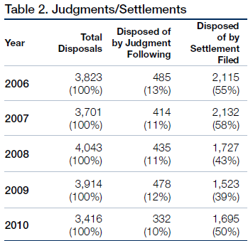

Alternative Dispute Resolution
Mediation
Pursuant to Civil Practice Note 1, cases before the Sydney District Court are referred to mediation where appropriate. The referral may be either to private mediation or to court provided mediation. The Assistant Registrars in Sydney undertake the court provided mediation. In 2010 the Sydney District Court referred 997 matters to mediation (842 were referred to private mediation and 155 to court provided mediation).
Approximately 46% of matters referred to mediation by Assistant Registrars were settled. There are no available statistics in relation to settlement of matters referred to private mediators.

Residual Jurisdiction
The Compensation Court Repeal Act 2002 abolished the Compensation Court, and transferred the Compensation Court’s jurisdiction to the Workers Compensation Commission or the District Court. The Act commenced on 1 January 2004.
The disputes that were transferred to the District Court are commonly referred as its “residual jurisdiction” and involve the following:
- The Police Act 1990 concerning police officers “hurt on duty” and the Police Regulation (Superannuation) Act 1906 concerning the payment of superannuation benefits to police officers;
- Payment under the Police Regulations (Superannuation) Act 1906, paid to STC (the SAS Trustee Corporation continued under the Superannuation Administration Act 1996) and special risk benefits payable by the Commissioner of `Police;
- The Workers’ Compensation Act 1987 concerning workers in or about a coal mine;
- The Workers Compensation (Dust Diseases) Act 1942;
- The Sporting Injuries Insurance Scheme;
- The Workers’ Compensation (Bush Fire, Emergency & Rescue Services) Act 1987.
During 2010, 299 actions were commenced and 263 were finalised. There were a total of 219 matters on hand in the residual jurisdiction at the end of 2010.

Sydney West
Sydney West had 4% of the total number of new actions started in the State in 2010 (excluding the Court’s residual jurisdiction). Figure 4 below tracks the variation in the proportional rate of registrations in Sydney West.
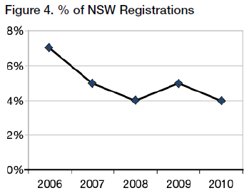
In Sydney West there were 184 matters registered and 254 dispositions throughout the year. At the end of 2010 the total pending caseload was 221, as compared to 240 the previous year.
Figure 5 shows comparative registrations, finalisations and pending caseloads for the past 5 years.
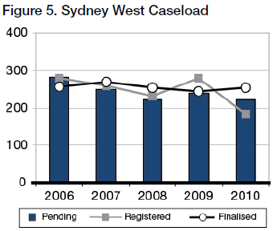
Pending matters in Sydney West fell by 8% and the median finalisation time was 10.9 months.
20% of pending cases exceeded 12 months and not more than 24 months and 4% exceeded 24 months.

Country
Venues outside of Sydney and Sydney West had 20% of the total number of new actions started in 2010 (excluding the Court’s residual jurisdiction).
Figure 6 tracks the proportional rate of registrations for Country venues.
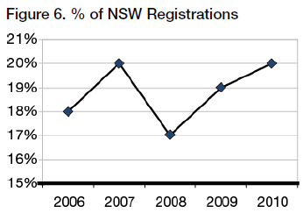
Outside of Sydney and Sydney West, there were 1,155 dispositions throughout the year. At the end of the year the total pending caseload was 1,238 as compared to 1,275 the previous year.
Figure 7 shows comparative registrations, finalisations and pending caseloads for the past 5 years.
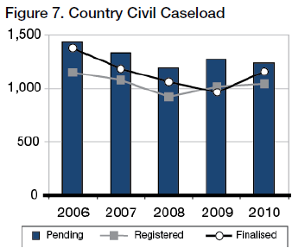
Pending matters in the country fell by 3% and the median finalisation time was 12.6 months.
22% of pending cases exceeded 12 months and not more than 24 months and 5% exceeded 24 months.

Criminal Jurisdiction

Trials
In 2010:
- Trial registrations fell by 1%
- Finalisations fell by 4%
- Number of pending trials rose by 3%
- Median disposals times fell from 35 to 34 weeks
- Average length of trials rose by 9%, from 7.84 to 8.64 days

Caseload
There were 1,650 criminal trials registered during 2010 in New South Wales, as compared to 1,671 in 2009 and 1,785 in 2008.
There were 1,618 trials finalised in 2010, as compared to 1,681 in 2009 and 1,782 in 2008.
There were 977 trials on hand at the end of 2010, as compared to 945 trials at the end of 2009.
Figure 8 tracks the statewide trends in the criminal trial caseload for the past 5 years.
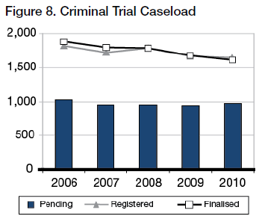
Figure 9 shows variation in trial and sentence registrations for the last 5 years.
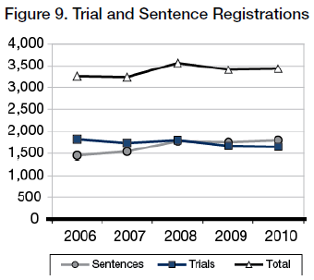
Sentence hearings are far less demanding on victims. They also absorb far less resources than trials. It is therefore important to ensure that in appropriate cases guilty pleas are entered at the earliest possible time, preferably at the committal stage.
Time Standards
The Court’s ideal time standards for the commencement of criminal trials are:
- 90% of cases within 4 months of committal, or such other event which causes the proceedings; and
- 100% of cases within 1 year.
In 2010, 35% of trial disposals where the accused was in custody were finalised within 4 months, and 7% exceeded 12 months. Where the accused was on bail, 22% of disposals occurred within 4 months, with 12% exceeding 12 months.
Figure 10 sets out comparative compliance rates with time standards for all trials finalised.
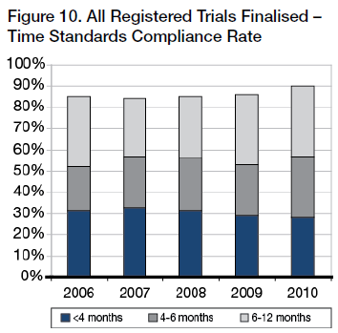
Figure 11 shows the age of all trials which were pending at the end of the year indicated.
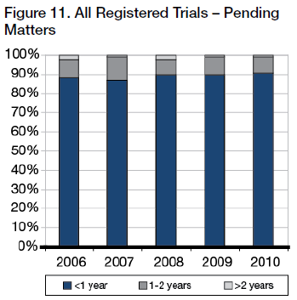
Figure 12 tracks the median disposal times, from committal to commencement of the trial, for matters finalised during the year indicated.
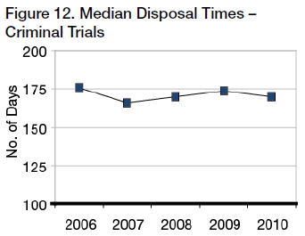
Trial Durations
The statewide average length of criminal trials finalised in 2010 was 8.64 days, as compared to 7.84 days in 2009. In Sydney the average duration was 10.66 days in 2010, compared to 9.57 days in 2009.
Figure 13 illustrates the fluctuating rise in the average trial duration time.
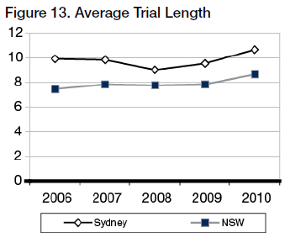
Trial Listing Outcomes
About 1,981 trials were listed for hearing in 2010.
Figure 14 shows the breakup of those matters not dealt with.
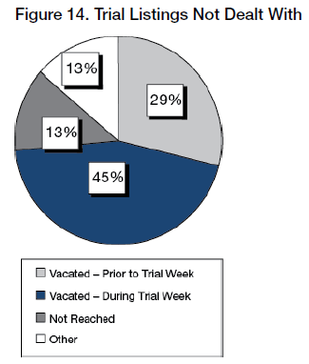
Figure 15 shows the break-up of those matters that were dealt with after being listed.
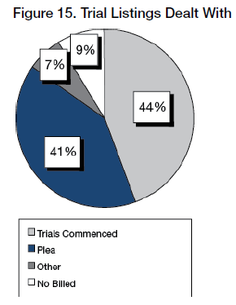
Figure 16 shows the outcome of those that commenced.
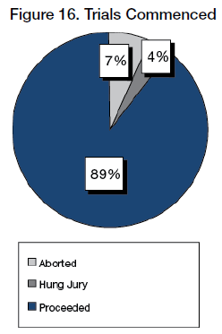
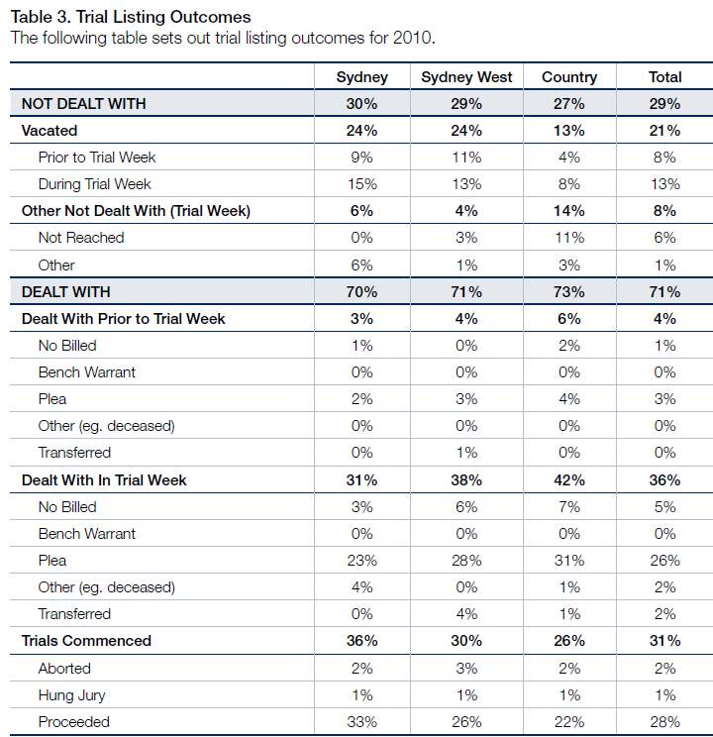
Of trials dealt with in 2010 (i.e. 71% of total listings):
- 48% pleaded Guilty
- 39% proceeded to verdict
- 9% were “no billed”
- 3% were transferred
- 3% were aborted
- 2% ended with a “hung Jury”
- 4% were otherwise disposed
- 0% had bench warrants issued

Short Matters
Sentences
There were 1,784 committals for sentence received in 2010 and 1,732 matters were finalised. At the end of the year there were 722 sentence matters pending, compared to 670 at the end of 2009.
Figure 17 tracks the sentence caseload for the last 5 years.
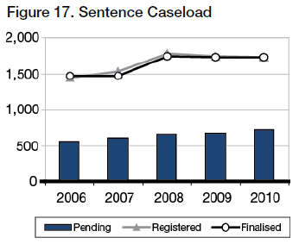
The ideal time standard from committal for sentence to hearing is 3 months in 90% of cases, with 100% being completed within 6 months.
Figure 18 illustrates compliance rates with time standards.
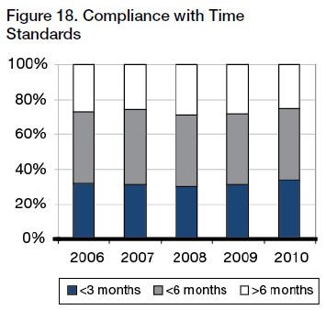
Conviction Appeals
There were 1,701 conviction appeals lodged in 2010 and 1,635 finalisations. At the end of the year there were 611 conviction appeals pending, compared to 545 at the end of 2009.
Figure 19 tracks the conviction appeal caseload for the last 5 years.
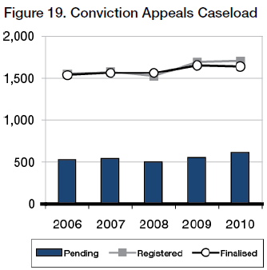
The ideal time standard from lodgement to finalisation is 4 months in 90% of cases, with 100% being completed within 12 months.
Figure 20 illustrates compliance rates with time standards.
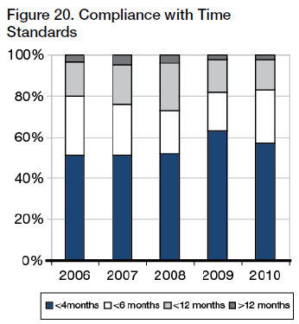
Sentence Appeals
There were 5,989 sentence appeals lodged in 2010 and 5,951 finalised. At the end of the year there were 922 sentence appeals pending, compared to 884 at the end of 2009.
Figure 21 tracks the sentence appeals caseload for the last 5 years.
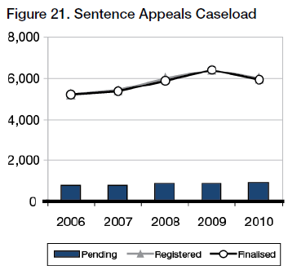
The ideal time standard from lodgement to finalisation for sentence appeals is 2 months in 90% of cases, with 100% being completed within 6 months.
Figure 22 illustrates compliance rates with time standards.
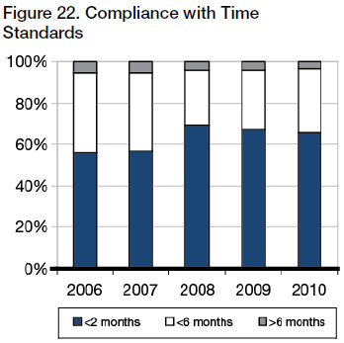

Judicial Resources

Allocated Sittings
Table 4 sets out the number of judicial sitting weeks allocated in 2010 as published in the Court’s Calendar of Sittings.
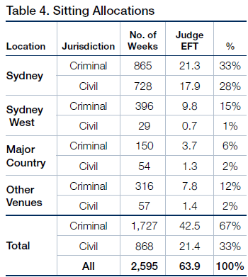
Judge EFT is calculated at 40.6 sitting weeks p.a. - i.e. 52 weeks less judicial vacations, public holidays and Annual Judges’ Conference

Actual Sittings
Table 5 sets out the number of days actually sat by the court in 2010 converted into weeks (by dividing the number of days by 5)
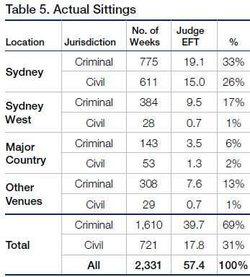
Judge EFT is calculated at 40.6 sitting weeks p.a.- i.e. 52 weeks less judicial vacations, public holidays and Annual Judges’ Conference
Comparisons with 2009
Overall, there were 122 fewer sitting weeks in 2010 than 2009. This included 98 fewer weeks in criminal sittings and 24 fewer weeks in civil sittings.
The decrease in sittings was due to a reduction in pending workload as a result of additional criminal weeks added to the country in the previous year (2008) to reduce trial backlogs.
Acting Judges
Acting Judges provided an extra 463 days of actual sitting. Based on the maximum of 40.6 sitting weeks per year for a permanent judge, this equated to 2.3 additional judges.
Figure 26 below shows the fluctuations in the number of Acting Judge weeks attained since 2006.
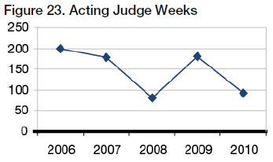
Sitting Details
The final table sets out the allocated, available and actual sittings at all venues, as well as the average daily recorded sitting hours.
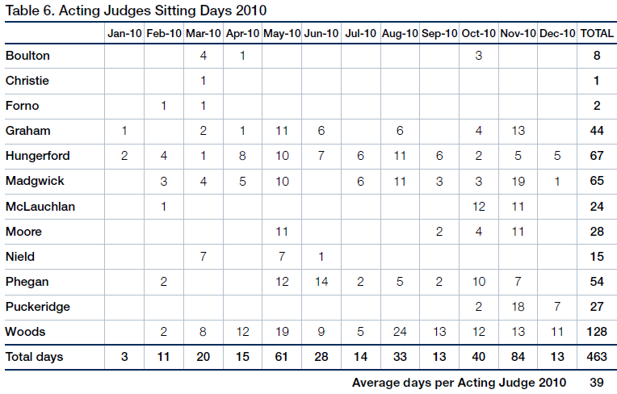
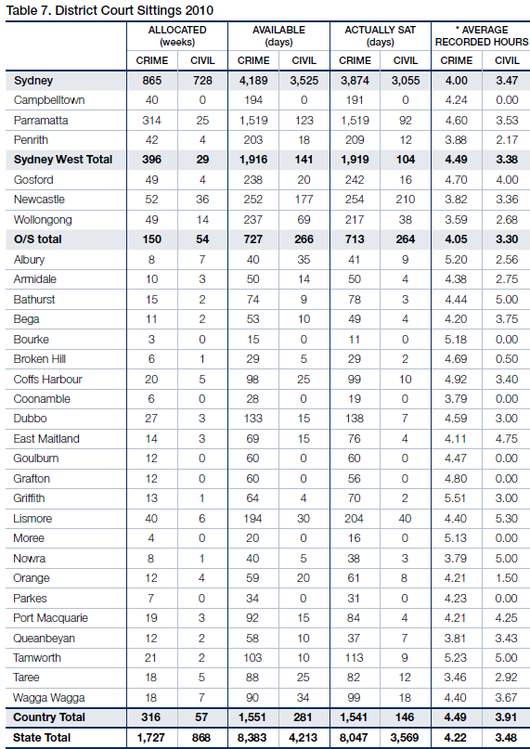
* “Average Recorded Hours” are based on the number of siting hours during which proceedings were recorded, as provided by the Reporting Services Branch, NSW Department of Justice & Attorney General. This is often less than the actual hours the Court sat.

Annexures

Annexure A – Civil Caseload
Annexure A1 - Civil Caseload
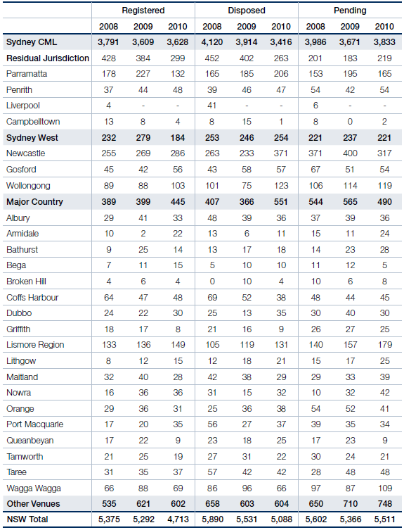
Annexure A2 - Civil Disposal Times
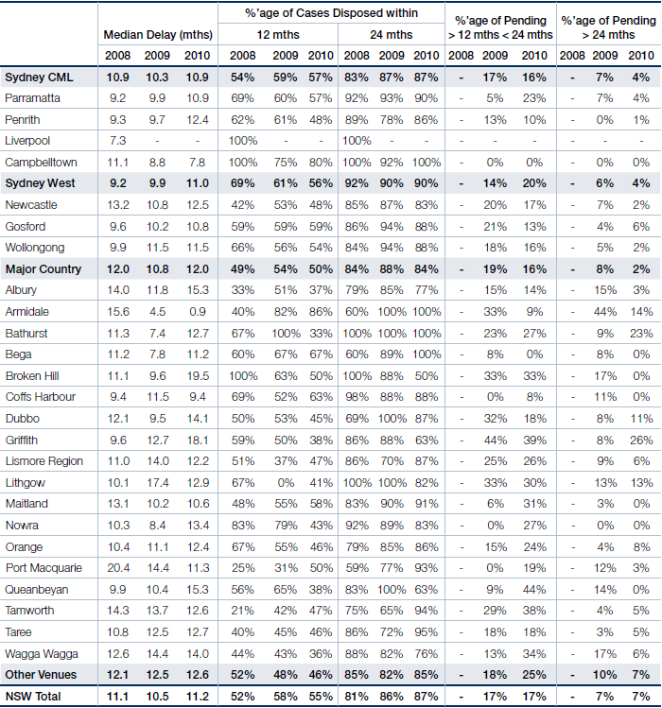

Annexure B – Criminal Caseload
Annexure B1 - Criminal Caseload
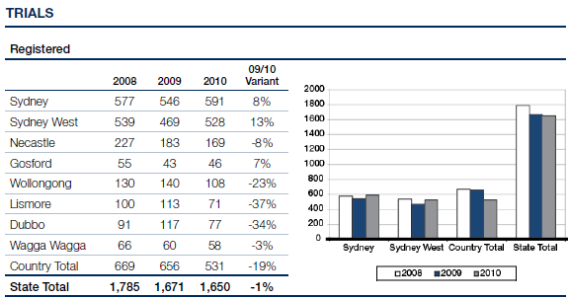
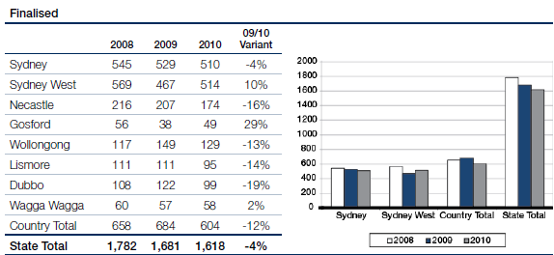
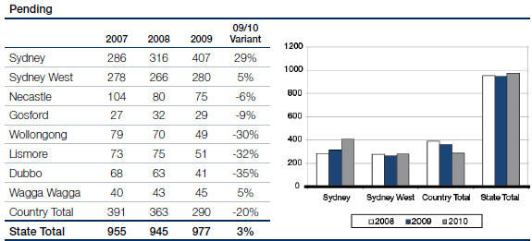
Annexure B2 - Criminal Caseload
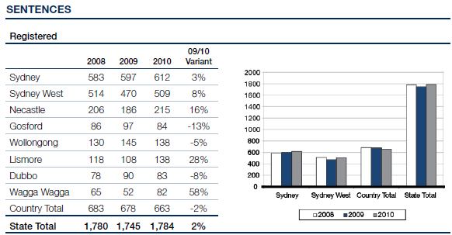
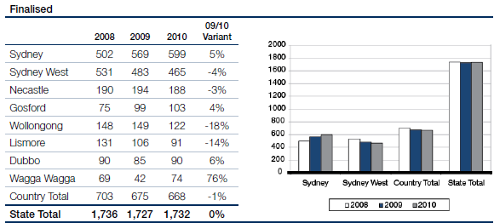
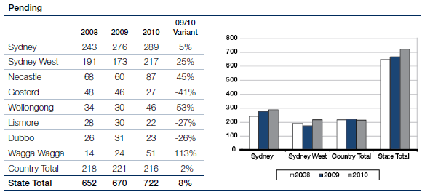
Annexure B3 - Criminal Caseload
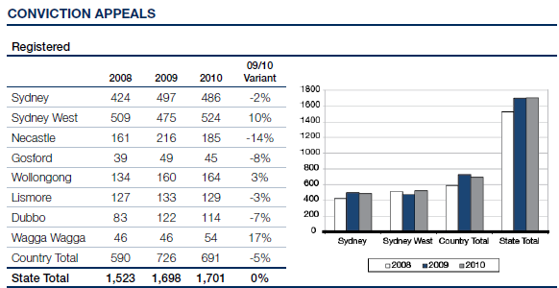
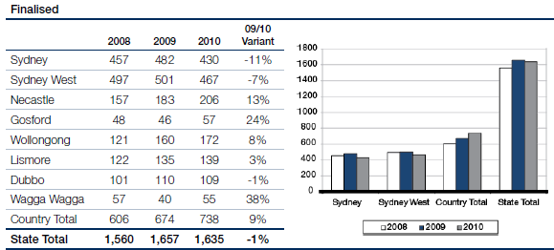
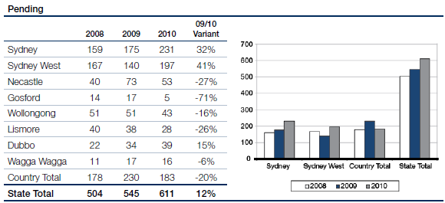
Annexure B4 - Criminal Caseload
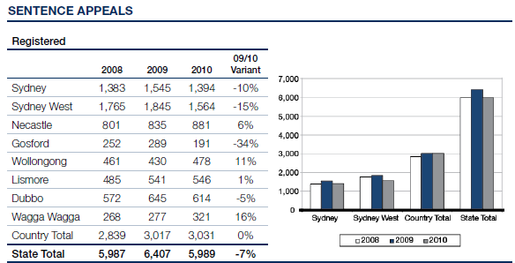
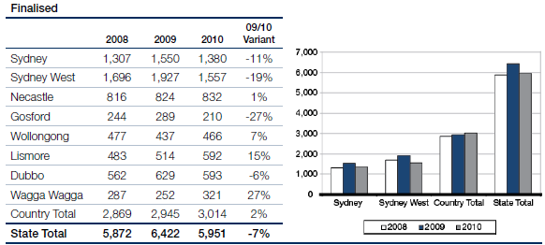
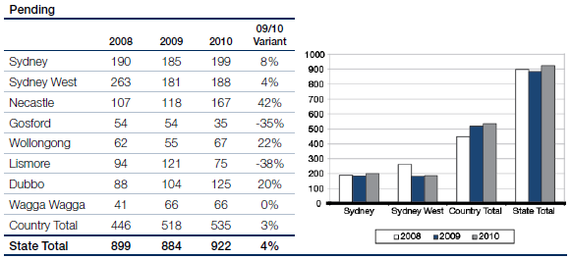

Annexure C – Compliance With Criminal Time Standards
Annexure C1 - Compliance With Criminal Time Standards
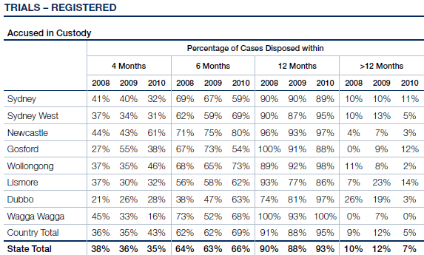
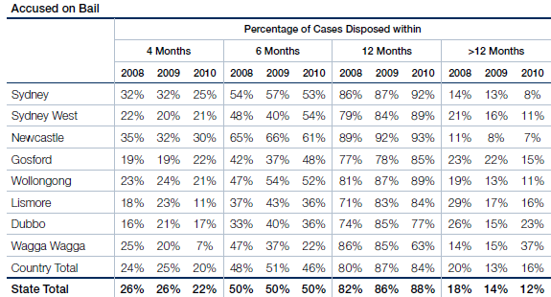
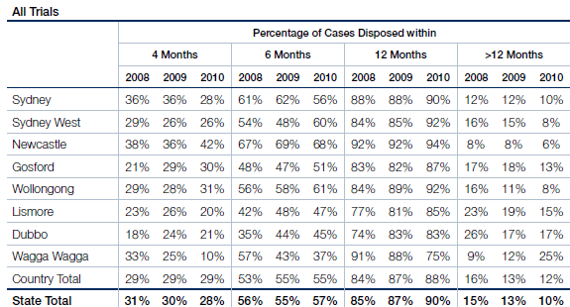
Annexure C2 - Compliance With Criminal Time Standards
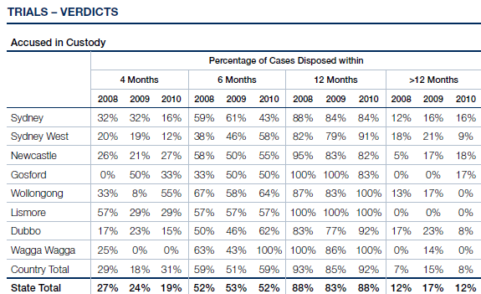
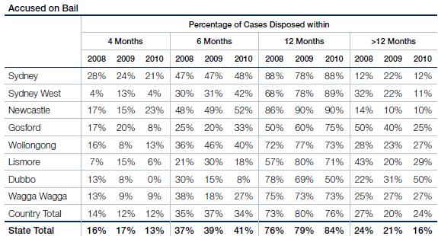
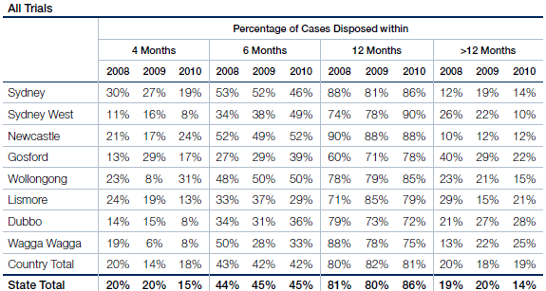
Annexure C3 - Compliance With Criminal Time Standards
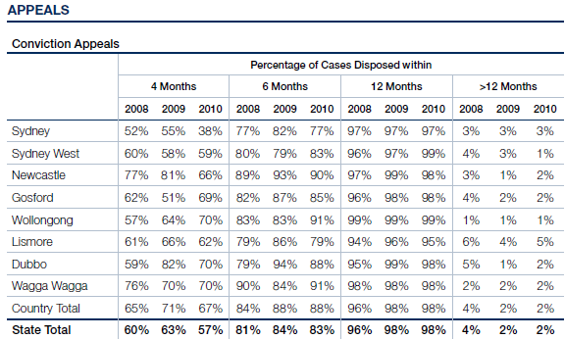
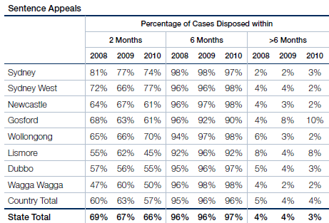
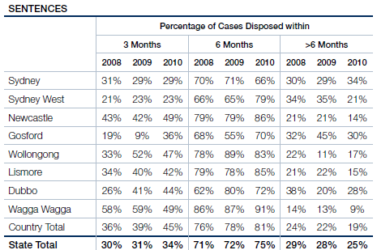

Annexure D – Court Committees
Annexure D - District Court Committees
Chief Judge’s Policy and Planning Committee
The Honourable Justice Blanch, Chief Judge, AM (Chair)
His Honour Judge Solomon (ex officio as Chair, Criminal Business Committee)
His Honour Judge Taylor, AM, RFD (ex officio as Chair, Education Committee, until August 2010)
His Honour Judge Garling (ex officio as Chair, Civil Business Committee, until June 2010)
Her Honour JudgeTruss (ex officio as Chair, Civil Business Committee, from July 2010)
His Honour Judge Robison
Her Honour Judge Morgan
Her Honour Judge Balla
His Honour Judge Toner
His Honour Judge Levy
Mr C Smith, Judicial Registrar (Secretary)
Rule Committee
The Honourable Justice Blanch, Chief Judge (Chair)
His Honour Judge Garling (Deputy Chair)
Her Honour Judge Sidis
His Honour Judge Robison
His Honour Judge Rolfe
His Honour Judge Neilson
His Honour Judge Johnstone
His Honour Judge Armitage
Mr P Khandhar, NSW Bar Association
Mr A Saxton Law Society of NSW
Mr A Grew (Secretary)
Civil Business Committee
His Honour Judge Garling (Convenor, until June 2010)
Her Honour Judge Truss (Convenor from July 2010)
Her Honour Judge Sidis
His Honour Judge Rolfe
His Honour Judge McLoughlin, SC
His Honour Judge Johnstone
His Honour Judge Colefax, SC (from October 2010)
Mr C Smith, Judicial Registrar
Ms J Hall, Insurance Council of Australia
Ms J Probert, Motor Accidents Authority
Mr P Deakin, QC, NSW Bar Association
Ms L King, SC, NSW Bar Association
Mr A McMurran, Law Society of NSW
Mr A Saxton, Law Society of NSW
Ms J Dunn, Civil List and Case Manager, District Court
Criminal Business Committee
His Honour Judge Solomon (Chair)
Mr J Kiely, Crown Prosecutor
Mr M Ierace, Senior Public Defender
Mr R Fornito, Criminal Listing Director, District Court
Mr D Giddy, NSW Law Society
Ms C Girotto, Office of the Director of Public Prosecutions (NSW)
Ms E Mackenzie, Office of the Director of Public Prosecutions (Commonwealth)
Mr R Kozanecki, Legal Aid Commission
Ms K Traill, Bar Association of NSW
Mr J Styles, Aboriginal Legal Service
Ms J Garvey, Judicial Support Coordinator, District Court (Secretary)
Professional Development (Education) Committee
His Honour Judge Taylor, AM, RFD (Chair until August 2010)
Her Honour Judge Sidis
Her Honour Judge Ashford (Chair from August 2010)
His Honour Judge Woods, QC
His Honour Judge Nicholson, SC
Her Honour Judge Sweeney
His Honour Judge Zahra, SC
His Honour Judge Cogswell, SC
His Honour Judge Lakatos, SC
His Honour Judge Elkaim, SC
His Honour Judge Colefax, SC
Mr C Smith, Judicial Registrar
Ms R Windeler, Education Director, Judicial Commission of NSW
Judicial Support Committee
His Honour Judge Solomon
His Honour Judge Taylor, AM, RFD (until August 2010)
His Honour Judge Garling
Her Honour Judge Truss
Her Honour Judge Sidis
Her Honour Judge Ashford
Judicial Commission, Standing Advisory Committee of Judicial Education
His Honour Judge Nicholson, SC
Judicial Commission, Ngara Yura Committee
His Honour Judge Norrish, QC (Chair)
His Honour Judge Nicholson, SC
Judicial Commission, Criminal Trial Courts Bench Book Committee
His Honour Judge Lakatos, SC
Downing Centre Library Committee
Her Honour Judge Truss
His Honour Judge Coorey
Deputy Chief Magistrate Culver
Magistrate Farnan
Ms V Blackmore, Acting Director, Library Services
Ms S Ramsey, Manager, Information Resources
Ms J Dennison, Manager, Downing Centre Library
Ms M Wearin, Research Officer, Dust Diseases Tribunal
John Maddison Tower and Downing Centre Building Committee
His Honour Judge Robison
His Honour Judge Kearns
Deputy Chief Magistrate Culver
Federal Magistrate Raphael
Mr C Smith, Judicial Registrar, District Court
Ms B Toomey, Sheriff’s Officer
Ms P Olsoen, Principal Registrar, District Court
Ms J Haywood, Executive Officer, Chief Magistrates Office
Mr R Gounder, Facilities Manager, Asset Management Services
Mr R Cowburn, Building Manager, John Maddison Tower & Downing Centre
Mr K Breen, Judicial Support Officer
Justicelink Committee
His Honour Judge King
His Honour Judge Rolfe
His Honour Judge Finnane, RFD, QC
Mr C Smith, Judicial Registrar
Mr R Fornito, Criminal Listing Director
Ms J Dunn, Civil List and Case Manager, District Court
Ms J Mathison, Manager, Justicelink Business Support Group
Ms N Ubrihien, Justicelink Project
Ms R Liston, Justicelink Project

