The District Court of New South Wales

Annual Review 2010
Contents
Annual Review 2010 1
Foreword by Chief Judge 2
The District Court 3
History 3
Jurisdiction 4
Judiciary 5
Venues 10
Court Staff 10
Strategic Plan 11
Civil Business Committee Report 12
Criminal Business Committee Report 13
Professional Development (Education) Committee Report 14
Civil Jurisdiction 15
New South Wales 15
Caseload 16
SYDNEY 17
Caseload 17
Alternative Dispute Resolution 19
Residual Jurisdiction 20
SYDNEY WEST 20
Country 21
Criminal Jurisdiction 22
Trials 22
Caseload 22
Short Matters 28
Judicial Resources 32
Allocated Sittings 32
Actual Sittings 33
Annexures 36
Annexure A – Civil Caseload 36
Annexure B – Criminal Caseload 38
Annexure C – Compliance With Criminal Time Standards 42
Annexure D – Court Committees 45

Foreword by Chief Judge
During the course of 2009 the Court continued to improve its efficiency. Again this Court was the only one of the Intermediate Courts in Australia to meet the national standard of having less than 10% of nonappeal cases older than 12 months. In its civil jurisdiction the Court was also one of the best performing of the equivalent Courts in Australia. The delays which were once endemic in this State have disappeared and the management of the Court is a matter of maintaining this efficiency. There has been an ongoing emphasis on sexual assault cases and although such cases are heard much more quickly in New South Wales than other jurisdictions in Australia, I believe we should continue to try to reduce the period it takes to get these cases to trial.
In the criminal jurisdiction there was a slight reduction in cases committed for trial but a significant increase in appeals from the Local Court. These appeals, however, are generally not too time-consuming and accordingly, the resources available to the Court are sufficient to deal with the increases.
In the civil business of the Court there was again a very slight reduction in the number of actions filed but so slight as to have no effect on the operations of the Court. The major decline in the filings of civil actions has been in country circuit areas and in order to maintain the civil circuits they have frequently been amalgamated with the criminal circuits because it is important to provide an ongoing service to regional areas in the State.
During the course of the year a user survey was conducted as to satisfaction with the facilities provided by the Court in Sydney and the operations of the Court. Of course in civil matters decided by the Court there is always a losing party. In criminal cases the survey included persons appealing against their sentences and their supporters. In spite of the fact that in many of these cases it might be expected people would have a negative reaction to the Court, the results of the survey indicated that 95% of the 191 respondents were satisfied with access to the court building, 85% were satisfied with the facilities in the court rooms and 83% were satisfied with their treatment by the Court. Of the 47 jurors who responded, all were satisfied with their treatment by the Court.
In 2010 there will be a continued focus on sexual assault cases and the circuit work of the Court. The new Parramatta Court Complex will be open with eight courts functioning and it is hoped that will improve even more the efficiency of the Court’s operations in Sydney West. That Court Complex draws cases from many of the areas previously serviced from Campbelltown and Penrith Courts, but generally speaking those are areas where it is more convenient to travel to Parramatta.
In December, 2009 I issued a Practice Note to ensure that criminal cases in all country areas where the Court sits permanently come quickly before the Court in the same way as occurs in Sydney. Also during the year the number of criminal trials listed each week in the circuits was reduced to two trials in an attempt to reduce the number of trials not reached. During the year the number of trials disposed of in the circuits increased partly due to increased sittings.
A revised Practice Note was also issued in 2009 relating to the civil business of the Court emphasising the need for cases to be referred to alternative dispute resolution wherever possible. This is to encourage litigants to resolve cases as early as possible and as cheaply as possible. The early referral of cases will be done with a view to minimising the costs to parties and in some cases mediation will be provided by registrars of the Court without any cost. The Court is committed to providing a system of justice which is as affordable as can be achieved.
The Honourable Justice R O Blanch, AM
Chief Judge

The District Court

History
By the middle of the 19th Century the court system in New South Wales consisted of:
- The Supreme Court of New South Wales which, under the Third Charter of Justice sealed in 1823, had a criminal and civil jurisdiction similar to that of the superior Courts of England;
- Courts of General and Quarter Sessions which could deal with “crimes and misdemeanours not punishable by death”;
- Courts of Requests in Sydney and the County of Cumberland, with a civil jurisdiction not exceeding $30; and
- Courts of Petty Sessions, which dealt with criminal misdemeanours in a summary way and had a civil jurisdiction up to $10 (or $30 if the defendant consented).
With the discovery of gold in 1851 the Colony’s population increased and became more dispersed. Litigation grew as the Colony prospered, and crime was not declining. The Supreme Court began to fall seriously into arrears, and this was not helped by the fact that it did not visit a lot of towns. Courts of Quarter Sessions were also few in number and had no civil jurisdiction.
By the mid 1850’s there were calls for a revision of the court system, to meet the growing needs of the Colony. As a result, the District Court Act 1858 (22 Vic No 18) was assented to on 12 November 1858.
This Act established District Courts, as courts of records, to replace Courts of Requests and divided the Colony into Districts. It conferred upon the District Courts a civil jurisdiction.
It also provided for the appointment of a District Court Judge as Chairman of any Court of Quarter Sessions or General Sessions, to be held within the limits of the District for which that Judge was appointed.
The purpose of the Act was briefly described in The Practice of the District Courts of NSW by W.J. Foster and C.E.R. Murray (Sydney, 1870), as follows:
“District Courts were established by the Legislature for the purpose of simplifying legal proceedings in the recovery of amounts under £200, and lessening the expenses of attending such proceedings, as well as to relieving the Supreme Court of some portion of the overwhelming civil business which the rapid progress of the colony had lately engendered.
The Act providing for the institution of these Courts also extended the jurisdiction of Courts of General and Quarter Sessions of the Peace, and prepared the way for a great increase in their numbers, under the presidency of District Court Judges as Chairmen, whereby criminal proceedings have been much facilitated, especially in the more distant and outlying portions of the country…”
The District Courts Act 1858 remained in force until 1973, although the jurisdiction of the Court was increased from time to time.
The District Court Act 1973 commenced on 1 July 1973. It abolished the District Courts and Courts of Quarter Sessions and established one District Court of New South Wales, with a statewide criminal and civil jurisdiction.

Jurisdiction
The District Court is the intermediate Court in the State’s judicial hierarchy. It is a trial court and has an appellate jurisdiction. In addition, the Judges of the Court preside over a range of tribunals.
In its criminal jurisdiction, the Court may deal with all criminal offences except murder, treason and piracy.
In its civil jurisdiction the Court may deal with:
- all motor accident cases, irrespective of the amount claimed;
- other claims to a maximum amount of $750,000, although it may deal with matters exceeding this amount if the parties consent.
In addition, the Court may deal with equitable claims or demands for recovery of money or damages for amounts not exceeding $750,000.
The Court is also empowered to deal with applications under the De Facto Relationships Act 1984, the Family Provisions Act 1982 and the Testator Family Maintenance and Guardianship of Infants Act 1916 that involve amounts, or property to the value of, not more than $250,000.

Judiciary
The following were the Judges of the Court as at 31 December 2009.
Chief Judge
The Honourable Justice Reginald Oliver Blanch, AM Judges
His Honour Judge John Lawrence O’Meally, AM, RFD*
His Honour Judge Ronald Herbert Solomon
Her Honour Judge Margaret Ann O’Toole
His Honour Judge David James Freeman
His Honour Judge Kenneth Victor Taylor, AM, RFD
His Honour Judge Anthony Frederick Garling
Her Honour Judge Dianne Joy Truss
His Honour Judge Garry William Neilson
His Honour Judge Christopher John Armitage
Her Honour Judge Margaret Sidis
His Honour Judge Christopher John George Robison
Her Honour Judge Robyn Christine Tupman
His Honour Judge James Patrick Curtis*
Her Honour Judge Helen Gay Murrell, SC
Her Honour Judge Deborah June Payne
His Honour Judge Martin Langford Sides, QC
His Honour Judge Robert Keleman, SC
Her Honour Judge Anne Mary Quirk
Her Honour Judge Ann Margaret Ainslie- Wallace
His Honour Judge Colin Phegan
Her Honour Judge Linda Margaret Ashford
His Honour Judge Gregory David Woods, QC
His Honour Judge Anthony Francis Puckeridge, QC
Her Honour Judge Helen Jane Morgan
His Honour Judge Norman Edward Delaney
His Honour Judge Jonathan Steuart Williams
His Honour Judge Kevin Patrick O’Connor, AM
Her Honour Judge Jennifer Anne English
His Honour Judge Allan Hughes
Her Honour Judge Susan Jennifer Gibb
His Honour Judge Gregory Scott Hosking, SC
His Honour Judge Ralph Coolahan
His Honour Judge Kevin Peter Coorey
His Honour Judge Richard Anthony Rolfe
His Honour Judge James Walter Black, QC
His Honour Judge Robert Arthur Sorby
His Honour Judge Stephen Ronald Norrish, QC
Her Honour Judge Audrey Suzanne Balla
His Honour Judge Michael John Finnane, RFD, QC
Her Honour Judge Penelope Jane Hock
Her Honour Judge Judith Clare Gibson
His Honour Judge John Cecil Nicholson, SC
His Honour Judge Stephen Lewis Walmsley, SC
His Honour Judge Anthony Martin Blackmore, SC
His Honour Judge Colin Emmett O’Connor, QC
His Honour Judge Peter Graeme Berman, SC
His Honour Judge Raymond Patrick McLoughlin, SC
His Honour Judge Colin David Charteris, SC
His Honour Judge Roy David Ellis
His Honour Judge Mark Curtis Marien, SC
His Honour Judge Brian John Knox, SC
His Honour Judge John Roger Dive
Her Honour Judge Deborah Anne Sweeney
His Honour Judge James Leonard Alexandre Bennett, SC
His Honour Judge Peter Lind Johnstone
His Honour Judge William Patrick Kearns, SC*
His Honour Judge Paul Vincent Conlon, SC
His Honour Judge Peter Raymond Zahra, SC
His Honour Judge Richard Dominic Cogswell, SC
Her Honour Judge Leonie Flannery, SC
His Honour Judge Robert Stephen Toner, SC
His Honour Judge Gregory Micheal Keating
His Honour Judge Paul Ivan Lakatos, SC
His Honour Judge Leonard Levy, SC
His Honour Judge Michael Elkaim, SC
His Honour Judge Michael King, SC
His Honour Judge David Clement Frearson, SC
His Honour Judge Andrew Michael Colefax, SC
Her Honour Judge Helen Syme
His Honour Michael Ivan Bozic, SC
His Honour John North
* denotes Members of the Dust Diseases Tribunal
Judicial Appointments
The following Judges were appointed during 2009 on the dates indicated in the brackets after their name:
His Honour Judge David Clement Frearson, SC (2 March 2009)
His Honour Judge Andrew Michael Colefax, SC (14 April 2009)
Her Honour Judge Helen Syme (14 April 2009)
His Honour Michael Ivan Bozic, SC (20 July 2009)
His Honour John North (29 July 2009)
Judicial Death in Office
Sadly, on 7 October 2009, His Honour Judge John Lester Goldring died in office.
Judicial Retirements
The following Judges retired during 2009 on the dates indicated in brackets after their name:
His Honour Judge William Harwood Knight (1 February 2009)
His Honour Judge Christopher James Geraghty (13 February 2009)
His Honour Judge John Roscoe Nield (23 September 2009)
District Court Judge appointed to the Supreme Court of NSW
His Honour Judge Robert Allan Hulme, SC was appointed as a Judge of the Supreme Court of NSW on 2 March 2009.
Appointments held during 2009
His Honour Judge John Lawrence O’Meally, AM, RFD, held the appointment of President of the Dust Diseases Tribunal of NSW.
His Honour Judge Kevin Patrick O’Connor, AM, held the appointment of President of the Administrative Decisions Tribunal of NSW.
His Honour Judge Gregory Michael Keating held the position of President of the Workers Compensation Commission of NSW.
His Honour Judge John Roger Dive held the position of Senior Judge of the Drug Court of NSW.
His Honour Judge Kenneth Victor Taylor, AM, RFD, held the position of NSW Privacy Commissioner.
His Honour Judge Mark Curtis Marien, SC held the position of President of the Childrens Court of NSW.
Medical Tribunal of NSW
The Honourable Justice Reginald Oliver Blanch, AM, Chief Judge, held the appointment of Chairperson of the Medical Tribunal of New South Wales.
The following Judges held appointments as Deputy Chairpersons of the Tribunal as at 31 December 2009:
His Honour Judge Ronald Herbert Solomon
His Honour Judge David James Freeman
His Honour Judge Kenneth Victor Taylor, AM, RFD
Her Honour Judge Margaret Sidis
Her Honour Judge Helen Gay Murrell, SC
His Honour Judge Robert Keleman, SC
Her Honour Judge Ann Margaret Ainslie- Wallace
His Honour Judge Anthony Francis Puckeridge, QC
Her Honour Judge Audrey Suzanne Balla
His Honour Judge Stephen Lewis Walmsley, SC
His Honour Judge Peter Lind Johnstone
Acting Judges During 2009
Mr Graham Hamlyn Traill Armitage, QC
Mr Terence Joseph Christie, QC
Mr Geoffrey John Graham
Mr Rodney Neville Madgwick, QC
Mr John Cecil McGuire
Mr Joseph Anthony Moore
Mr Colin Phegan
Mr Brian James Boulton
Mr Garry Spencer Forno, QC
The Honourable Barrie Clive Hungerford, QC
Mr Michael John McGrowdie
Mr Neil McLauchlan
Sir Robert Kynnersley Woods, CBE
Mr Ian Barnett
Judicial Registrar
Section 18FA of the District Court Act 1973 provides for the appointment of a Judicial Registrar.
Ms Catherine Admonisha McDonald’s appointment as Judicial Registrar expired on 4 December 2009.

Venues
In 2009 the Court sat permanently in Sydney at the Downing Centre, 143-147 Liverpool Street, Sydney (in crime), where it occupies 17 courtrooms, and at the John Maddison Tower, 86 Goulburn Street, Sydney, where it occupies 22 courtrooms (mostly in civil).
In Sydney West, Judges sat full-time in the Court Houses at Parramatta (4 courtrooms), Penrith (3 courtrooms) and Campbelltown (3 courtrooms). In addition, continuous sittings were conducted at Newcastle, Gosford, Wollongong and Lismore. The places where the Court sat were:
Albury, Armidale, Bathurst, Bega, Bourke, Broken Hill, Campbelltown, Coffs Harbour, Coonamble, Dubbo, East Maitland, Gosford, Goulburn, Grafton, Griffith, Inverell, Lismore, Maitland, Moree, Newcastle, Nowra, Orange, Parkes, Parramatta, Penrith, Port Macquarie, Queanbeyan, Sydney, Tamworth, Taree, Wagga Wagga, Wollongong.

Court Staff
Principal Registrar and Director Judicial Support
The Principal Registrar and Director Judicial Support is Mr Craig Smith, who is responsible for undertaking statutory functions and delegated court functions; maintaining a collaborative approach with the judiciary in the effective management of the Court; providing effective judicial support; and, oversighting the listing and case management functions on a statewide basis.
Criminal Listings and Judicial Arrangements
Schedules cases in accordance with Court policy; prepares lists; allocates courtrooms; and co-ordinates the assignment of judges to venues throughout the State.
The Manager, Criminal Listings and Judicial Arrangements is Rob Fornito.
Civil Case Management and Listing
Implements civil case management and listing practices for the timely disposition of cases; schedules cases; prepares lists and allocates courtrooms.
The Manager, Civil Case Management is Jane Dunn.

Strategic Plan
In August 2007 the Court introduced its third Strategic Plan. The first such plan was adopted in 1995 and it provided a template for significant changes in the way the Court operated as did the second Strategic Plan in 2000.
The Strategic Plan articulates the values of the Court and sets out the goals to be achieved over 2007-2012 in carrying out this role in line with these values.
The Court is committed to discharging its responsibilities to ensure:
- That the Court is accessible to the public and those who need to use its services;
- The effective determination of cases in an orderly, cost effective and expeditious manner. The equal protection of the law to all;
- The independence of the Judges of the Court, and the Court as a branch of our system of government;
- Accountability for the performance of the Court and its use of public funds;
- The highest standard of excellence in the functioning of the Court.
As in past plans, the Court will continue to maintain a Policy and Planning Committee to provide advice to the Chief Judge on matters relating to the business of the Court. There are also four major business committees that are accountable to the Policy and Planning Committee. Those Committees are:
- The Criminal Business Committee;
- The Civil Business Committee;
- The Professional Development (Education) Committee;
- The Resources Committee.

Civil Business Committee Report
Terms of Reference
To monitor, report and advise on any matter relating to the Court’s goal of providing a system for the earliest, most effective and efficient resolution of civil disputes.
Meetings Held
The Committee consists of representatives from the judiciary, registry, NSW Attorney General’s Department, the legal profession (including the Law Society of NSW and Bar Association of NSW), Insurance Council of Australia and Motor Accidents Authority.
The Committee met on 4 occasions during the year.
Activities
- The Committee monitors the Court’s Operational Performance Report. Statistical information is presented at each meeting which includes the number and types of registrations and disposals from the caseload; the percentage of cases 12 months old in the caseload; the number of cases listed before Judges; the adjournments from the judicial hearing list; the not reached rate; the results of pre-trial and status conferences; the number of motions listed before and dealt with by the Court; the results of mediations conducted by Assistant Registrars; and, the long hearings.
Where it becomes apparent that there is a problem in any area of the system in place for the swift and efficient disposal of civil actions by the Court it is dealt with by the Committee.
- The Committee keeps under review the case managed system, particularly in relation to pre-trial conferences and status conferences. A decision was made in 2008 to alter the system of case management and to put in place a new Practice Note. The Chief Judge issued Practice Note 13 on 1 September 2008. The new system resulted in a significant increase in the number of cases taking a hearing date from the status conference.
- In light of the success of the regime introduced in Practice Note 13, in 2009 the Committee undertook a review of all of the Civil Practice Notes. The Committee undertook significant consultation with stakeholders and substantial submissions from the Law Society and Bar Association were received and considered in great detail. Drafts were discussed at length and consequential amendments of the Uniform Civil Procedure Rules identified. The ultimate result was the revision of Practice Notes 1,7 and 8, the recision of Practice Notes 2, 3, 4, 9 and 13, and the amendment of the Uniform Civil Procedure Rules in relation to the specialist lists.
- During 2009, the Committee continued to monitor the operation of the Professional Negligence List.
- The Committee continued to track the scheme introduced at the commencement of the Civil Procedure Act for mediation of matters by Assistant Registrars of the Court. The statistics continued to demonstrate that approximately 50% of cases referred to the Assistant Registrars are being resolved as a result of the mediation.
- The Committee continues to monitor hearings estimated to take 5 days or longer. These matters are given priority when being listed and all matters have been reached over the last 6 years.
- The Committee also discussed the following issues:
- The delay being occasioned by the Court having to wait for medical assessments in motor accident cases. It is not uncommon for a case to be delayed while awaiting an assessment a further assessment or a review of an assessment. A solution to this problem would result in a more speedy hearing of these cases;
- Appeals from the Consumer, Trader and Tenancy Tribunal, costs assessment appeals and appeals from the Small Claims Division of the Local Court that were previously heard in the Supreme Court. This has resulted in a number of litigants appearing in person. The Committee has looked at methods of handling these appeals.

Criminal Business Committee Report
The ROGS (Report on Government Services) show that the NSW District Court continues to lead the way in criminal case time standards. The report indicted that in nonappeal cases NSW had a caseload of 6.7% of matters older that 12 months. This compares with 31.5% in Victoria; 19.8% in Queensland; 10.6% in Western Australia and 21.4% in South Australia.
The start of second term (20 July 2009) saw the relocation of two courts from Penrith to the new Parramatta Trial Court Complex. One full time court now sits at Penrith and six at Parramatta. This has resulted in the redirection of work into Parramatta from various police commands.
There were 54 additional weeks allocated to the Country regions this year. This was achieved by cutting the number of courts sitting in Sydney and reallocating resources into circuit sittings.
In February 2009, the JusticeLink case management computer system was implemented in the Court’s criminal jurisdiction.
In December 2009 the Chief Judge issued Practice Note 1 regarding listing procedures at courts with full time sittings and Practice Note 2 concerning circuit sittings of the District Court.

Professional Development (Education) Committee Report
Annual Conference
The Annual Conference held in Sydney on Wednesday, 24 June 2009 was attended by 44 judges, three acting judges and the judicial registrar. This one-day conference focusing on a range of “nuts and bolts” issues relevant to the District Court was held in conjunction with the 20th Biennial District and County Court Judges’ Conference held in Sydney from 24-27 June. The conference focused on providing challenging and interesting educational sessions, while also providing a valuable opportunity for discussion and debate. The program consisted of a range of sessions relevant to the day-to-day work of the Court, including:
- Court of Appeal Review by The Honourable Justice Allsop, President, Court of Appeal;
- Litigation in the Special Statutory Compensation List by His Honour Judge Neilson;
- Commercial Law Update by His Honour Judge Elkaim, SC;
- Evidence by His Honour Judge Marien, SC;
- Sentencing by His Honour Judge Berman, SC;
- Expert Evidence by The Honourable Justice McClellan, Chief Judge at Common Law.
National Judicial Orientation Program
In 2009, three new judges of the Court attended the National Judicial Orientation Program conducted by the National Judicial College of Australia, the Judicial Commission of New South Wales and the Australasian Institute of Judicial Administration.
Occasional Seminars
The Education Committee has continued to work with the Judicial Commission to organise a series of breakfast, lunch and twilight education sessions at the John Maddison Tower, including:
- Recent Amendments to the Jury Act presented by The Honourable Justice Megan Latham;
- Courts, DoCS and Child Protection in NSW presented by Ms Jennifer Mason, Director General of DoCS with a commentary by the Honourable James Wood, AO, QC;
- The Parole Authority presented by Mr Ian Pike, AM;
- Independent Commission Against Corruption presented by The Honourable Jerrold Cripps, QC, ICAC Commissioner.
Also conducted was a field trip to the Drug Court and the Compulsory Drug Treatment Correctional Centre with His Honour Judge Roger Dive, Senior Judge, Drug Court of NSW and Ms Astrid Birgden, Director, Compulsory Drug Treatment Correctional Centre.
Judgment Writing Workshop
Professor James Raymond, a legal writing consultant from New York, conducted a two day Cross-Jurisdictional Judgment Writing Workshop in September 2009 for 13 judges, including six from the District Court. Through analysing and discussing their own writing, participants worked on developing their judgment writing skills and the ability to write clear, concise, well-structured judgments.

Civil Jurisdiction

New South Wales
Full statistical data on the Court’s civil operations is set out in Annexures A (1) and (2).
In 2009:
- Registrations fell by 1%
- Finalisations fell by 7%
- Pending cases fell by 4%
- Median time for disposals fell from 11.1 to 10.5 months

Caseload
Explanatory Background
Comparing registrations and finalisations is not an exact science. For example, a matter in the course of its life may, for various reasons, be registered more than once. Multiple parties and cross actions can further affect the equation. Cases determined at arbitration can be re-heard. A matter previously dismissed can be restored or a retrial may be ordered. Further, actions may be transferred between registries, which can complicate matters as each registry has its own registration numbering system. Registries also conduct stock-takes of cases on hand during the course of the year, with pending statistics being adjusted as necessary.
It is therefore important to view comparisons of registrations and finalisations against pending caseload with some caution, as it is often difficult to reconcile the figures. However, they are helpful in providing general trends concerning the incoming and outgoing work of the Court.
Registrations
There were 5,297 matters registered in 2009, compared to 5,375 in 2008.
Disposals
There were 5,531 disposals in 2009, compared to 5,980 in 2008.
Pending
At the end of 2009 the pending caseload was 5,366, compared to 5,602 in 2008.
Comparison with previous years
Figure 1 below tracks the Court’s caseload for the past 5 years.
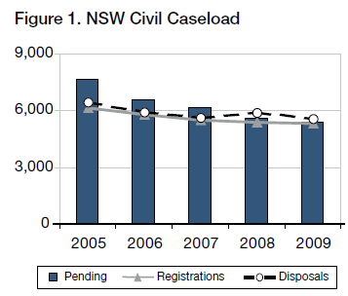
Disposal Times
In 2009, 58% of all actions completed were finalised within 12 months, with 86% being completed within 24 months. This compares to 52% and 81%, respectively, in 2008.
Of the pending caseload at the end of 2009, 17% exceeded 12 months and not more than 24 months and 7% more than 24 months.

SYDNEY
In 2009:
- Registrations fell by 5%
- Finalisations fell by 3%
- Pending cases fell by 8%
- Median disposal time fell from 10.9 to 10.3 months

Caseload
In 2009, Sydney civil case managed matters represented 68% of the State’s registrations and 68% of the matters on hand.
Figure 2 below shows the ratio of new civil actions commencing in Sydney, as compared to the whole State for the past 5 years.
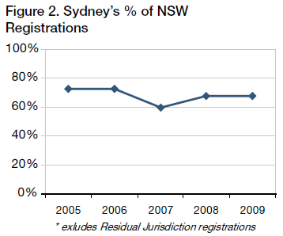
Registrations, Disposals and Pending
Excluding the Residual Jurisdiction, there were 3,609 new actions commenced and 3,914 finalised in Sydney in 2009. At the end of the year there were 3,671 actions pending. Figure 3 tracks Sydney’s caseload for the last five years.
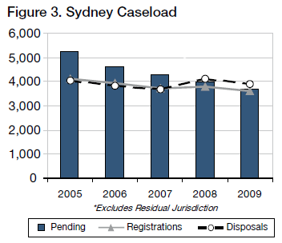
Disposal Times
The Court’s ideal time standard for civil cases is to achieve a 90% disposition rate within 12 months of commencement, and 100% within 2 years.
In 2009, 59% of all actions completed were finalised within 12 months, with 87% being completed within 24 months. This compares to 54% and 83%, respectively, in 2008.
Of the pending caseload at the end of 2009, 17% exceeded 12 months and not more than 24 months and 7% exceeded 24 months.
How Cases are Finalised
Table 1 below shows the breakup of how case managed list matters were completed in 2009. The categories of “Dismissed” and “Discontinued” include matters that settled without judgment being entered and/or terms of settlement being filed.
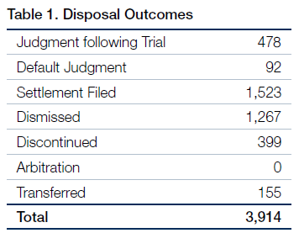
Table 2 below compares two of the seven categories of disposal outcomes as against the total number of disposal outcomes. These two categories are selected because i. “Disposed of by judgment following trial” represents the number of hearings to judgment before judges, and ii. “Disposed of by settlements filed” includes matters that settled as a result of ADR. 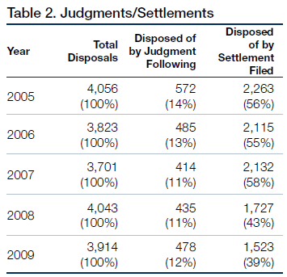

Alternative Dispute Resolution
Mediation
Pursuant to Civil Practice Note 1, cases before the Sydney District Court are referred to mediation where appropriate. The referral may be either to private mediation or to court provided mediation. The Assistant Registrars in Sydney undertake the court provided mediation. In 2009 the Sydney District Court referred 592 matters to mediation (458 were referred to private mediation and 134 to court provided mediation).
Approximately 50% of matters referred to mediation by Assistant Registrars were settled. There are no available statistics in relation to settlement of matters referred to private mediators.
Arbitration
The arbitration scheme in operation in the Court is the “Philadelphia” scheme (named after a similar scheme in Philadelphia, Pennsylvania, USA). Under this scheme, a number of Arbitrators are rostered to attend court provided accommodation on a nominated date and the Registry provides support services. This enables multiple matters to be listed and reserve matters are allocated to Arbitrators as previous matters conclude.
In 2009, 2 matters were referred to arbitration as compared to 30 in 2008, 98 in 2007, 179 in 2006 and 296 in 2005.
This substantial drop is another indication of the changing nature of the Court’s workload, with less actions being suitable for resolution through arbitration.

Residual Jurisdiction
The Compensation Court Repeal Act 2002 abolished the Compensation Court, and transferred the Compensation Court’s jurisdiction to the Workers Compensation Commission or the District Court. The Act commenced on 1 January 2004.
The disputes that were transferred to the District Court are commonly referred as its “residual jurisdiction” and involve the following:
- The Police Act 1990 concerning police officers “hurt on duty” and the Police Regulation (Superannuation) Act 1906 concerning the payment of superannuation benefits to police officers;
- Payment under the Police Regulations (Superannuation) Act 1906, paid to STC (the SAS Trustee Corporation continued under the Superannuation Administration Act 1996) and special risk benefits payable by the Commissioner of Police;
- The Workers’ Compensation Act 1987 concerning workers in or about a coal mine; • The Workers Compensation (Dust Diseases) Act 1942;
- The Sporting Injuries Insurance Scheme;
- The Workers’ Compensation (Bush Fire, Emergency & Rescue Services) Act 1987. During 2009, 384 actions were commenced and 402 were finalised. There were a total of 183 matters on hand in the residual jurisdiction at the end of 2009.

SYDNEY WEST
Sydney West had 5% of the total number of new actions started in the State in 2009 (excluding the Court’s residual jurisdiction). Figure 4 below tracks the variation in the proportional rate of registrations in Sydney West.
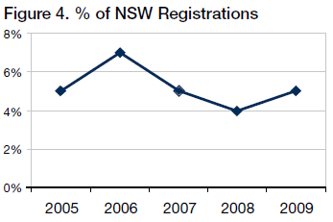
In Sydney West there were 279 matters registered and 243 dispositions throughout the year. At the end of 2009 the total pending caseload was 240, as compared to 221 the previous year.
Figure 5 shows comparative registrations, finalisations and pending caseloads for the past 5 years.
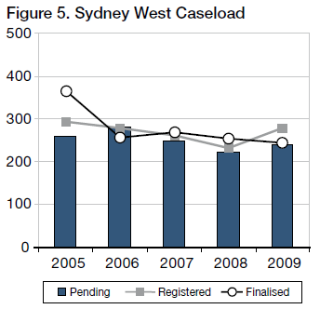
Pending matters in Sydney West rose by 8% and the median finalisation time was 9.9 months.
14% of pending cases exceeded 12 months and not more than 24 months and 6% exceeded 24 months.

Country
Venues outside of Sydney and Sydney West had 19% of the total number of new actions started in 2009 (excluding the Court’s residual jurisdiction). Figure 6 tracks the proportional rate of registrations for Country venues.
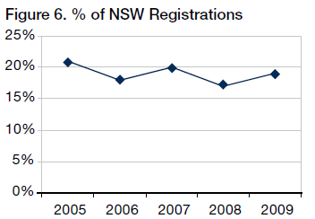
Outside of Sydney and Sydney West, there were 969 dispositions throughout the year. At the end of the year the total pending caseload was 1,275 as compared to 1,194 the previous year.
Figure 7 shows comparative registrations, finalisations and pending caseloads for the past 5 years.
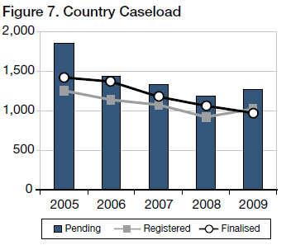
Pending matters in the country rose by 6% and the median finalisation time was 11.7 months.
19% of pending cases exceeded 12 months and not more than 24 months and 8% exceeded 24 months.

Criminal Jurisdiction

Trials
In 2009:
- Trial registrations fell by 6%
- Finalisations fell by 6%
- Number of pending trials fell by 1%
- Median disposals times rose from 34 to 35 weeks
- Average length of trials rose by 1%, from 7.75 to 7.84 days

Caseload
There were 1,671 criminal trials registered during 2009 in New South Wales, as compared to 1,785 in 2008 and 1,726 in 2007.
There were 1,681 trials finalised in 2009, as compared to 1,782 in 2008 and 1,801 in 2007.
There were 945 trials on hand at the end of 2009, as compared to 955 trials at the end of 2008.
Figure 8 tracks the statewide trends in the criminal trial caseload for the past 5 years.
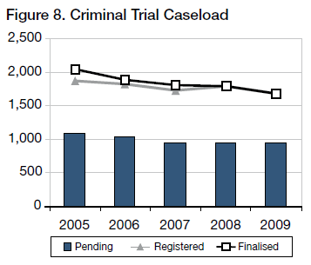
Figure 9 shows variation in trial and sentence registrations for the last 5 years.
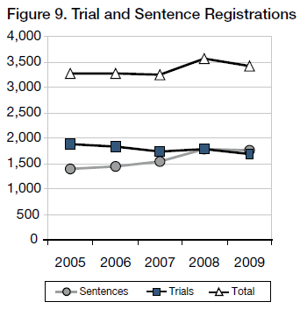
Sentence hearings are far less demanding on victims. They also absorb far less resources than trials. It is therefore important to ensure that in appropriate cases guilty pleas are entered at the earliest possible time, preferably at the committal stage.
Time Standards
The Court’s ideal time standards for the commencement of criminal trials are:
- 90% of cases within 4 months of committal, or such other event which causes the proceedings; and
- 100% of cases within 1 year.
In 2009, 35% of trial disposals where the accused was in custody were finalised within 4 months, and 13% exceeded 12 months. Where the accused was on bail, 25% of disposals occurred within 4 months, with 15% exceeding 12 months.
Figure 10 sets out comparative compliance rates with time standards for all trials finalised.
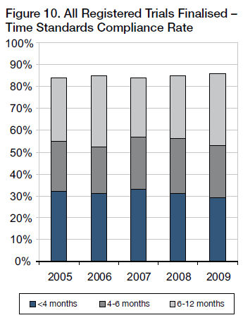
Figure 11 shows the age of all trials which were pending at the end of the year indicated.
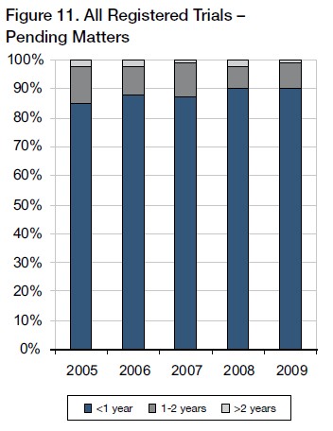
Figure 12 tracks the median disposal times, from committal to commencement of the trial, for matters finalised during the year indicated.
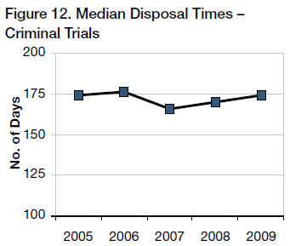
Trial Durations
The statewide average length of criminal trials finalised in 2009 was 7.84 days, as compared to 7.75 days in 2008. In Sydney the average duration was 9.57 days in 2009, compared to 9.03 days in 2008.
Figure 13 illustrates the fluctuating rise in the average trial duration time.
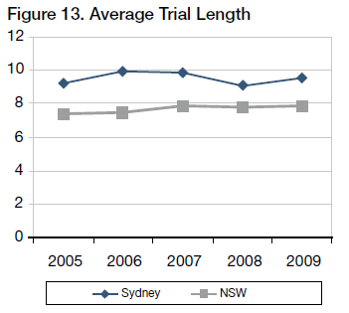
Trial Listing Outcomes
About 2,180 trials were listed for hearing in 2009.
Figure 14 shows the break up of those matters not dealt with.
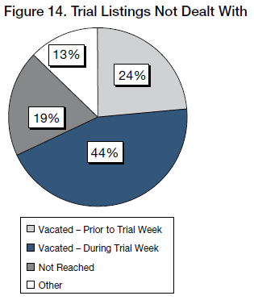
Figure 15 shows the break-up of those matters which were dealt with after being listed.
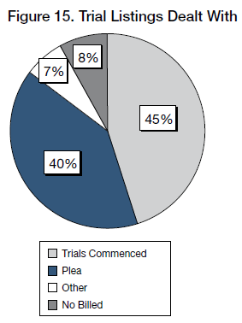
Figure 16 shows the outcome of those which commenced.
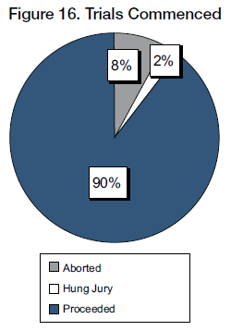
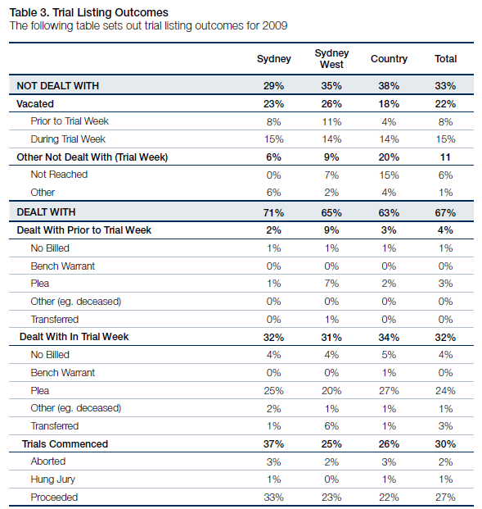
Of trials dealt with in 2009 (i.e. 67% of total listings):
- 49% pleaded guilty
- 40% proceeded to verdict
- 8% were “no billed”
- 4% were transferred
- 4% were aborted
- 1% ended with a “hung jury”
- 2% were otherwise disposed

Short Matters
Sentences
There were 1,745 committals for sentence received in 2009 and 1,727 matters were finalised. At the end of the year there were 670 sentence matters pending, compared to 652 at the end of 2008.
Figure 17 tracks the sentence caseload for the last 5 years.
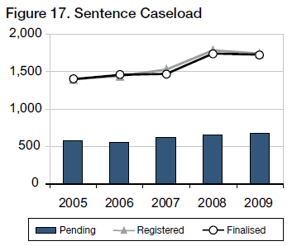
The ideal time standard from committal for sentence to hearing is 3 months in 90% of cases, with 100% being completed within 6 months.
Figure 18 illustrates compliance rates with time standards.
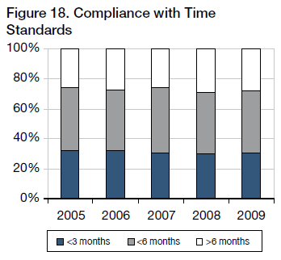
Conviction Appeals
There were 1,968 conviction appeals lodged in 2008 and 1,657 finalisations. At the end of the year there were 545 conviction appeals pending, compared to 504 at the end of 2008.
Figure 19 tracks the conviction appeal caseload for the last 5 years.
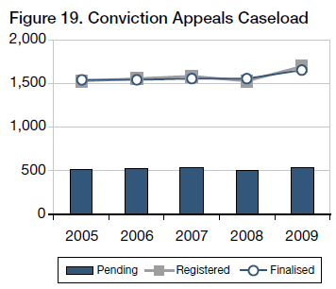
The ideal time standard from lodgement to finalisation is 4 months in 90% of cases, with 100% being completed within 12 months.
Figure 20 illustrates compliance rates with time standards.
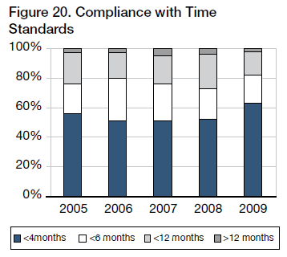
Sentence Appeals
There were 6,407 sentence appeals lodged in 2009 and 6,422 finalised. At the end of the year there were 884 sentence appeals pending, compared to 899 at the end of 2008.
Figure 21 tracks the sentence appeals caseload for the last 5 years.
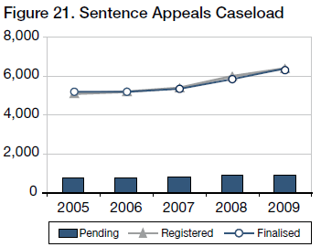
The ideal time standard from lodgement to finalisation for sentence appeals is 2 months in 90% of cases, with 100% being completed within 6 months.
Figure 22 illustrates compliance rates with time standards.
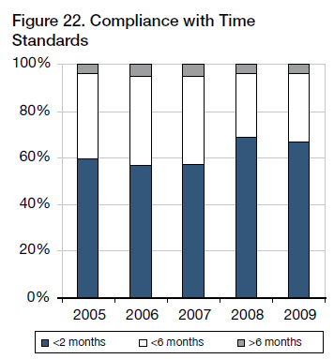

Judicial Resources

Allocated Sittings
Table 4 sets out the number of judicial sitting weeks allocated in 2009 as published in the Court’s Calendar of Sittings.
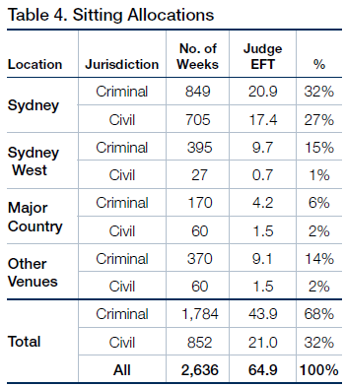
Judge EFT is calculated at 40.6 sitting weeks p.a. - i.e. 52 weeks less judicial vacations, public holidays and Annual Judges’ Conference

Actual Sittings
Table 5 sets out the number of days actually sat by the court in 2009 converted into weeks (by dividing the number of days by 5).
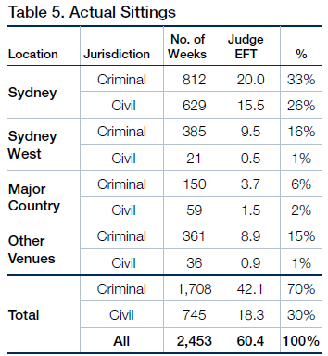
Judge EFT is calculated at 40.6 sitting weeks p.a.- i.e. 52 weeks less judicial vacations, public holidays and Annual Judges’ Conference
Comparisons with 2008
Overall, there were 20 additional sitting weeks in 2009 compared to 2008. This resulted in 29 additional criminal sittings and 9 fewer weeks of civil sittings.
The increase in criminal sittings was as a result of additional criminal weeks added to the country in order to reduce trial backlogs.
Acting Judges
Acting Judges provided an extra 900 days of actual sitting. Based on the maximum of 40.6 sitting weeks per year for a permanent judge, this equated to 4.4 additional judges.
Figure 23 below shows the fluctuations in the number of Acting Judge weeks attained since 2005.
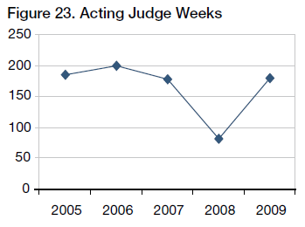
Sitting Details
The final table sets out the allocated, available and actual sittings at all venues, as well as the average daily recorded sitting hours.
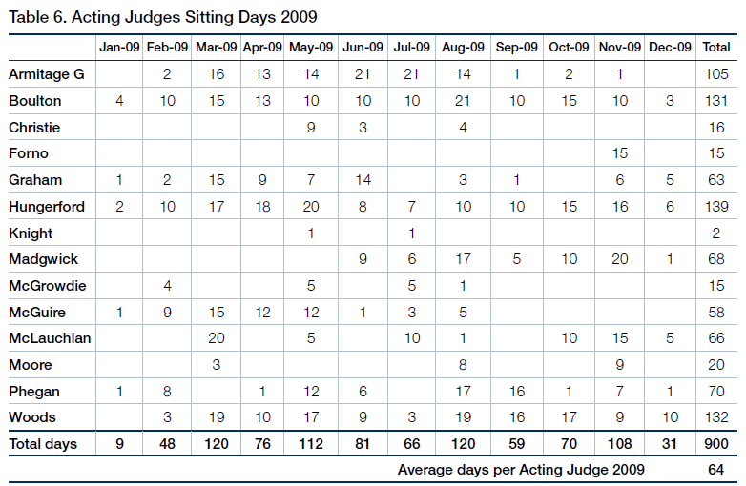
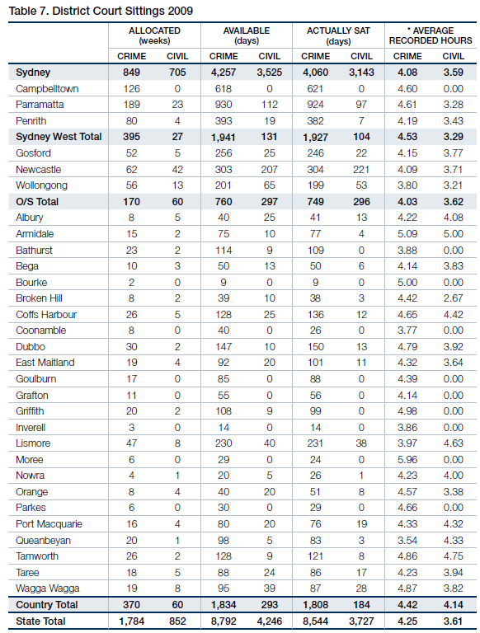
* “Average Recorded Hours” are based on the number of siting hours during which proceedings were recorded, as provide by the Reporting Services Branch, NSW Attorney General’s Department. This is often less than the actual hours the Court sat.

Annexures

Annexure A – Civil Caseload
Annexure A1 - Civil Caseload
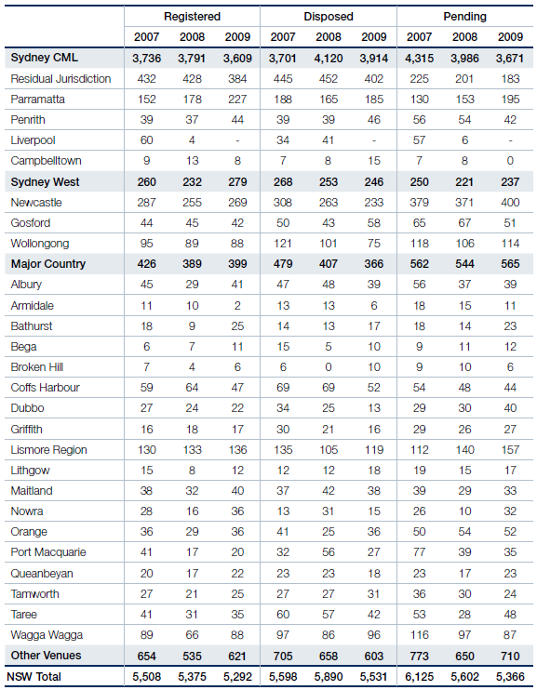
Annexure A2 - Civil Disposal Times
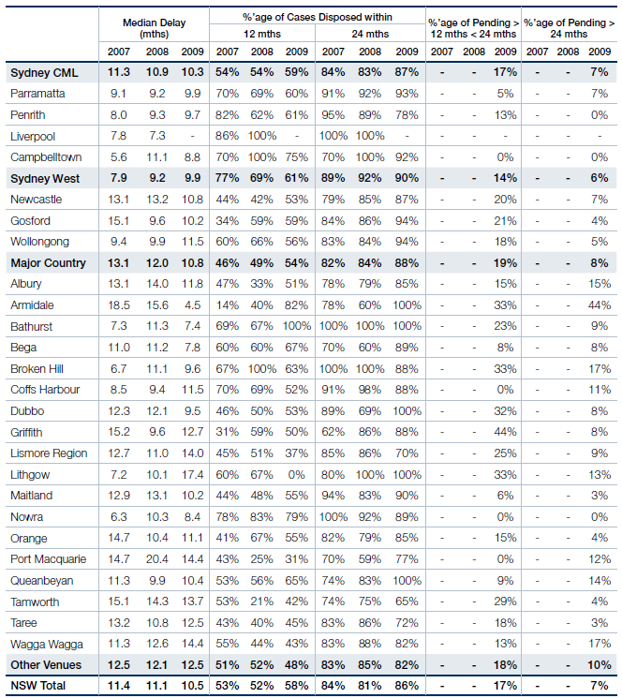

Annexure B – Criminal Caseload
Annexure B1 - Criminal Caseload
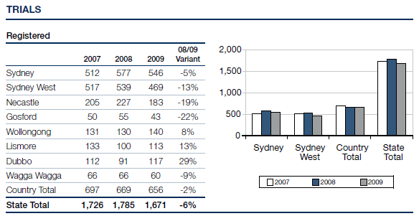
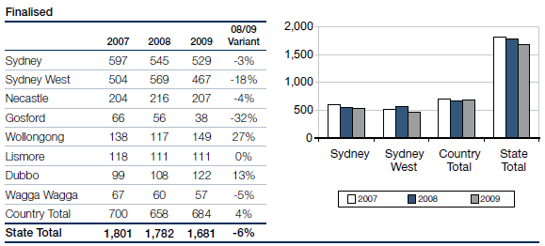
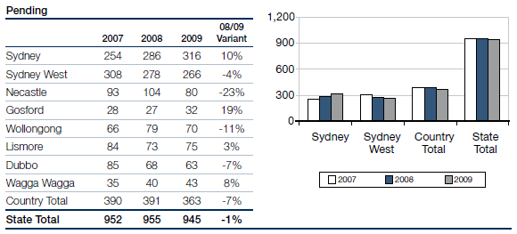
Annexure B2 - Criminal Caseload
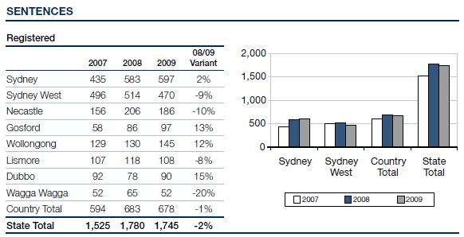
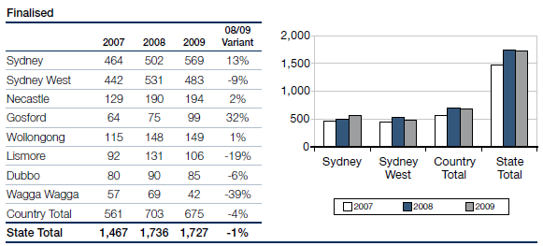
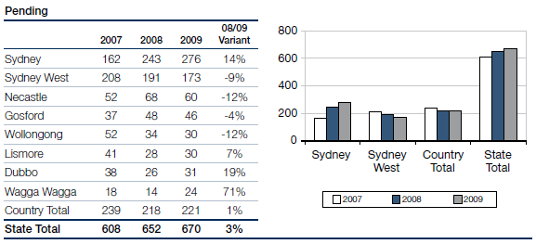
Annexure B3 - Criminal Caseload
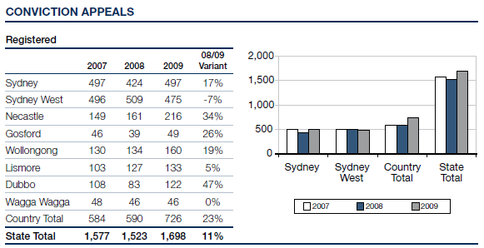
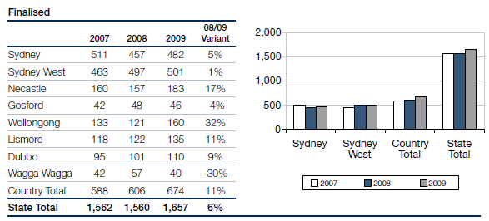
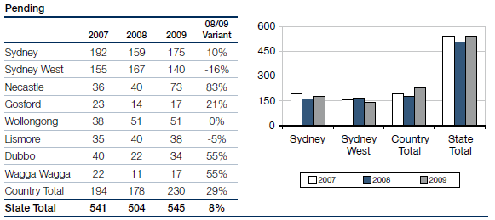
Annexure B4 - Criminal Caseload
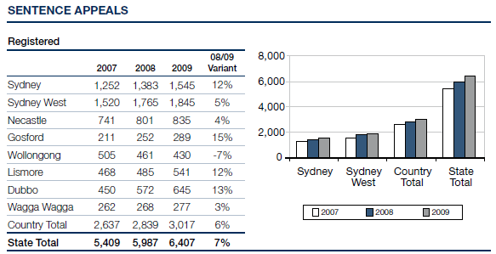
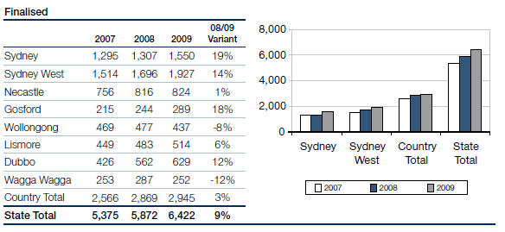
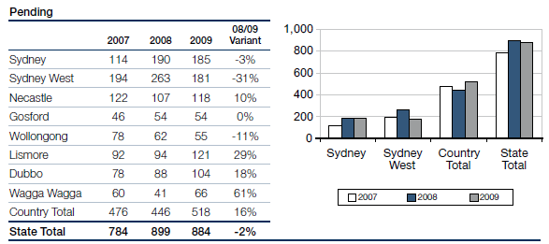

Annexure C – Compliance With Criminal Time Standards
Annexure C1 - Compliance With Criminal Time Standards
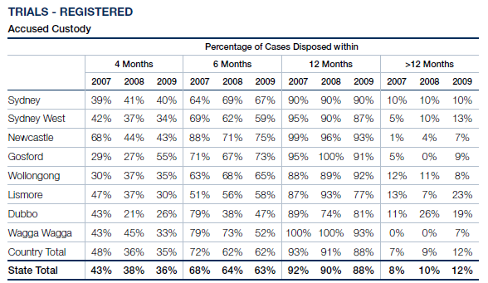
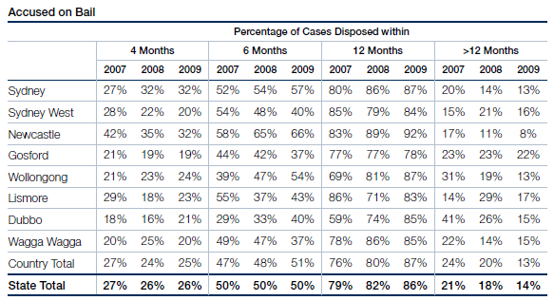
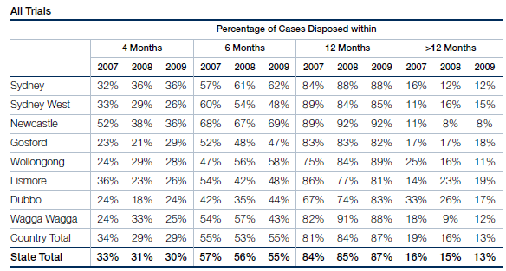
Annexure C2 - Compliance With Criminal Time Standards
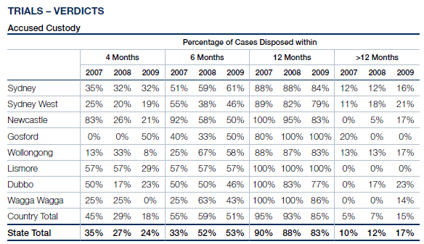
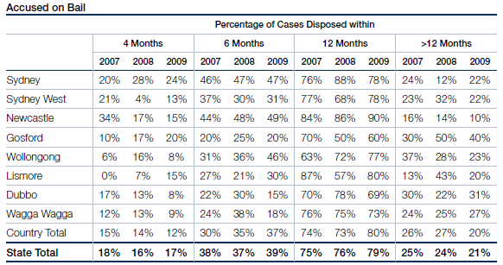
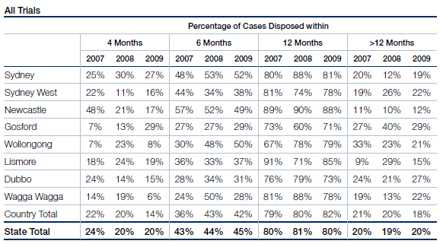
Annexure C3 - Compliance With Criminal Time Standards
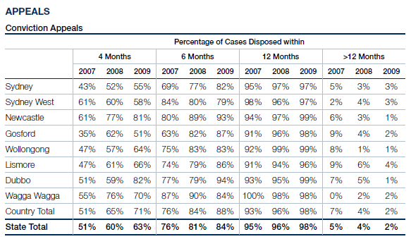
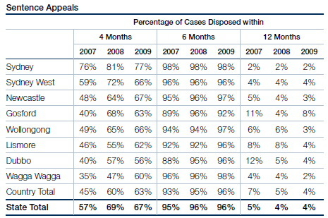
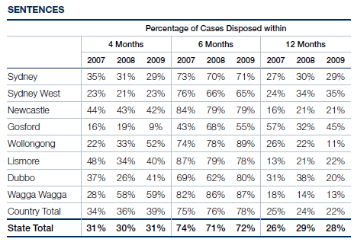

Annexure D – Court Committees
Annexure D - District Court Committees
Chief Judge’s Policy and Planning Committee
The Honourable Justice Blanch, Chief Judge (Chairman)
His Honour Judge Solomon (ex officio as Chair, Criminal Court Users Committee)
His Honour Judge Taylor, AM, RFD (ex officio as Chair, Education Committee)
His Honour Judge Garling (ex officio as Chair, Civil Court Users Committee)
Her Honour Truss
His Honour Judge Robison
Her Honour Judge Morgan
His Honour Judge Goldring (to 7/10/2009)
Her Honour Judge Balla
His Honour Judge Hulme, SC (to 1/3/2009)
His Honour Judge Toner
His Honour Judge Levy
Mr C Smith, Principal Registrar and Director Judicial Support (Secretary)
Rule Committee
The Honourable Justice Blanch, Chief Judge (Chairman)
His Honour Judge Garling (Deputy Chairman)
Her Honour Judge Sidis
His Honour Judge Robison
His Honour Judge Rolfe
His Honour Judge Neilson
His Honour Judge Johnstone
Mr P Khandhar, NSW Bar Association
Mr A Saxton, Law Society of NSW
Mr A Grew, Registrar Assistant (Secretary)
Civil Business Committee
His Honour Judge Garling (Convenor)
Her Honour Judge Truss
Her Honour Judge Sidis
His Honour Judge Rolfe
His Honour Judge McLoughlin, SC
His Honour Judge Johnstone
Ms C McDonald, Judicial Registrar (to 4/12/2009)
Ms J Hall, Insurance Council of Australia
Ms B Cassidy, Motor Accidents Authority
Mr P Deakin, QC, NSW Bar Association
Ms L King, SC, NSW Bar Association
Mr A McMurran, Law Society of NSW
Mr A Saxton, Law Society of NSW
Mr C Smith, Principal Registrar and Director Judicial Support
Ms J Dunn, Civil Listing and Case Manager
Criminal Business Committee
His Honour Judge Solomon (Chairman)
His Honour Judge Sides, QC
His Honour Judge Woods, QC
Mr J Kiely, Crown Prosecutor
Mr M Ierace, Senior Public Defender
Mr R Fornito, Criminal Listing and Case Manager
Mr D Giddy, NSW Law Society
Ms C Girotto, Office of the Director of Public Prosecutions (NSW)
Mr J Joliffe, Office of the Director of Public Prosecutions (Commonwealth)
Mr R Kozanecki, Legal Aid Commission
Ms K Traill, Bar Association of NSW
Mr C Franklin, Aboriginal Legal Service
Mr C Smith, Principal Registrar and Director Judicial Support
Ms J Garvey, Judicial Support Coordinator (Secretary)
Resources Committee
His Honour Judge Taylor, AM, RFD (Chairman)
Her Honour Judge Ainslie-Wallace
His Honour Judge Finnane, RFD, QC
Mr C Smith, Principal Registrar and Director Judicial Support (Secretary)
Professional Development (Education) Committee
His Honour Judge Taylor, AM, RFD (Chairman)
Her Honour Judge Sidis
Her Honour Judge Ashford (Acting Chair)
His Honour Judge Nicholson, SC
His Honour Judge Knox, SC
Her Honour Judge Sweeney
His Honour Judge Zahra, SC
His Honour Judge Cogswell, SC
Mr C Smith, Principal Registrar and Director Judicial Support
Ms R Windeler, Education Director, Judicial Commission of NSW
Judicial Support Committee
His Honour Judge Solomon
His Honour Judge Taylor, AM, RFD
Her Honour Judge Truss
Her Honour Judges Sidis
Judicial Commission, Standing Advisory Committee of Judicial Education
His Honour Judge Nicholson, SC
Judicial Commission, Joint Steering Committee with the Alja Aboriginal Cultural Awareness Program
His Honour Judge Norrish, QC
His Honour Judge Dive
Judicial Commission, Criminal Trial Courts Bench Book Committee
His Honour Judge Berman, SC
His Honour Judge Hulme, SC (to 1/3/2009)
Downing Centre Library Committee
His Honour Judge Knight to (1/2/2009)
His Honour Judge Knox, SC
John Maddison Tower and Downing Centre Building Committee
His Honour Judge Robison
His Honour Judge Kearns
Mr C Smith, Principal Registrar and Director Judicial Support
Mr C Allen, Sheriff
Mr R Goundran, Engineering Officer, Asset Management Services
Mr R Cowburn, Building Manager
Mr P Futcher, Judicial Support Officer
Mr G McCoubrie, Federal Magistrate
Justicelink Committee
His Honour Judge Williams
His Honour Judge Rolfe
His Honour Judge Finnane
His Honour Judge Hulme, SC (to 1/3/2009)
Judicial Registrar McDonald
Mr C Smith, Principal Registrar and Director Judicial Support
Mr R Fornito, Criminal Listing and Case Manager
Ms J Dunn, Civil Listing and Case Manager
Ms J Mathison, Manager Justicelink Business Support Group
Ms N Ubrihien, Justicelink Project
Ms R Liston, Justicelink Project

